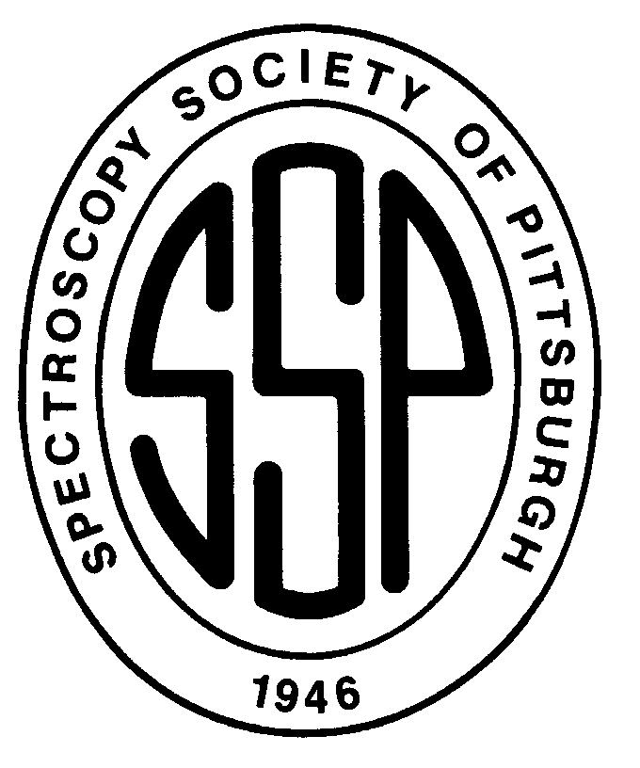
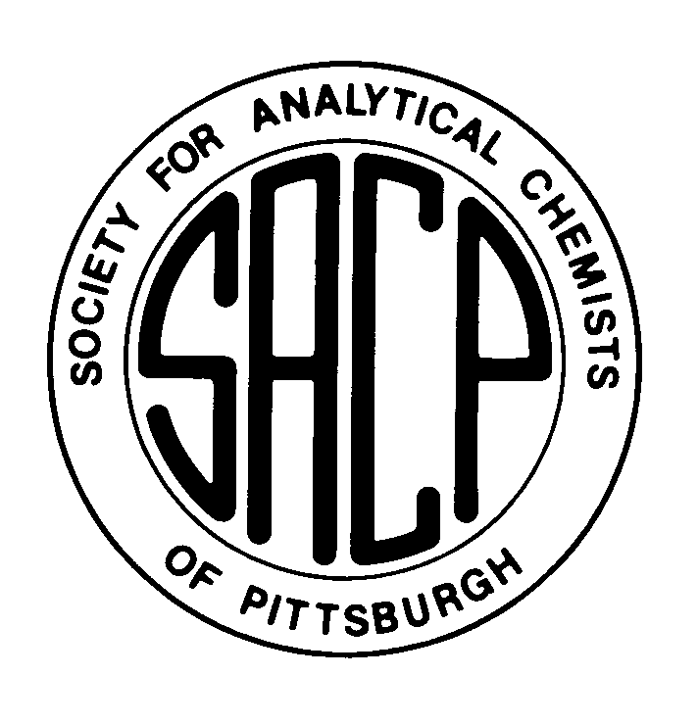
Society for Analytical Chemists of Pittsburgh

Spectroscopy Society of Pittsburgh
300 Penn Center Blvd • Suite 332 • Pittsburgh, PA 15235-5503
412-825-3220 • www.sacp.org • www.ssp-pgh.org

TO: HIGH SCHOOL/MIDDLE SCHOOL PRINCIPALS AND SCIENCE DEPARTMENT HEADS

The Spectroscopy Society of Pittsburgh (SSP) and the Society for Analytical Chemists of Pittsburgh (SACP) offer a wide variety of science outreach programs for students and teachers at all grade levels. Most of these programs are provided at a minimal cost or no cost at all. The teacher workshops offer Pennsylvania teachers Act 48 in-service credit through the Allegheny Intermediate Unit. The SSP and SACP have been conducting these types of science outreach activities for more than 65 years.

Additional information and registration/application forms for these programs are available on the websites of the SACP and SSP. Please encourage your teachers to check these sites periodically as additional information about programs is added from time to time. Registration/ Application Forms are NOT mailed to schools unless specifically requested (except for the Faraday Lectures).

SACP HIGH SCHOOL AND MIDDLE SCHOOL ESSAY CONTESTS
Students in grades 7 - 9 and 10 - 12 are invited to submit essays on a specific topic in science and compete for 13 cash prizes valued from $100 to $500 for high school students and $50 to $250 for middle school students. This is an excellent opportunity for students to practice their writing skills in preparation for state assessment tests. Each school may submit two essays in each category. Entry forms will be available on the SACP website.

SACP ELEMENTARY/MIDDLE SCHOOL EQUIPMENT GRANTS PROGRAM
This program gives elementary and middle school teachers an opportunity to submit proposals for the purchase of up to $600 worth of science equipment and supplies. The application form is not difficult or time consuming to complete. The SACP typically funds 75 to 80 percent of the proposals received. The forms will be available on the SACP website. Equipment is purchased by the SACP and shipped directly to your school.

SACP COMPUTER WORKSHOP FOR CHEMISTRY & PHYSICS TEACHERS
This full-day teacher workshop will be held April 11, 2019 at the National Energy Technology Center in South Park, PA. At the workshop, teachers explore a variety of computer software programs and internet websites for the teaching of important concepts in chemistry and physics. All the concepts and activities correlate well with the new Pennsylvania science goals. Teachers take home all of the computer programs used at the workshop, receive a free one year subscription to the Journal of Chemicl Education and 5 hours of Act 48 credit through the Allegheny Intermediate Unit. The registration form will be available on the SACP website or you can email Hub MacDonald at macdonald@pittcon.org for further information.

SSP KEIVIN BURNS OUTSTANDING HIGH SCHOOL TEACHER AWARD
This award consists of a plaque and an honorarium for outstanding science teaching at the secondary school level. It requires a nomination from a Principal or Science Dept. Head. Application forms will be available on the SSP website.

PITTCON PLANETARIUM
The SSP will bring an inflatable planetarium to your school and conduct a sky show for your students. Ceiling height must be at least 16 feet or more. Contact Neal Dando at dando@pittcon.org for information.

SSP HIGH SCHOOL EQUIPMENT GRANTS

This program provides high school science teachers with equipment of value upwards of $2,000 that utilizes or teaches principles of spectroscopy and related topics. An application form will be available on the SSP website.

2018 PSTA CONVENTION
If you plan on attending the PSTA Convention at the Penn Stater, Sept. 30 – Oct. 1, 2018, visit the SSP & SACP booth and look for our abbreviated versions of the SSP “Light, Color and Spectroscopy for Kids” Workshop and the SACP “Computer Software Workshop for Chemistry/Physics Teachers”.

SSP COMPUTER SOFTWARE SERVICES LIBRARY
The SSP offers schools a one-year subscription to Journal of Chemical Education Web-Based Software – either an individual or institutional subscription - as well as selected chemistry software published by Victor Bendall of Eastern Kentucky University. The software is all offered free of charge and the Bendall software includes a site license. Instructions for obtaining this software will be available on the SSP website.

SSP “LIGHT, COLOR & SPECTROSCOPY FOR KIDS” TEACHER WORKSHOP
This full-day teacher workshop for Middle and Elementary School teachers will be scheduled in April, 2019 at the National Energy Technology Center in South Park, PA. At the workshop, teachers will explore a wide variety of activities to assist their students in understanding important concepts about light and color. All these activities correlate well with the new Common Core standards. Teachers attending will receive most of the materials needed to perform these activities in their own classrooms plus 5 hours of Act 48 credit through the Allegheny IU. A registration form will be available on the SSP website or you can email John Varine at <varine@pittcon.org> to register.

ANNUAL FARADAY SCIENCE LECTURE
Each year, the SSP and SACP sponsor a series of science lecture-demonstrations at Soldiers and Sailors Hall in the Oakland section of Pittsburgh. Three lecture-demonstrations are held – an evening one for the general public and two for middle and high school students. The 2018 lectures will be held Nov. 13 & 14 for middle and high school students. Additional information & tickets can be obtained here: http://www.sacp.org/faraday. The evening lecture, free and open to the public, will be Nov. 13. The 2018 lecturer will be Dr. Gregg Gould of California Univ. of PA. Additional information will be available on the two Society websites.

NETL TRIPLE E SEMINAR

The National Energy Technology Laboratory near South Park, PA offers a 2-day “Education, Environment, Economics” seminar for elementary teachers each year. This year’s seminar will be Nov. 15-16, 2018. Contact Alicia Delmastro at <Alicia.Delmastro@netl.doe.gov> for information and schedule.

Funding for all these programs comes from Pittcon, the yearly conference and exposition owned and operated by volunteer members of the SSP and SACP, and intended for individuals who work in the broad field of laboratory science and companies that market to that field. Pittcon provides over a million dollars per year to the societies to support a wide variety of science outreach activities at all levels from kindergarten through the professional career level. Membership in the SSP and SACP is open to all who work in a science related field.

Don Antczak, Chair
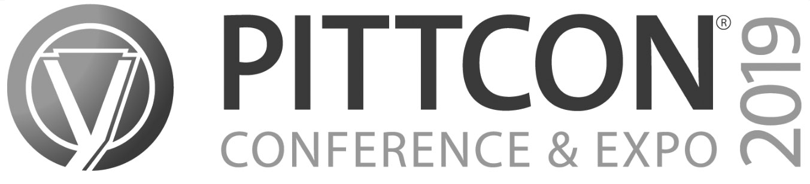
Spectroscopy Society of Pittsburgh

Amit Ghosh, Chair
Society for Analytical Chemists of Pittsburgh

Chuck Gardner, Pittcon 2019 President Mar. 17 – Mar. 21, 2019 * Philadelphia

www.ssp-pgh.org www.sacp.org www.pittcon.org

