Coal Gasification in China
A Study Report
US-China Energy Center, National Research Center for Coal and Energy, West Virginia University, Morgantown, WV 26506-6064

Completed under Task 3 of Cooperative Agreement DE-FC26-06NT42804, “Development of Alternative Coal Gasification Technologies Data Base”




Table of Contents
PREFACE iv
EXECUTIVE SUMMARY v
FORWARD vii
ACRONYMS viii
1. INTRODUCTION 1
1.A.1 The Early Days (1950-1980) 1
1.A.2 The Transition Period (1980-1995) 3
1.A.3 Implementation of the Clean Coal Technology Program (1996-~) 5
2. THE GASIFIERS AND THEIR USE 13
2.A. International Origin 13
2.A.1 Air Liquide GmbH / Lurgi Clean Coal Tech Co. (FBDB) 13
2.A.2 Environtherm GmbH (BGL) 23
2.A.3 General Electric Energy Co. (GE) 32
2.A.4 KBR Inc. (TRIG) 42
2.A.5 Gencorp / Pratt Whitney Rocketdyne (Entrained) 50
2.A.6 Shell Global Solutions International B.V. (Shell) 55
2.A.7 Siemens AG (SFG) 65
2.A.8 Synthesis Energy Systems Inc. (U-Gas) 74
2.B. Chinese Origin 84
2.B.1 Aerospace Science and Technology Corporation (HT-L) 84
2.B.2 East China University of Science and Technology (OMB) 90
2.B.3 Institute of Coal Chemistry (AFB) 101
2.B.4 Northwest Research Institute (MCSG) 109
2.B.5 SiChuan Blue Star Machinery (WUG) 117
2.B.6 Thermal Power Research Institute (TPRI) 122
2.B.7 Tsinghua University (OSEG) 130
3. SUMMARY 140

Figure 1. Schematic Illustration of the Lurgi Fixed-Bed Dry-Bottom (FBDB) Gasifier 19
Figure 2. Project Location of Lurgi 21
Figure 3. Schematic Illustration of the British Gas / Lurgi Slagging Gasifier 28
Figure 4. Project Location of BGL 30
Figure 5. Schematic View – GE Gasifier 37
Figure 6. Project Location of GE 40
Figure 7. Schematic Illustration of the TRIG Gasifier 46
Figure 8. Project Location of TRIG (KBR) 48
Figure 9. Schematic Illustration Rocketdyne Dry-Feed, Plug-Flow, Entrained Gasifier 53
Figure 10. Schematic Illustration of the Shell Gasifier⁽⁴⁾ 61
Figure 11. Project Location of Shell 63
Figure 12. Schematic Illustration of the SFG-500 Gasifier 70
Figure 13. Project Location of Siemens 72
Figure 14. Schematic Illustration of U-Gas Gasifier 78
Figure 15. Development of U-Gas Technology 79
Figure 16. Scale-up of U-Gas Gasifier 80
Figure 17. Project Location of U-Gas 82
Figure 18. Schematic Illustration of the HT-L Gasifier⁽¹⁾ 86
Figure 19. Project Location of HT-L 88
Figure 20. Schematic Illustration of the OMB Gasifier 96
Figure 21. Project Location of ECUST 99
Figure 22. Schematic Illustration of the AFB Gasifier 105
Figure 23. Project Location of AFB 107
Figure 24. Schematic Illustration of MCSG Gasifier 112
Figure 25. Project Location of MCSG 115
Figure 26. Project Location of WUG 120
Figure 27. Schematic Illustration of TPRI Gasifier 126
Figure 28. Project Location of TPRI 128
Figure 29. Schematic Illustration of OSEF Gasifier 134
Figure 30. Project Location of Tsinghua First Generation 137
Figure 31. Project Location of Tsinghua Second GenerationREFERENCES 138
Figure 32. Grouping of Provinces into Coal Planning Regions 146

Table 1. Projects with Lurgi Fixed Bed, Dry Bottom (FBDB) Gasifiers 20
Table 2. Gasifier Technology Imported in Early Program⁽²⁾ 38
Table 3. Projects with British Gas / Lurgi (BGL) Gasifiers 29
Table 4. Projects with General Electric (GE) Gasifiers 39
Table 5. Projects with TRIG Gasifiers 47
Table 6. Projects with Shell Gasifiers 62
Table 7. Projects with Siemens Gasifiers 71
Table 8. Projects with U-GAS Gasifiers 81
Table 9. Projects with HTL Gasifiers 87
Table 10^{(13).} Utilization of OMB Gasifiers with Varying Design Capacities 97
Table 11. Projects with Opposed Burners (OMB) Gasifiers 98
Table 12. Projects with Pressurized, Agglomerated Fluidized Bed (AFB) Gasifiers 106
Table 13. Multi-Capacity, Slurry Gasifiers (MCSG) – Available Capacities⁽¹⁾ 113
Table 14. Projects with Multi-Component Slurry Gasifiers (MCSG) 114
Table 15. Projects with Wuhuan Gasifiers (WHG) 119
Table 16. Projects with Two-Stage, Dry-Feed, Up-Flow (TPRI) Gasifiers 127
Table 17. Projects with Oxygen-Staged Entrained-Flow (OSTF) Gasifiers 135
Table 18. Projects with Coal-Water Slurry and Water Cooling Wall Gasifiers 136
Table 19. Summary list of Chinese and International Gasifier Being Commercialized in China 142
Table 20. Distribution of Gasification Projects to Coal Planning Regions 143
Table 21. Distribution of Projects to Provinces 144
Table 22. Estimated Coal Resource by Province and Type (Gt) 145

PREFACE

The data used in the Study comes from resources publically available in the Chinese and English literature (i.e. presentations, reports, earlier studies, press announcements, news clips, etc.). The degree to which the number of projects listed for any technology is complete or incomplete is determined by the coverage given to their projects by the technology licensor/owner, the industrial developer of the plant or project, the financial supporters of the project, local press, etc. Throughout the study an effort was made to eliminate duplication in the listing of projects resulting from the practice to identify the same project by more than one name. It should be noted also that the continued support of the Government and Industry in this area of coal utilization is resulting in planning and implementation of additional projects. Consequently, this report may not represent all existing plants and plants under consideration, and limitations of available sources may cause some discrepancies and errors in the tabulated information. The Department of Energy does not warrant the accuracy or suitability of this information.

EXECUTIVE SUMMARY

Coal is recognized as a high priority component of the China’s Energy Strategy. Significant amounts of the Nation’s economic resources, from both the Government and the Industrial sectors, are being dedicated to the development or acquisition of the technology and support services necessary to fully utilize the potential coal offers in producing energy products and systems essential to achieving China’s energy goals.
Within a period of 40 years the coal conversion industry has acquired and implemented the technology needed to be responsive to these goals as stated by the Administration at a much earlier time:
- “As China’s economy grows from National Energy and Security Perspectives, coal conversion can be one of the important solutions for China to address the shortage of oil”
- “Clean Coal Conversion is an inevitable choice for sustainable development”
To fully achieve the intent of these statements, the Chinese Government not only has and continues to support a significant number of research and development programs at several universities and institutions it has supported the acquisition of the most advanced coal conversion technology available from the International Community
At present, seven major Chinese institutions, universities and corporations, have successfully developed and commercialized a number of different gasifiers. Data acquired to date, indicates that these gasifiers and gasification technologies are being used in over 100 projects. These projects are widely distributed among a large number of the 30 Chinese Provinces.
Supplementing these efforts, additional technologies representing nine International manufacturers and/or licensors of gasifiers and gasification technologies have been acquired by representatives of the Chinese coal industry through a variety of cooperative licensing agreements. The gasifiers and associated processes subsequently are, or are being, considered for operation in approximately 80 coal conversion projects. These projects also are widely distributed among many of the 30 Chinese Provinces. It should be noted that only three of the 30 provinces do not have any of the coal conversion projects currently existing or being planned by the coal industry.
The technology currently available to the coal industry is broadly based, sophisticated and capable of producing an array of products. These products include direct coal liquids (CTL), indirect coal liquids (IDL), synthetic natural gas (SNG), methanol, methanol to gasoline (MTG), methanol to olefins (MTO), propylene, polypropylene di-methyl-ether, etc., along with the products of an earlier time, ammonia and urea.
The future direction of the coal conversion industry may be reflected in a recent announcement by the National Development and Reform Commission (NDRC). The announcement authorized preliminary development to begin on ten new coal conversion projects. The authorization provides some certainty that the growth of the industry being experienced today will continue. In a similar manner, the numerous Research and Development Programs in coal chemistry and associated disciplines being supported by Governmental Agencies, Universities and Industry insures the continued advancement of the technology and its application in the production of a broader slate of products generated more efficiently and with a reduced environmental footprint.

FORWARD

This report describes work completed under Task 3 of Cooperative Agreement DE-FC26-06NT42804, Development of Alternative Coal Gasification Technologies Data Base”. The database includes U.S. and Chinese Technology descriptions, estimates of scale and assessments of the impacts of the Technologies. Included also are brief introductions to the technology developers and the current owners and or licensors of the technology.

ACRONYMS

A
- AGA – American Gas Association
- APFBC – Advanced Pressurized Bed Gasification/Combustion
- ARC – Allied Resources Corporation
- ASC – Allied Syngas Corporation
- ASU – Air Separation Units

B
- BAR – Barometric Pressure
- BARG – Barometric Pressure Gauge
- BCURA – British Coal Utilization Research Association
- BGL – British Gas/Lurgi Slagging Gasifier
- BRICC – Beijing Research Institute for Coal Chemistry

C
- CAE – China Academy of Engineering
- CAS – China Academy of Science
- CASC – China Aerospace Corporation
- CAPEX – Capital Expense
- CCRI – China Coal Research Institute
- CCS – Carbon Capture and Sequestration
- CERI-HIT – Combustion Engineering Institute at Harbin Institute of Technology
- CDT – China Datang (Group) Corporation
- CFB – Circulating Fluidized Bed Gasifier
- CHD – China Huadian Corporation
- CHNG – China Huaneng Group
- CHNG-CERI – Huaneng Clean Energy Research Institute
- CMC – Ceramic Matrix Composite
- CNTIC – China National Import Corporation
- CO – Carbon Monoxide
- CO₂ – Carbon Dioxide
- CO + H₂ – Representative of Syngas
- COD – Completion of Development
- COED – Char Oil Energy Development Process
- CPECC – China Power Engineering Consulting Group Corporation
- CPI – China Power Investment Corporation
- CTC – Coal to Chemicals
- CTL – Coal to Liquids
- CTO – Coal to Olefins
- CUMT – China University of Mine Technology
- CWS – Coal Water Slurry

D
- DBI – Deutsches Brennstoffinstitute
- DCL – Direct Conversion Process for Coal to Liquids
- DME – Coal to Dimethylether

E
- ECUST – East China University of Science and Technology
- EERC – North Dakota Energy and Environmental Research Center
- EOR – Enhanced Oil Recovery
- EPC – Engineering, Procurement, Construction
- ERDA – Energy Research and Development Administration

F
- FBDB – Fixed Bed, Dry Bottom Gasifier
- FCC – Fluidized Bed Catalytic Cracker
- ºF – Degrees Fahrenheit
- FT- Fischer Tropsch
- FT³ – Cubic Foot

G
- GD – China Guodian (Group) Corporation
- GE – General Electric Corporation
- GE ENERGY – General Electric Energy
- GENCORD – An Aerospace and Technology Firm
- GMIE – Gemeng International Energy
- GNPD – Great Northern Power Development
- GSP – Gaskombinat Schwarze Pumpe
- GTI – Gas Technology Institute

H
- HCERI – Huaneng Clean Energy Research Institute
- HIT – Harbin Institute of Technology
- HH – Shangdon Hai Hua Coal and Chemical Co., Ltd
- HT – High Temperature Methanation Process
- HT-L – A Gasifier Developed by China Aerospace Science and Technology Corporation
- HYGAS – A High Pressure Coal Gasifier/Gasification Process

I
- ICC – Institute of Coal Chemistry
- ICCT – Institute of Clean Coal Technology
- ICCCAS – Institute of Coal Chemistry/China Academy of Science
- ID – Internal Diameter
- IDL – Indirect Coal Conversion Process (Coal to Liquids)
- IGCC – Integrated Gasification Combined Cycle
- IGT – Institute of Gas Technology

J
- ---

K
- KBR – Kellogg Brown Root, Inc.
- Kg/cm² – Kilograms per Square Centimeter Pressure
- KT – Koppers Totzek
- Kt/y – 1000 Tons per year

L
- Lbs/Hr – Pounds per Hour
- LCCT – Lurgi Clean Coal Technology Company
- LLNL – Lawrence Livermore National Laboratory
- LNB –Low NO_{x} Burner
- LNG – Liquefied Natural Gas

M
- M³ – Cubic Meter
- M³/Hr – Cubic Meter per Hour
- MCSG – Multi-Component Slurry Gasifier
- MEA – Monoethanolamine
- MEG – Coal to Monoethylglycol
- MeOH – Methanol
- MK⁺ - MK PlusTM – Advanced Lurgi Fixed Bed Dry Bottom Gasifier
- MM – Millimeter
- MOST – Ministry of Science and Technology
- MTA – Methanol to Aromatics
- MTO – Methanol to Olefins
- MTP – Methanol to Propylene
- Mtpa – Metric Tons per Annum
- Mtpd – Metric Tons per Day
- Mw – Megawatt
- Mw_{th} – Megawatt Thermal
- NWU – Northwest University

N
- NDRC – National Development and Reform Commission
- NGCC – Natural Gas Combined Cycle
- Nm³/hr –Normal Cubic Meters per Hour
- NWRICI – Northwest Research Institute of Chemical Industry

O
- OMB – Opposed Multi-Burner
- OSEFG – Oxygen-Staged Entrained Flow Gasifier

P
- PCGERC – Pulverized Coal Gasification Engineering Research Center
- PDP – Process Design Package
- PFBC – Pressurized Fluidized Bed Combustion
- PP – Polypropylene
- PRC – People’s Republic of China
- PRENFLOW – Pressurized, Dry Feed, Entrained Flow Gasifier
- PSA – Pressure Swing Adsorption
- PSDF – Power Systems Development Facility
- PSIA – Pounds per Square Inch Atmospheric Pressure
- PSIG – Pounds per Square Inch Gauge :Pressure
- PWR – Pratt Whitney Rocketdyne

Q
- ---

R
- R and D – Research and Development
- RMB –
- ROI – Return on Investment

S
- S & T – Science and Technology
- SCCC – Shanghai Coking and Chemical Corporation
- SCGP – A Dry Feed, Pressurized, Up Flow, Entrained, Slagging Gasifier
- SCGP-1 – Shell Coal Gasification Plant – 1
- SCSP – Shell Coal Gasification Process
- SCQ – Syngas Quench System
- SELCEP – State Engineering Laboratory for Carbon Fiber Preparation
- SELICL – State Engineering Laboratory for Indirect Coal Liquefaction
- SES – Systems Energy Systems Co.
- SEP – Samenwerkende Electriciteits Produktieledriven
- SGP – Shell Gasification Process
- SFG – Siemens Fuel Entrained Flow Gasifier
- SHED – South Hart Energy Development
- SIRCCCET – Shanxi Int’l Research Center for Coal Chemical Engineering & Tech
- SKLCC – State Key Laboratory of Coal Conversion
- SNCG – Shenhua Ningxia Coal Group
- SNG – Synthetic Natural Gas
- SOFA – Secondary Overfire Air
- SOW – Statement of Work
- SPC – State Power Corporation Commission of China

T
- t/d – Tons per Day
- t/hr – Tons per Day
- TPD – Tons per Day
- TCGP – Texaco Coal Gasification Process
- THU –Tsinghua University
- TMEP – Tian Ming Electric Power Co.
- TMP – Technical Management Plan
- TPRI – Thermal Power Research Institute
- TRIG – Transport Integrated Gasifier
- TSA – Temperature Swing Adsorption
- TVA – Tennessee Valley Authority

U
- UBC – Unburnt Carbon
- UGI –
- U-GAS – Synthesis Energy Systems Agglomerating Bed Gasifier
- UKy – University of Kentucky
- UNESCO –
- USC – Ultra Super Critical
- USD – United States Dollar

V
- VLE – Vapor Liquid Equilibrium

W
- WHG –Watergas, Entrained Bed, Dry Feed Gasifier

X
- ----

Y
- ----

Z
- ZJU – Zhejiang University

INTRODUCTION
THE GROWTH OF COAL GASIFIERS AND GASIFICATION
SYSTEMS IN CHINA

Approximately sixty years of practical, economic, and political events have merged to position coal and its associated conversion technologies as a significant factor in China’s energy market and a major driver of its national energy policies
This current, accumulated body of information, now driving the coal industry in its assigned role as a source of energy, chemical products, alternate fuels, etc., represents experience acquired as the industry matured through numerous stages. The stages, for convenience, have been grouped into three sequential phases. The phases are briefly reviewed. The goal of the review is to provide some insight into the coal conversion/utilization activity as it was and is being implemented in China’s coal industry.

1.A.1 The Early Days (1950-1980)
As early as the 1950’s, coal gasification technology was being imported into China⁽¹⁾ and by 1978 a significant gasifier development program was in progress. The gasifiers imported during the early days, principally Woodall Duckham units and UGI Blue Water gas reactors, were used either to generate a fuel gas for kilns, iron melting and various industrial furnaces and boilers⁽²⁾or to produce a syngas suitable for the conversion to ammonia and the ammonia fertilizer industry⁽³⁾. A recent assessment report⁽⁴⁾ noted that, at one time, there were 10,000 of these reactors in operation. Although the actual numbers of each gasifier installed is unknown, a recent presentation⁽⁵⁾ noted that there were 3,985 UGI fixed-bed gasifiers still being used to produce ammonia.
During this same period, several industrial facilities were engaged in a limited but broadly based gasifier technology development effort. The following brief review of these projects, grouped by the type of gasifier being developed, confirm the observation that these R & D efforts were supported principally by industry.
- PRESSURIZED, FIXED-BED GASIFICATION: In the late 1950’s, China decided to establish a coal producer gas testing plant that would generate data needed for the design of industrial scale coal gasifiers⁽⁵⁾. A Lurgi type fixed-bed gasifier, constructed at Peking with an inner diameter of 650 mm (2.2 ft.), was successfully used in the investigation of the gasification characteristics of a number of coal types (lignite to anthracite). In 1964, a pressurized fixed bed gasifier was constructed and operated in Shenyang, Leaoning Province⁽⁶⁾.
- FLUIDIZED-BED GASIFICATION: In 1979, a report⁽⁷⁾⁽⁸⁾ noted that a two-chambered fluidized-bed gasification pilot plant had been installed in the Hundred-Color Chemical Fertilizer Plant in Guang-Xi, China. The capacity of the experimental system was approximately 500m³ of gas produced from the gasifier.

- ENTRAINED-BED GASIFICATION: The first Koppers – Totzek gasifier was built in China in 1959⁽⁹⁾. This bench-scale size reactor (gasifier volume of 0.6 m³) with a gas production rate of approximately 226 m³/hr was designed and constructed at the Shanghai Chemical Engineering Research Institute. The operational results from this reactor were used to design the first medium-scale Koppers-Totzek. The design was used in the construction of five such gasifiers for installation in the first medium-scale Koppers-Totzek gasification Plant. The plant was built in Northwestern China and operated until 1974⁽¹⁰⁾. An earlier report⁽¹¹⁾, noted that the Ministry of Chemical Engineering, in the continued development of gasification of pulverized coal, had under construction a Koppers-Totzek reactor featuring two symmetrical, high-temperature, burner heads diametrically opposed to each other at both sides of the gasifier. It was subsequently reported⁽¹²⁾ that a demonstration unit was put into operation in the Shanxi Province in 1980. A second source⁽¹³⁾, noted that the K-T gasification technology was tested at middle scale between mid1960s to late 1970s in Xinjiang, Lucaogo and Shandong, Huangxian.

- VORTEX GASIFIER FOR PULVERIZED COAL: The first vortex gasifier with a diameter of 500 mm (1.64 ft.) was built in 1965 by the Nanlin Chemical Engineering Plant at Guang-xi with a throughput capacity

of 265 lbs/hr dry coal equivalent to 400 tons of synthetic ammonia per year⁽¹⁴⁾. The experimental/operational data obtained from its operation were considered in the planning efforts made for constructing a larger pilot plant. Although a design was prepared and the plans were approved in 1967, the construction of the proposed facility was never realized. However, a commercial Vortex gasifier with a 1.4 meter (4.5 ft.) inner diameter, was installed in the Yun-lin (Guang-xi) Ammonia Fertilizer Plant in 1975 to solve the problem of converting local lignite to a synthesis gas for ammonia manufacture. The plant was constructed and the facility did go on stream in 1978⁽¹⁵⁾.

- MOLTEN SLAG BATH GASIFIERS FOR PULVERIZED COAL: The first single-cylinder slag bath gasifier with a diameter of 1.14 meters (3.7 ft.) was installed in the Peking Boiler Plant in 1965⁽¹⁶⁾. A second gasifier with a diameter of 1.6 meters (5.2 ft.) was constructed in the Peking Special Steel Plant in 1972, and a third pilot plant was built in the Wine Spring Steel Plant with a gasifier of 2.1 meters (6.8 ft.) in diameter. This third gasifier, after 3 years of testing, completed a run of 114 hours on August 9, 1977.
In an associated activity, a second type of a slag-bath gasifier was developed⁽¹⁷⁾. The double-chamber, slag-bath gasifier was developed from the simpler, single cylinder, process with a mixture of air and steam replacing the air medium. Subsequent to the installation of a double-chamber, slag-bath gasifier in the Peking Boiler Plant, and after numerous runs, the technology of the double-chamber, slag-bath gasification process was critically reviewed in 1975. The results were used in the following year when the next such gasifier was installed in the Au-Chi (Zhejiang) Chemical Fertilizer Plant. The production capacity of the unit was sufficient to support a 30 ton/hr synthetic ammonia plant.
By 1979⁽¹⁸⁾, the gasifier/gasification development effort in China had supported the construction and operation of 14 projects each dedicated to the development of a particular type of an advanced gasifier technology.

1.A.2 The Transition Period (1980-1995)
Early in the 1980s, it was noted that a number of factors supported the observation that coal gasification technology was and would continue to be of major importance to the People’s Republic of China (PRC) as it moved to prioritize, develop and use its energy resources. These factors included the immense coal reserves, a growing demand for critical consumer products (e.g. ammonia, ammonia fertilizer, methanol etc.), the interest being demonstrated by the international community in the development of the technology as well as a demonstrated capability of emerging international gasifiers/gasification technology available to meet China’s coal utilization priorities.
Confirmation of this trend in China’s emerging energy policy was evident in the statement, “In order to develop our coal chemical industry, to produce more chemical fertilizer and to support agriculture, Lurgi and Texaco gasification technologies have been imported selectively from among modern Coal Gasification Processes that appear promising⁽¹⁹⁾. A confirmation of the statement was evident in the installation of an estimated 13 Texaco gasifiers in 13 separate locations and four Lurgi MARK IV gasifiers at a single site.
Further definition of the emerging policies of China with respect to coal during this period appeared in a 1981 statement⁽²⁰⁾ by Dr. Wu Chung – Hua, Executive Chairman of the Presidium which noted, “the long term policy of the PRC is to utilize coal as a major source of energy”. It was reported⁽²⁰⁾and observed⁽²¹⁾ that an essential part of the policy was the immediate application of commercial or near-term technology to solve existing energy supply problems and to provide the time required to prepare the technology for the selection and/or development of the advanced technology that will be required to achieve China’s long range goals.
A much stronger foundation for the governmental policies that confirmed coal as a major component of China’s Energy Policy was framed in China’s Agenda 21⁽²²⁾, a white paper on China’s Population, Environment, and Development in the 21st century. The Agenda 21 also supported the development or acquisition of the technology that would utilize coal to generate the products the nation needed. A few of the statements in Agenda 21 relevant to coal and its role in the Chinese economy include:
- CHAPTER 13, SUSTAINABLE ENERGY PRODUCTION AND CONSUMPTION
- Program Areas
- Comprehensive Energy Planning and Management
- Improving Energy Efficiency and Energy Conservation
- Disseminating less polluting coal mining and clean coal technologies
- Development of new and renewable energy resources

- Area C – Disseminating less polluting coal mining and clean coal technologies
Paragraph 13.42 – OBJECTIVES: Reinforce the development, application, and popularization of low-polluting coal extraction and clean coal technologies. Encourage the transformation of traditional coal extraction, processing, and utilization techniques in environmentally friendly directions. Improve coal utilization rates. Reduce environmental pollution. Enhance China’s ability to meet its environmental challenges.
Paragraph 13.43 – ACTIVITIES: Formulate and improve policies and Regulations that are conducive to the development of low-polluting coal extraction and clean coal technologies…..promote highly effective and clean use of coal.
Paragraph 13.45 - ……establish demonstration sites
E – Develop or import coal-water slurry preparation and combustion technologies
F – Develop or import coal gasification and integrated gasification combined cycle technologies
Paragraph 13.51 - ……introduce foreign capital and technology for the technical transformation of the Chinese coal industry. Establish projects to demonstrate the reduction of pollution.
A study report⁽²³⁾summarized the importance of, “The Agenda for the 21st Century of China’s placing Clean Coal Technology as a crucial part of important measures for Chinese Sustainable Development Strategy.
During the early to middle 90s the Chinese Government put forward other policies to support the development of a coal gasification industry. These policies included the following⁽²⁴⁾:
- In 1997, the State Council issued, “the Ninth Five-Year Plan for Chinese Clean Coal Technology”
- “The Coal Law of the People’s Republic of China
- “The Energy-Conservation Law of the People’s Republic of China”
- “The Chinese Compendium of Energy Conservation Policies….and…
- According to “The Guide for Developing Fields of the Industrialization of High Technology (catalog)” the Government will develop and promote the Clean Coal Technology and will regulate the processes of Clean Coal Technologies.
Within this same period, the Chinese Government initiated fundamental policies creating the mechanisms whereby it could provide funding, over a longer term, for fundamental research. A large portion of these funds have, historically, been used to support research and development in coal chemistry, gasifier technology and gasification processes. The National High Tech R & D Program (863 Program)⁽²⁵⁾ and The National Basic Research Program of China (973 Program)⁽²⁶⁾ were among the most significant policies implemented.
The 863 Program: In 1986, to meet the global challenges of new technology, revolution, and competition, four Chinese Secretaries, WANG, Daheng, WANG, Ganshang, YANG, Jiachi and CHEN, Fangyun, proposed to accelerate China’s high –tech development with strategic vision and resolution. The late Chinese leader, Mr. DENG Siaopene, personally approved the National High Tech R &D Program namely the 863 Program. Implemented during successive Five-Year Plans, the Program has boosted China’s overall technology development, R & D Capacity, Socio-Economic development, and National Security.
The 973 Program: The Program recognized that basic research is a driving force for the progress of human civilization, a source and backbone of S&T and economic development, a precursor of inventions and new technology, and a cradle of S&T talents. Continuous fast socio-economic growth imposes increasingly higher demands on basic research, while many scientific issues press for solutions derived from in-depth basic research. Significant breakthroughs from basic research often trigger remarkable changes in economic and social sectors. On June 4, 1997, the State Science and Education Steering Group decided to formulate, “The National Plan on Key Basic Research and Development” and organize the implementation of the “National Program on Key Basic Research Project (973 Program)”. The purpose of these two initiatives was to strengthen basic research in line with National Strategic Targets.
During the transition period and as the coal industry of China approached the turn of the century, it had achieved a high priority in China’s energy strategy. The policies needed to support an aggressive R & D program in coal utilization technology were in place and its interest in acquiring foreign technology that would facilitate its efforts to achieve its planned objectives for coal in its National Energy Strategy had been recognized.

1.A.3 Implementation of the Clean Coal Technology Program (1996-~)
By the beginning of the 9th 5-year plan (1996-2000) the Chinese Government had in place the policies and mechanisms necessary to support their two phase program to implement a Clean Coal Technology Program as a major component of the National Energy Plan. During the 10th and 11th 5-year plans, these two activities, a significant Research and Development effort in coal gasification technology and the participation of the international community in the Program had been initiated.
The R&D Effort:
The goals of the Chinese Clean Coal Program are driving an aggressive research and development activity in coal utilization technology primarily focused on coal conversion (i.e. coal gasifier and gasification process) technology. These efforts are in progress in a number of institutions and businesses distributed across the country. A few of the principal institutions and examples of the studies in progress follow:
A. East China University of Science and Technology (ECUST)
- Development and commercialization of the Opposed Multi-burner Gasifier
- Development and commercialization of the Single-stage, Down-flow, entrained flow gasifier
- Investigation of multi-phase turbulent reactive flows and impinging streams
- Studies of liquid atomization and particle distribution
- Process simulation of entrained-flow and gasification systems
- Investigation of bio-mass pyrolysis and gasification reactions
- Investigation of dense phase pneumatic conveying of pulverized coal
- Analysis of process and mechanisms of gasification reactions
- Investigation of gas-liquid-solid multi-phase heat and mass transfer and separation
- Investigation of multi-phase flow, heat transfer, and behavior of molten slag in radiant synthesis gas coolers
B. Tsinghua University, Department of Thermal Engineering
- Development and commercialization of the Oxygen Staged, Entrained Flow, Gasifier and Gasification Technology
- Investigation of the theory and practice of fluidized-bed combustion
- Investigation of the theory and practice of pulverized coal
- Investigation of the theory and practice of coal gasification
- Study of pollution control during combustion
- Investigation of multi-phase flow and heat transfer
- Optimization of heat utilization in systems
- Analysis of energy sources available from biomass
C. Northwest Research Institute of Chemical Industry and the Institute of Coal Gasification
- Development and commercialization of the Multi-Component Slurry Gasifier and Gasification Technology
- Investigation of gasification slurry preparation
- Studies of the reduction of CO₂ to CO
- Investigation of coal char, oxygen enriched continuous gasification of synthesis gas
- Exploring new additives for coal-water slurry gasification
- Investigating the production of synthesis gas or hydrogen from the residues of direct CTL processes
D. Institute of Coal Chemistry, Chinese Academy of Science
- Development and Commercialization of the Ash Agglomerated Fluidized-bed Gasifier and Gasification Technology
- Participation in over 23 separate Research and Development Projects in coal utilization technology
E. Thermal Power Research Institute
- Development and commercialization of the Two-stage Dry Pulverized Coal Gasifier and Gasification Technology
- Investigation of ultra-super-critical and super critical power generation technologies
- Investigation of integrated coal gasification combined cycle systems
- Investigation of natural gas combined cycle systems
- Analysis of coal gasification and Synthesis gas cleanup processes
- Investigation of the production of hydrogen from coal
- Fuel cell and hydrogen turbines
- Implementation and operation of the GreenGen Program
F. China Aerospace Science and Technology Corporation and the Beijing Aerospace Propulsion Institute
- Development and commercialization of the HT-L Coal Gasifier and Gasification Technology
- Studies of coal slurry gasification technology
- Investigation of pressurized coal burners

International Participation
Early statements of China’s vision⁽²⁷⁾⁽²⁸⁾ of its long range role for coal as a major component of its energy program would include the immediate application of commercial or near term technology to solve existing energy supply problems and to provide the time required to prepare for the selection or development of the advanced technology required to achieve China’s long range goals.
This vision, implemented as policy, has experienced great success in which eight licensors of currently commercial gasifiers and/or gasification processes have negotiated agreements with a variety of Chinese Industrial, Institutional, or manufacturing groups to use these systems in existing or planned projects. The eight technology licensors from the international community and the gasifier types now operating, being installed or planned for future use in one or more projects in China’s Clean Coal Program include:
- Air Liquide/Lurgi GmbH
Fixed – Bed, Dry-Bottom Gasifier
- EnvironTherm GmbH
British Gas Lurgi Slagging Gasifier (BGL)
- GenCorp/Pratt Whitney Rocketdyne
Dry-feed, Plug-flow, Entrained Gasifier
- General Electric Energy
GE Direct Quench, Entrained Gasifier
- Kellogg, Brown, & Root, Co.
Transport Integrated Gasifier (TRIG)
- Royal Dutch Shell/Shell Global Solutions International
Shell Coal Gasification Process (SCSP)
- Siemens AG
Siemens Fuel Entrained Flow (SFG) Gasifier
- Synthesis Energy System
U-GAS Fluidized Bed Gasifier
The participation of the international community in China’s Clean Coal Program also exists through other Cooperative Agreements:
- A joint venture company has been organized between China Shenhua Coal to Liquid and Chemical Co. and General Electric with an investment of 6 million U.S. dollars. Each participant holds 50% of the Company. The Company will focus on research and promotion of coal gasification technology⁽³⁰⁾.
- A Cooperative Agreement has been signed between Shenhua Ningxia Coal Industry (SNCG) and the Engineering and Construction division of Air Liquide. The Agreement supports a joint effort for continuous improvement and further development of the Lurgi Methanol-to-Propylene (MTP) technology. SCNG also has agreed to support the marketing of the MPT technology in China⁽³¹⁾.
- Accelergy Corporation of Houston, Texas, a global leader in the production of clean, high grade, distillate fuels, together with the Beijing Research Institute for Coal Chemistry (BRICC) have developed a first-of-a-kind facility that will test Chinese Coals and certify Coal-to-Liquids projects in China. The pilot plant is the only testing facility that can certify Accelergy’s large scale coal-to-liquids projects for permitting by the Chinese Government. Accelergy funded the renovation of the BRICC plant. The China Coal Research Institute (CCRI) which oversees BRICC was formed in the early 1980s^{(32).} Accelergy also supports coal assay and bench scale testing with Shanghai Advance Research Center of the Chinese Academy of Science/Shapotou Desert Research Institute⁽³³⁾.
- East China University of Science and Technology (ECUST) and Valero, the largest refining enterprise in America, have signed a technology licensing agreement. Under the Agreement ECUST will provide 5 opposed multi-burner (OMB) gasifiers to Valero for use in the gasification of coke. “It is reported also that the project will be the world’s largest gasification equipment and also is the largest ever investment of equipment of Valero Energy Corporation”⁽³⁴⁾.
- L. P. Amina has signed an agreement with a Chinese Power Producer, Gemeng International Energy (GMIE) to build a polygeneration power plant using Technology developed by L. P. Amina⁽³⁵⁾. The project will enable a full-scale application of a technology that produces both chemicals and electric power. By combining these processes (polygeneration) green-house gases can be reduced by over 25% when compared to conventional technology.

The Program Focus
The focus of the coal conversion industry in China as the Country moves into the middle of the 12th five year plan (i.e. 2011 – 2015) is consistent with the observation⁽³⁶⁾:
- “As China’s economy grows from National Energy and Security Perspectives, coal conversion can be one of the important solutions for China to address the shortage of oil”
- “Clean coal conversion is an inevitable choice for sustainable development”
The same source notes that the purposes of an industry participating in clean coal conversion are reported to⁽³⁷⁾:
- Reduce dependence on oil imports
- Increase coal utilization efficiency
- Enhance safety and reliability of long term production
- Reduce Carbon Dioxide emissions
- Reduce pollution
The technology currently available to industry to implement projects consistent with these purposes is broadly-based, sophisticated, and capable of producing a complex array of products. The seven coal conversion projects planned for implementation by the Shenhua Group⁽³²⁾ during the 12th five year cycle (i.e. 2011 – 2015) is representative of the current stage of coal gasification, the coal conversion industry and the products being produced in China. The products include direct coal liquids (DCL), indirect coal liquids (IDL), synthetic natural gas (SNG), methanol, methanol-to-gasoline (MTG), methanol-to-olefins (MTO), propylene, polypropylene, dimethylether, etc. along with ammonia, urea, etc., the products of an earlier time.
A measure of the future direction of the industry appeared in the recent announcement (March 2013) of the National Development and Reform Commission (NRDC). The announcement authorized preliminary development to begin on ten new coal conversion projects. The authorization provides some certainty that the growth of the industry being experienced today will continue. In a similar manner, the numerous Research and Development programs in coal chemistry and associated disciplines being supported by Governmental Agencies, Universities and Industry insures the continued advancement of the technology and its application in the production of a broader slate of products generated more efficiently and with a reduced environmental footprint.

REFERENCES

- Xie, K. Y., “Development of Gasification of Pulverized Coal in China”, Journal of Coal Science and Technology, (MEITAN KEXUE JISHU), No.2, 1979, Peking, China
- Miller, C. L. “Coal Gasification Technology in China”, A Study Paper, Office of Fossil Energy, Department of Energy, 1986
- Flowers, A. B., et al, “Advanced Coal Gasification Symposium”, Beijing, China, September 28-30, 1980
- “Report on Applying Coal Gasification Technology in China’s Coal Chemical Industry” Chair, UNESCO/SHELL Study on Coal Gasification Technology, UNESCO Office, Beijing, China, 1987
- Yu, Zunhong, Gong Xin, Wang Fuchen, “Coal Gasification Technology in China: Application and Development”, Research Institute of Clean Coal Technology, East China University of Science and Technology, Shanghai, China, January 2005
- Wang, Y. R., “Coal Chemistry and Utilization in China”, Unpublished Presentation Given at Meeting Between Representatives of the Department of Energy and the People’s Republic of China, Peking, China, June 6, 1979
- Wu, W.R. K., “Fossil Energy Program of the People’s Republic of China”, Trip Report, Office of Fossil Energy, Department of Energy, December 1979
- Wu, W. R.K., ibid
- Xie, K.Y., op.cit
- Xie, K.Y., ibid
- Wu, W. R. K., op. cit
- Xie, K. Y., op.cit
- Flowers, A. B., op.cit
- Second source
- Xie, K.Y., op. cit
- Flowers, A. B., op.cit
- Xie, K.Y., op.cit
- Xie, K. Y., op.cit
- Wu, W. R. K., op.cit
- Experts Report, “Integrated Gasification Combined-Cycle Technology (IGCC)”, Prepared Jointly by U.S. Department of Energy, Office of Coal and Power Systems, Federal Energy Technical Center and PRC State Science and Technology Commission, Chinese Academy of Sciences, Institute of Engineering Thermophysics
- Wu, Dr. Chung-Hua, Executive Chairman of the Presidium, Observations Made During Conference at Morgantown Energy Technology Center, April 27, 1983
- Wang, Dr. Yinren, “Status of Coal Gasification Research in China and R&D Outlook for the 1980s”, Second International Gas Research Conference, Los Angeles, California, September 28 – October 1, 1981
- “China’s Agenda 21: White Paper on China’s Population, Environment, and Development in the 21st Century”, Adopted at the 16th Executive Meeting of the State Council of the People’s Republic of China, March 25, 1994
- “Applying Coal Gasification Technology in China’s Coal Chemical Industry”, Report by The Chair, UNESCO/SHELL Study on Coal Gasification Technology, UNESCO’s Office , Beijing, China, 1987
- Ibid, UNESCO’s Study
- “The National High Technology Research and Development Program (863 Program)
- “The National Basic Research Program of China (973 Program)
- Wu, Dr. Chung-Hua, op. cit
- Wang, Dr. Yinren, op.cit
- G.E. News e-mail information@MASTOPT.Com, “G.E. and Shenhau Announce Formation of Cleaner Coal Technology Joint Venture in China”, January 18, 2011, Down Loaded October 15, 2012
- http://Lurgi.Com/website/SingleNews.125.0html?/l=2&chash=5673&c229e832577b24d Lurgi GmbH: Engineering and Construction: A New Lurgi MPT Unit for China
- Fiato, Rocco A. “Accelergy Corporation: Coal and Natural Gas to Liquids Strategy”, Accelergy Corporation, September 7, 2012
- WWW.altiragroup.com, “Accelergy Unveils Pilot Plant and Signals Move Into the Chinese Market”
- News Clip, Hong Kong Daily News, October 9, 2008
- Seligsohn, Deborah, “Two Governments Signed TMP: New Technologies to Reduce Carbon” Posted September 23, 2011
- Zhang, Yu Zhuo, ZhengPing Lu, “The Cleaner Coal Conversion & Utilization Technologies in Shenhua and China” Pittsburgh, Pennsylvania, September 9, 2011
- Ibid
- China Chemical Industry News, China Coal Resource, April 23, 2013

THE GASIFIERS AND THEIR USE

2.A. International Origin

2.A.1 Air Liquide GmbH / Lurgi Clean Coal Tech Co. (FBDB)
Gasifier / Gasification Technology: Lurgi Fixed-Bed, Dry-Bottom (FBDB) Gasifier
Technology Owner and / or Licensor: Air Liquide / Lurgi Clean Coal Technology Co.

Air Liquide⁽¹⁾:
Air Liquide is a global leader in industrial and medical gases and related services with nearly 37,000 employees in 72 countries. The Group offers innovative solutions based on constantly enhanced technologies and produces air gases (i.e. e. oxygen, nitrogen, argon, rare gases, etc.,) including hydrogen.
Founded in 1902, Air Liquide has successfully developed a long-term relationship with its Shareholders. Since the publication of its first consolidated financial statement in 1971, Air Liquide has posted strong and steady earnings growth with sales outside France accounting for almost 80%.
Air Liquide finalized its acquisition of the engineering firm Lurgi AG on July 20, 2007. The integration of Lurgi into the Air Liquide Group broadens the technology portfolio of Air Liquide’s Engineering and Construction Division, particularly in Hydrogen and Synthetic Gas production processes, in bio-fuels (bio-ethanol and bio-diesel) and methanol. The acquisition also gives Air Liquide a foothold in the coal-to-fuels (CTL) and coal-to-chemicals (CTC) technologies. Finally, the acquisition doubles the size of the Engineering Division (now with 2,800 employees) and expands its geographic reach.
Air Liquide has been performing engineering and construction activities in China since 1995. Its Engineering and Construction Division in China is one of the leading engineering and technology providers for gases, coal conversion and Air Separation Units (ASU). Its scope covers engineering, procurement and construction activities for Air Liquide and third party customers. Included also are two engineering centers based in Hangzhou and Shanghai, one sales office in Beijing and one manufacturing workshop in Hangzhou.
The Hangzhou Center has recognized capabilities in ASU as well as a manufacturing capacity for cryogenic units. The Shanghai Center has capabilities in project development and execution for HYCO and Lurgi technologies. The center Beijing supplies Lurgi technologies through licensing, process design packages (PDP), proprietary equipment and technical services for gas cleaning (e.g. Rectisol), coal gasification, (e.g. SNG, methanol and propylene) and synthesis, polymer and petrochemical technologies.

Lurgi GmbH:
Lurgi GmbH is a leading technology company operating world-wide in the fields of process engineering and plant contracting. It focuses on proprietary technologies and exclusively licensed technologies in the product areas of gas-to-petrochemical products via synthesis gas or methanol and synthetic fuels, gas generation and treatment, petrochemical intermediates and end products, bio fuels as well as food and olechemicals⁽²⁾.
The current structure of the Lurgi organization is the result of a long series of mergers, acquisitions, technology purchases and development that date back to 1881 when the technology branch of the Metallgesellschaft was established by Wilhelm Merton. Some milestones significant to the growth of gasification/fuels as a component of Lurgi’s project portfolio include:
- By the end of World War I, the Company had gathered expertise in the upgrading of solid fuels and the processing of the resulting gaseous and liquid products
- In 1922 Lurgi pooled its activities associated with carbonization and gasification processes for solid fuels into one company.
- As 1925 ended, Lurgi utilized its pyrometal lurgical know how for the treatment of waste and residue created during the upgrading of solid fuels by carbonization.
- Based on its fuel technology Lurgi engaged in the Fischer-Tropsch Synthesis in 1930 as the founding stone for hydrocarbon technology and petrochemistry.
- Lurgi’s ability to offer over 200 processes, of which almost half were based on proprietary technology, permitted it to quickly recover from the economic stagnation prevailing after World War II.
- As early as 1956, Lurgi was generating over half of its sales outside of Germany
- The oil crisis of the 70s gave a new boost to coal technologies. Lurgi revived its know-how in its dedicated hydrocarbon technology company.
Lurgi AG became an organizational component of Air Liquide’s Engineering and Construction Division in July 2007. Subsequent to its acquisition, and in order to become a limited liability company under German Law, Lurgi AG changed its legal form in 2009 to that of a GmbH. Through its acquisition of Lurgi GmbH, Air Liquide gained access to Lurgi S.A., Lurgi Clean Coal Technology Company (LCCT) and through the LCCT the Lurgi Fixed Bed Dry Bottom Gasifier and gasification technology.
Within the Air Liquide Organization, the responsibility for the management and negotiation of the licenses for the Lurgi Fixed Bed Dry Bottom Gasifier and Gasification Technology rests with the Lurgi GmbH Organization. These licenses are processed by the Lurgi Clean Coal Technology Company, a company within the Lurgi GmbH Organization.

THE LURGI FIXED BED DRY BOTTOM GASIFIER
AND GASIFICATION TECHNOLOGY
Background
One source⁽³⁾ reports that as of late 2008, 41% of the total global gasification capacity and 75% of the total coal gasification capacity was being performed in Lurgi Fixed Bed Dry Bottom (FBDB) systems. The same source noted successful fuel deployment and operation of well over 101 Lurgi FBDB gasifiers in the last 50 years, with greater than 20 million operating hours and well over 1 billion tons of coal consumption at Sasol alone.
The development of the FBDB gasifier was initiated in the early 1930s in the Hirschfelde pilot plant in Saxong, Germany with the first full scale commercial plant being constructed in 1936 at Bohlen, Saxong, Germany. Further development of the gasifier occurred at the Ruhr 100 pilot plant at Dorsten, Germany. The principal characteristics of the Ruhr pilot plant gasifier included an operating pressure of 25 to 100 bar, a diameter of 1.5 meters, and twin coal locks.
Various other bench and pilot scale units have been constructed and operated to generate performance data on the gasifier as it processed various coals and utilized alternate designs. In 1946, bench scale units of 4, 6, and13.5 inches were built in the U. S. at the Central Experimental Station of the Bureau of Mines to test Alabama caking coals. In 1953, a pilot plant was erected at Holten, Germany to test the Lurgi gasifier performance on various high volatile and weakly caking coals. A 170 MW combined cycle plant utilizing the Lurgi pressure gasification system was tested in Lunen, Germany in 1973⁽⁴⁾.
In the 75-80 years since the development of the FBDB gasifier concept was initiated, the reactor technology has advanced through five distinct versions, i.e. the Mark II, Mark III, Mark IV, Mark V and Mark VI⁽⁵⁾ gasifiers. In this process the internal diameter (ID) of the gasifier increased from 2.6 meters to 4.7 meters with a processing capacity expansion from 28 to 75 tons per hour⁽⁶⁾. The accumulated high pressure operational data base and the performance of specific design features are being used in the continued development of the next advanced unit, the MK⁺ FBDB gasifier⁽⁷⁾.

The Technology
One observer has noted that the “LURGI FBDB coal gasification technology has, over the past decades, managed to demonstrate its versatility and efficiency in many areas. The purpose of the LURGI FBDB gasifier is to gasify coal under pressure in the presence of high pressure steam and pure oxygen to produce valuable synthesis gas, consisting mainly of hydrogen and carbon monoxide. LURGI used its heritage in gasification technology to further improve the LURGI FBDB coal gasification technology along with making it more environmentally friendly and suitable for a number of applications including synthetic natural gas, reduction gas, chemicals and transport fuels”⁽⁸⁾.
The LURGI gasifier is identified as a pressurized, fixed bed, dry bottom reactor. As shown in Figure 1⁽⁶⁾, the gasifier is of vertical construction and in operation sized coal enters at the top through a lockhopper and moves down through the body of the gasifier. At the bottom coal ash is removed from the gasifier through another lock hopper. Steam and oxygen are introduced at the bottom of the gasifier through the rotating grate to promote the gasification reactions. Other functions of the grate are to support the coal bed and to ensure a constant and even withdrawal of the ash. The temperature in the combustion zone near the bottom of the reactor is in the range of 2000ºF. By comparison the temperature of the gases leaving the drying and devolatilization zone near the top of the gasifier are approximately 500 – 1000 ºF The raw gas containing unreacted steam, oil, tars, phenols, ammonia, sulfur compounds and dust (from coal and ash) is quenched directly with recycle water. The gasifier vessel is cooled through a water jacket which generates a portion of the steam used in the gasifier. Sufficient steam is injected to keep the temperature at the bottom of the gasifier below the melting temperature of the ash.
As noted, the continuing development of the ‘Mark’ series of gasifiers has resulted in the next generation of gasifier, the MK-Plus. It has been reported⁽⁷⁾⁽⁹⁾ that this gasifier has proven operational capability and is approaching commercial application. The physical differences between the Mark IV and the MK-Plus gasifiers are reported to be an increase in diameter from 4.13 to 5.05 meters; an increase in height from 12.5 to 17.0 meters and a design pressure that is increased from 40 barg to 60 barg.
At the present time there are reported to be over 100 Lurgi Gasifiers operating worldwide. It is reported that the majority of these are Mark IV units.

Current Status
Subsequent to the announcement in 2007 of Lurgi’s new parent company, representatives of Lurgi noted, “LURGI AB will continue on its successful course as a leading international technology company operating in the energy sector with the full backing of its Paris based, French owner, Air Liquide S. A”⁽²⁾. Such support permits Lurgi to maintain a consistent portfolio in which Lurgi focuses on proprietary and exclusively licensed technologies in the product areas of gas-to-petrochemical products via synthesis gas or methanol and synthetic fuels gas generation and treatment, petrochemical intermediates and end products, bio-fuels as well as food and chemicals. This portfolio is advanced by a strong research and development program and an aggressive marketing activity.
The success of the R&D effort is evident in over 200 processes, of which almost half are based on proprietary technology, offered commercially. Most recent examples of this success of this activity are the announcements that the Engineering and Construction Division of Air Liquide has signed a contract with the Shenhua Ningsia Coal Industry Group (SNCG) to build the second 500,000 tpa methanol-to-propylene (MTP) plant. This project follows the success of Lurgi with the first MTP that was also built and operated for the same client, SNCG. In a recent presentation⁽⁹⁾, the evolution of an advanced Lurgi HT methanation process and associated catalyst also was introduced. In this context, SNCG and Air Liquide signed a cooperative agreement that includes the continuous improvement and further development of the Lurgi MTP technology. In addition, SNCG agreed to support the marketing of the MPT technology in China and to support Air Liquide’s Engineering and Construction Division with its own startup and operational expertise. At the same time Air Liquide will remain the sole owner and licensor of the technology⁽¹⁰⁾.
As further evidence of the ongoing R&D program is a companion activity focused on developing the next generation of the Lurgi FBDB gasifier. In an earlier report, the advanced unit was identified as the Mark Plus Gasifier. In a recent presentation however, this advanced gasifier, had been given the name the MK PLUS Gasifier and has been featured in a Coal to SNG Technology Package⁽⁹⁾. Although the same presentation noted that the operation of the Lurgi FBDB MK PLUS unit had been established, there was not an associated commercial project, existing or planned, mentioned that used the new unit.
Several new projects have been reported⁽³⁾. However, they are to be located in India, supported by Jindal Steel and Power Limited of New Delhi, India. Two of the plants (Angul 1, and Rargarh 1) are reported to be for the production of Syngas to be used in the direct reduction of iron. The third plant, (Jindal CTL) is being planned for the production of 80,000 barrels per day of Fischer Tropsch fuels.
A recent accounting⁽³⁾ of the Lurgi Gasifiers in operation in 2009 as well as their distribution included the following:
- 80 Mark IV units in Secunda, S.A. for Sasol Fuels
- 14 Mark IV units in North Dakota, USA for Dakota Gasification Co.
- 5 Mark IV units in Lucheng, Shanxi Province, PRC, for Shanxi-Tianj Coal Chem. Co
- 2 Mark IV units in Yima City, Henan Province for Yima

Lurgi Gasifiers in China
The report that four Lurgi gasifiers were ordered in 1978 for construction in China was supported by a list prepared by the Lurgi Corporation this list confirmed that four Lurgi Gasifiers had been purchased by the China National Import Corporation (CNTIC) Targuan⁽¹¹⁾⁽¹²⁾. The purchase of the gasifiers is consistent with the observation.
“In order to develop our coal chemical industry to produce more chemical fertilizer and to support agriculture, Lurgi and Texaco gasification technologies have been imported selectively from among modern coal gasification processes that appear promising”⁽¹³⁾.
It is believed that the Lurgi Gasifiers were constructed at the Shanxi Chemical Fertilizer Plant⁽¹³⁾. Lurgi supplied complete engineering and equipment for the gasification facility consisting of four (one spare) Mark IV gasifiers each having an internal/external diameter of 3,848/4100 mm and their ancillaries. The gasifiers operated at 3.l Mpa and had capacities of 16.69 tons of coal per hour per gasifier and produced 36,000 Nm³. The gasification unit commissioning was completed in July 1987.
Ten projects have been identified that feature the use of the Lurgi FBDB gasifiers. These projects are listed in Table 1 and the general location of each project is shown in Figure 2. Descriptions of three of the projects include:
- The Lu’an Group has installed a Lurgi Gasifier in a Polygeneration facility that produces 160,000 tons per year liquid fuels plus 60MW_{e} electricity. The plant was put into operation in 2008⁽¹⁴⁾.
- The Tianji Coal Chemical Co. of Lucheng, Shanxi Province, started up a facility in 1987 that utilized 5 Mark IV Lurgi gasifiers to produce 300,000 tons per year ammonia, 540,000 tons per year nitric acid, 200,000 thousand tons per year ammonium nitrate and 900,000 thousand tons per year of nitro phosphate⁽⁶⁾⁽¹⁵⁾. The facility has been in operation for 20 years.
- Yima Coal Gasification of Yima City, Henan Province began operation of 2 Mark IV gasifiers in 2000. The facility produces 80,000 tons per year of methanol⁽⁶⁾⁽¹⁵⁾ .
It should be noted also that Lurgi has many priority ‘downstream’ processes that are important and being used to achieve China’s goals in processing coal to liquids, fuels and chemicals.

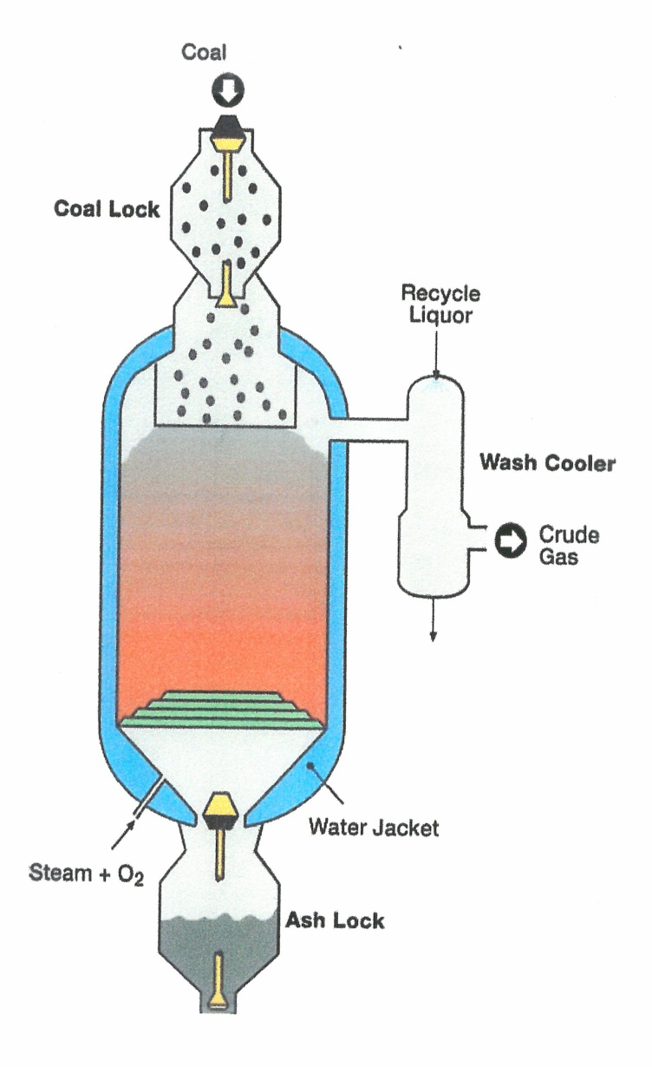

Figure 1. Schematic Illustration of the Lurgi Fixed-Bed Dry-Bottom (FBDB) Gasifier

Table 1. Projects with Lurgi Fixed Bed, Dry Bottom (FBDB) Gasifiers

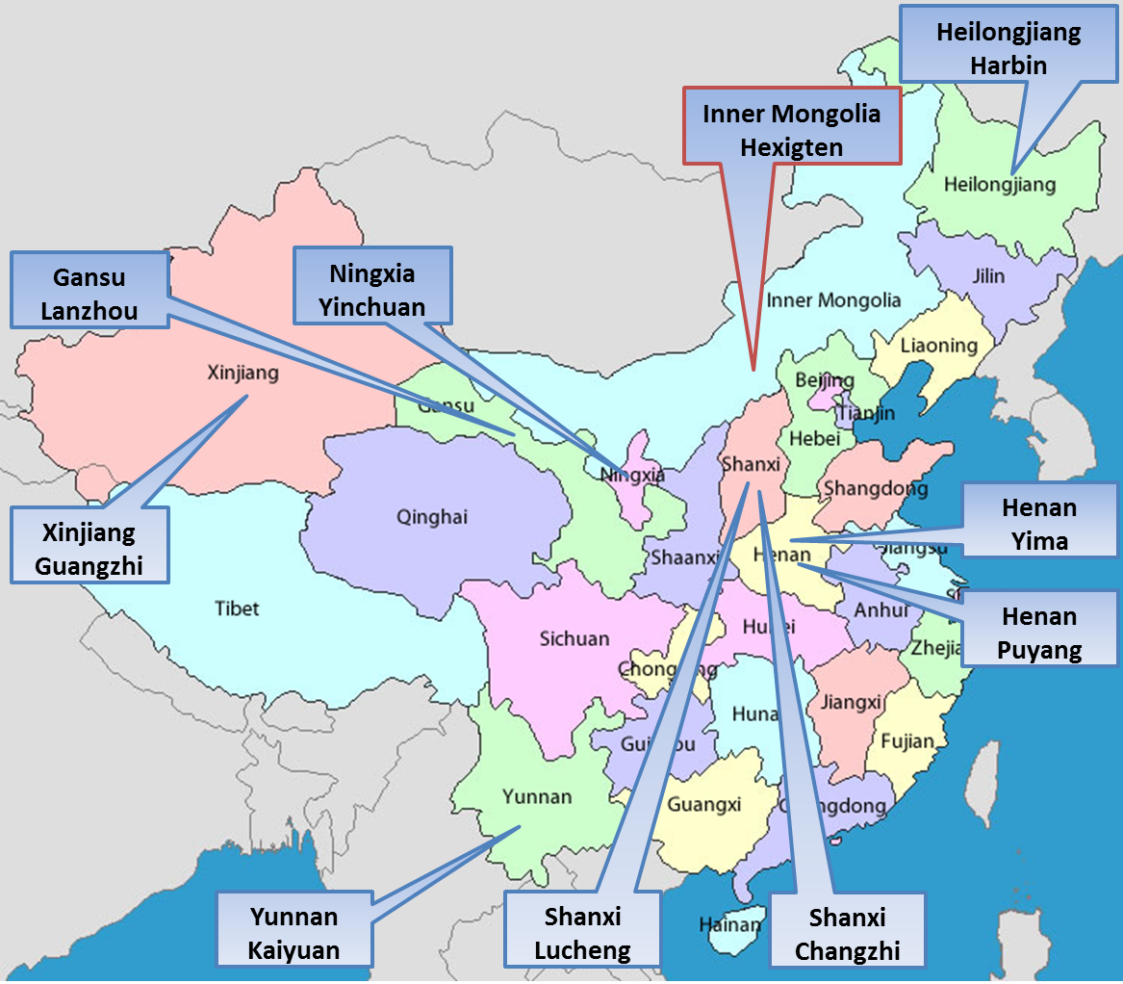

Figure 2. Project Location of Lurgi

REFERENCES

- Air Liquide Finalizes Lurgi Acquisition, http://Lurgi.com/website/single news.125.0.html?&l=1&CHASH=b98d7d70cc7604aaaa21
- Lurgi History, http://lurgi.com/website/lurgi-GmbH.15.0.html?&l=1
- Weiss, Max-Michael, Osman Turna, “Lurgi Clean Coal Technology Co –LCCT, A New Name, But A Well Proven Technology Back to Lurgi”, Gasification Technology Conference 2009, Colorado Springs, Colorado, October 4-7, 2009.
- Raj, D. Parekh, “Handbook of Gasifiers and Gas Treatment Systems”, Prepared for the U.S.DOE under Contract No. DE-AC01-78ET10159, UOP/SDC, a Joint Venture, September 1982.
- The Lurgi Mark VI
- Turna, Osman, “Sasol-Lurgi Fixed-Bed Dry Bottom Gasification for Fuels and Chemicals”, 2nd International Freiberg Conference on IGCC & XtL Technologies, Freiberg, Germany, May 8-12, May 2007.
- Weiss, Max-Michael, “A New HP Version of Lurgi’s FBDB “Gasifier is Bringing More Value to Clients”, Gasification Technology Conference 2011, San Francisco, California, October 9-12, 2011.
- Lurgi Fixed Bed Dry Bottom Coal Gasification, http://lurgi.com/website/lurgi-fixed-bed-dry-bottom.887.0.html?&l=1, November 12, 2012.
- Weiss, Max-Michael, Stephen Schwinghammer, “Lurgi Advanced MK PLUS Gasifier Technology Applied for SNG Production”, Gasification Technology Conference 2012, Washington, D.C., October 28-31, 2012.
- Lurgi GmbH: Engineering & Construction: A New Lurgi MTP Unit for China, http://lurgi.com/website/SingleNews.125.0.html?&L=2&cHash=567de229e832577b24d
- Miller, C. L., “Coal Gasification in China”, Unpublished Study, Office of Fossil Energy, Department of Energy, 1984.
- Lurgi Corporation, “Ammonia Plants Based on Coal”, Lurgi Express Report 0 1323/5.79, Lurgi Kohle Und Mineral Ol Technik GmbH, Coal Technology Division
- IGCC Experts Report: Prepared Jointly by U.S.DOE and The People’s Republic of China State Science and Technology Commission, DOE/FE 0357, December 1996.
- Cai, Ningsheng, “Development of Coal Gasification and Polygeneration in China”, Department of Thermal Engineering, Tsinghua University, IEA-Most Workshop On Fossil Fuel Technologies, Beijing, China, June11, 2010.
- Van de Venter, Eric, “Update on the Sasol-Lurgi Technology Company Business Activities and the Application of the S-L FBDB Gasification Technology”, 2007 Gasification Technology Conference, San Francisco, California, October 15-17, 2007.

2.A.2 Environtherm GmbH (BGL)
Gasifier / Gasification Technology: British Gas / Lurgi Slagging Gasifier
Technology Owner and / or Licensor: Environtherm GmbH / Zemag Clean Energy Technology GmbH

Environtherm
Allied Resources Corporation (ARC) of Wayne, Pennsylvania, parent company of Allied Syngas Corporation (ASC) also of Wayne, PA, and 70% owner of Allied Technologies GmbH of Frankfurt, Germany acquired rights to the British Gas/Lurgi (BGL) gasifier technology from Lurgi through the acquisition of a German processing firm, Environtherm GmbH in 2003. It has been reported that the BGL technology is jointly owned by Envirotherm GmbH and ZEMAG Clean Energy Technology GmbH⁽¹⁾.
Environtherm GmbH of Essen, Germany⁽²⁾ is an integrated clean energy and environmental service company utilizing proprietary technologies. In the organizational structure of the Allied Group, Environtherm reports directly to Allied Technologies. Its clean energy activities include:
- Gasification
- Production of syngas or fuel gas from solids fuels
- BGL – pressurized fixed bed slagging gasifier
- CFB – atmospheric circulating fluidized bed gasifier
- Waste –to – Energy
- Waste – to – Energy power generation from residues
Sludges, secondary materials
- Circulating Fluidized Bed (CFB) technology
- Bubbling bed technology
- Bogie hearth furnace technology (tunnel oven)
Envirotherm utilizes the services of the Advantica Firm. Advantica, a part of Germanischer Lloyd, is an engineering consultancy providing a range of technical expertise, engineering services and software solutions designed to enhance safety and performance in the energy and water source sectors.

BRITISH GAS LURGI SLAGGING GASIFIER (BGL)
AND GASIFICATION SYSTEMS⁽³⁾⁽⁴⁾⁽⁵⁾⁽⁶⁾
Background
It has been reported that as early as 1953, Lurgi and Ruhrgas had started the development of a slagging version of its fixed bed gasifier at a pilot plant in Oberhausen – Holten, Germany. The resulting small pilot plant of Lurgi was purchased in 1955 by England’s Ministry of Power and erected at the British Gas Mid Lands Research Station, Solihull, England. Further development of the concept continued until 1958. The Ministry of Power was also supporting an effort by the British Coal Utilization Research Association (BCURA) to work on slagging gasification at Leatherhead England. The BCURA program evolved into an investigation of factors affecting slag behavior in gasification processes.
In 1960, the gasifier at the British Gas Midlands Station was extensively modified and equipped to operate at 20 atmospheres. This 3 foot reactor, with a processing capacity of 100 tons per day and commissioned in 1962, was operated for two years. However in 1964, further development of the technology, while considered to be ready for scale-up for commercial use, was suspended in response to the discovery of the natural gas deposits in the North Sea.
In May 1974, the British Gas Corporation, supported by 14 oil, pipeline and gas companies from the United States, began modifying one of the conventional Lurgi dry-ash gasifiers at the existing Westfield, Scotland town gas plant of British Gas into a slagging system. Modifications of the gasifier were completed in March 1975 and the first run was completed in April 1975. This 6-foot diameter pilot plant with an operating pressure of 25 Bar subsequently processed a wide variety of coals at coal feed rates of about 300 t/d and did successfully gasify over 100,000 tons of coal in over 8000 hours of operation between 1975 and 1983. Approximately 40,000 tons of U. S. Coal were tested⁽³⁾.
Utilizing data generated during the successful operation of the 300 t/d pilot plant, British Gas Corporation constructed a larger demonstration gasifier at the existing Westfield site. This unit, 7.5 feet in diameter, with a capacity of approximately 500 t/d began operation in late 1984. Subsequent to an operational failure in early 1985, resulting in substantial modifications to the gasification process, the demonstration reactor again began its developmental operation in 1987. This R & D campaign was continued until the end of 1990 when the 500 tons per day (t/d) demonstration unit was shut down.
In 1991, a high pressure British Gas Lurgi Slagging Gasifier (BGL) with a 1.2 meter diameter, capable of operating at 1000 psig (25-70 Bar) with a feed capacity of 200 t/d constructed at the Westfield site by British Gas began operation. The experimental program was focused, in part, on the study of the effect of higher pressure on methane formation. The first commercial scale BGL slagging gasifier (3.6 meters) was constructed at the Schwarze Pumpe facility in Germany and operated from 2000 until 2007. This gasifier has been relocated to Dharma, Orissa, India through the sponsorship of Shiram EPC Ltd, Chennai, India.

Technology
The British Gas/ Lurgi Slagging Gasifier (BGL), as shown in Figure 3⁽¹⁾, is a pressurized, oxygen-blown, fixed-bed reactor. It is operated at a bottom temperature that is above the melting point of the coal ash so that the ash is removed from the reactor as a liquid slag. The gasifier is water jacketed, refractory lined. Coal feed is introduced into the reactor by means of a pressurized lockhopper system. The coal flows by gravity from the pressurized lockhopper into the top of the gasifier and is mechanically distributed uniformly across the reactor by a rotating distributor system. Hot rising synthesis gases rapidly heat the coal to initiate devolatilization and coking. The devolatilized coal moves downward through the reactor as it is gasified. The coal ash is removed from the bottom of the gasifier as a molten slag through a slag tap, quenched in water and removed by means of a lockhopper. As a part of the process, steam and oxygen are injected through tuyeres at the bottom of the bed and react with the coal as the gases move up through the bed. The counter-current action results in wide temperature differences between the top and bottom of the gasifier with reaction zones similar to those of a conventional Lurgi gasifier. Crude synthesis gas leaves the top of the gasification reactor and is directly quenched with recycle water to remove solids and condensable liquids. The physical processes occurring as the solids move downward through the gasifier include a number of overlapping and interacting stages. “Included among these processes are preheating, drying, and devolatilization of coal at the top of the bed, countercurrent flow of reacting gases and solids with heat exchange; for agglomerating coals, heating, swelling, and passage through the plastic stage with subsequent re-solidification and contraction; reaction of steam with fixed carbon and carbon monoxide and reaction of carbon monoxide with fixed carbon; heat release from the reaction of oxygen with fixed carbon and phase change associated with melting of ash to form slag”.⁽⁴⁾

Current Status:
Support of the continued development and commercialization of the British Gas Lurgi Slagging Gasifier and gasification technology is ongoing. The development effort⁽⁵⁾ will proceed in a pilot scale gasifier being installed in the IEC, TU Bergakademie Freiberg, Germany, next to the HP-POX and STF unit. The pilot plant includes coal intermediate storage, feeding systems, reactor gas cooling and gas water systems. The gasifier, capable of operating at 40 bar and processing 1.38 tons per hour of sub-bituminous coal, has a 0.6 meter inner diameter, three tuyeres (inlet nozzles) for gasification agents and the single vessel that contains the reactor and quench systems. The main purpose of the Research and Development effort is the investigation of liquid slag behavior under high pressure and the characterization of slag from different ash compositions. Additionally, the facility permits the testing of coals to demonstrate the applicability of an unknown feedstock without interrupting the operation of a commercial plant. Commissioning of the facility is projected to occur in the first quarter of 2013⁽⁶⁾.
In the commercial arena, it is reported⁽⁷⁾ that 22 gasifiers have been installed or are in the construction phase, (two in India, and twenty in China). In addition, it is anticipated that two additional gasifiers, utilizing a briquetted lignite feed at a feed rate of 5,700 tons per day, will be constructed in South Heart, North Dakota by the South Heart Energy Development, LLC (SHED). SHED is a joint venture of the Great Northern Power Development, LP (GNPD) and The Allied Syngas Corporation (ASC). The product is expected to be hydrogen (approximately 4.7 million Nm³/d for power production) and utilization of CO₂ (2.1 million tons per year) for enhanced oil recovery (EOR).
A coal conversion facility constructed in Dharma, Oressa, India, by the Shriram EPC Ltd, of Chennai, India, for the production of synthetic ammonia has two BGL gasifiers. One of these gasifiers was relocated from the Schwarze Pumpe facility in Germany while the second unit is being constructed to be identical to the relocated gasifier. These gasifiers, approximately twelve-to-thirteen feet internal diameter, process an estimated 1,600 tons per day of a high ash domestic hard coal to produce 150,000 Nm³/h of raw gas. The startup of the facility is projected to occur in 2012.
The current gasifier technology includes gasifiers of approximately 13 feet in diameter that can operate at pressures of up to 40 bar with a coal feed throughput of up to 1,600 tons per day. Some information is available that refers to a BGL gasifier that could be 14 feet in diameter with an estimated processing capacity of 1,700 tons per day⁽⁸⁾.

The BGL Gasifier in China
As of spring 2012, 12 BGL gasifiers are reported to have been or are being constructed to operate in three projects in China⁽⁹⁾. As listed in Table 2 and as illustrated in Figure 4, the first three have been installed in the Hulunbeier project sited in Inner Mongolia, two are planned for installation in the Yituo, project located at Luoyang, Henan Province and seven are planned for installation in a project to be located at Ordos Tuke , Inner Mongolia. The project has been fully designed and is currently under review by the China National Coal Development Co. Ltd. Earlier references⁽¹⁰⁾⁽¹¹⁾ identify a fourth project that will utilize 8 gasifiers to produce ammonia and urea. A brief summary of four projects projects follow:
The Yuntianhua United Commerce Co. Ltd, of Kunming, Yunnan, PRC, and the Hulunbeier New Gold Chemical Co. Ltd. of Hailaer, Hulunbeier, Inner Mongolia, PRC, are sponsors of this project. Three gasifiers (two on line, one on standby) each 13 feet inner diameter, operating at a pressure of 40 BARG, will process 1,250 tons per day of domestic dried and briquetted lignite to produce 119,000 Nm³/h of syngas. The syngas will be the feedstock for the production of 500,000 tons per year ammonia, 800,000 tons per year urea. The installation of the entire plant began in May of 2008 when site clearance and civil work commenced. The process design package was delivered in the 4th quarter of 2008, with the detailed design completed in the 3rd quarter of 2009. The gasifier installation on site occurred during the 2009 – 2010 time period and training of the plant operators began in August 2010. The installation of the entire plant was completed in 2011.
The China Yituo Group Co. Ltd. of Luoyang, Henan Province, PRC, are the sponsors of the project to be located in Luoyang, Henan Province, China. The detailed design of the project was finished in 2011 and civil work is in progress. The facility will utilize 2 BGL gasifiers (one on line and one on standby) each 13 feet inner diameter. The gasifiers will operate at pressures of up to 30 BAR and at feed rates of approximately 630 tons per day of hard coal to produce 43,000 Nm³/h fuel gas. The fuel gas will be used in an industrial complex as a substitute for eighteen existing fixed-bed low pressure gasifiers.
The third project, to be located at Ordos Tuke, Inner Mongolia, is supported by China National Coal Development Co. Ltd. and the China National Coal Corporation both of Beijing, PRC. The facility will have 7 gasifiers (five on line and 2 on standby) each 13 feet inner diameter. The gasifiers operating at 40 BAR will produce 295,000 Nm³/h of synthesis gas from 1,250 tons per day of weekly caking bituminous coal. The synthesis gas will be used for the production of 1,000,000 tons per year ammonia, 1750,000 tons per year urea. The detailed design for the project has been finished and the currently projected startup date is 2013.
The commissioning, in 2006, of a pilot scale slagging gasifier at an existing gasification facility of the Yunnan Coal Chemical Group has been reported. For over 30 years the Group had been operating 14 low pressure fixed bed dry ash gasifiers. The Group, becoming aware of the Westfield experience with the British Gas/Lurgi slagging gasifier, initiated an effort to evaluate the technology as a possible way to upgrade their gasification system. In the implementation of this initiative, the Yunnan Group employed the Advantica Group to convert an existing dry ash gasifier to slagging operation. The data generated from the operation of this pilot gasifier was to be used in a subsequent decision to replace the other gasifiers. A subsequent report noted that the Yunnan Group was progressing with a commercial project. However, no other reference to the project has been located.
With the information currently available, projects with one or more BGL gasifiers, operating or planned, are located in 2 of the 30 Chinese provinces. A current projection of the data suggests that these projects will be consuming 20,207 t/d coal to produce 168 kt/d ammonia, 285 kt/d urea and 43,000 Nm³/hr fuel gas.

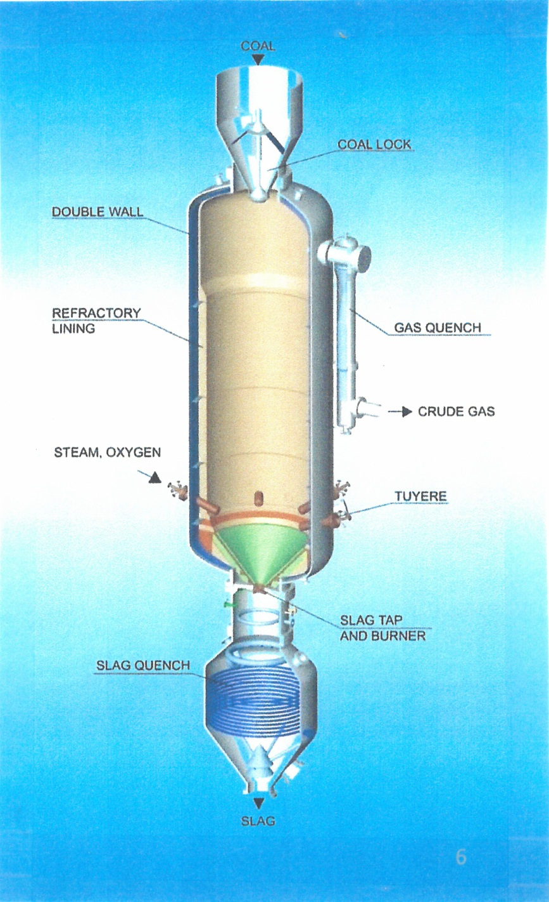

Figure 3. Schematic Illustration of the British Gas / Lurgi Slagging Gasifier

Table 2. Projects with British Gas / Lurgi (BGL) Gasifiers

Figure 4. Project Location of BGL
REFERENCES

- Olschar, M. and O. Schulze, “The BGL Commercial Plants and Pilot Testing”, 5th International Freiberg Conference on IGCC & CTL Technologies, Leipzig, Germany, May 21 – 24, 2012
- ENVIRONTHERM GmbH, Presentation of the ENVIRONTHERM GmbH Group
- Coal Gasification Guidebook: Status, Applications and Technologies, Electric Power Research Institute, Final Report TR102034 for Project 221-39, Prepared by SFA Pacific, Inc., December 1993
- Handbook of Gasifiers and Gas Treatment Systems, Report No. WD-TR-82/008-010, Prepared by UOP/SDC, For the Department of Energy under Contract No.DE-AC01-78ET10159, September 1982
- Olschar, M., op.cit
- Olschar, M., ibid
- Olschar, M., ibid
- Hirschfelder, Hansjobst, and Mathias Olschar “ Further Developments and Commercial Progress of the BGL Gasification Technology” Gasification Technologies Conference 2010, Washington, D.C., October 31 – November 3, 2010
- Olschar, M., op.cit.
- Seed, M. A., A. R. Williams, D. J. Brown, and H, Hirschfelder, “Application of Slagging Gasification Technology to as Received Lignite in China”, Clean Coal Technology (CCT007) Cagliari, May 2007
- Seed, M. A., A. R. Williams, D. J. Brown and H. Hirschfelder, “Operational Status of the BGL Gasification Technology on Low Rank Coal and other Fuels”, 2nd International Freiberg Conference on IGCC and XtL Technologies, Leipzig, Germany, May 2007

2.A.3 General Electric Energy Co. (GE)
Gasifier / Gasification Technology: Single-Stage, Downward Feed, Entrained-Flow, Refractory Lined Reactor
Technology Owner and / or Licensor: General Electric Energy

General Electric
GE (NYSE:GE) is a diversified infrastructure, finance and media company taking on the World’s toughest challenges. From aircraft engines and power generation to financial services, health care solutions and television programming, GE operates in more than 100 countries and employs about 300,000 people worldwide.
General Electric Energy
General Electric Energy serves the energy sector by developing and deploying technologies that help make efficient use of natural resources. With nearly 85,000 global engineers and 2010 revenues of $38 billion, GE Energy is one of the world’s leading suppliers of power generation and energy delivery technologies. The businesses that comprise GE Energy, GE – Power & water, GE- Energy Services, and GE – Oil and Gas work together to provide integrated product and service solutions in all areas of the energy industry including coal, oil, natural gas, and nuclear energy: renewable resources such as water, wind, solar, and biogas and other alternative fuels⁽¹⁾.
Resources available to GE Energy include GE’s Global Research Centers⁽²⁾.
- Niskayuna, New York, U.S.A. – Global Research Center headquarters
- Shanghai, China – China Technology Center
- Bangalore, India – John F. Welch Technology Center
- Munich, Germany – General Research – Europe
- Rio de Janeiro, Brazil
General Electric Energy is licensor of the GE Gasifier and Gasification Technology

THE GENERAL ELECTRIC GASIFIER
Background
General Electric expanded its interest in the Clean Coal Energy Market in 2004 with the purchase of the Texaco Gasification Technology from Chevron Texaco Corporation. The development of the Texaco Gasification Technology began in the 1940’s at Texaco’s Montebello, California Laboratories. The development activity continued at the Montebello Pilot Plant during the 1946 -1954 time period. The effort provided data to support the construction and operation of a 100 TPD Texaco coal gasifier at the Olin Mathieson Chemical Plant in Morgantown, West Virginia. The pilot plant was operated from 1956 to1958 to gasify coal for the production of ammonia⁽³⁾
In the1970s, subsequent to a period in the late 1950s when the availability of expensive oil and gas caused Texaco to direct its development efforts toward the partial oxidation of oil and gas, the following increase in oil prices and associated supply disruptions, renewed interest in the Texaco partial oxidation process for gasification of coal. Three 15 TPD pilot plants at the Montebello laboratories were used to test a variety of coals. Two larger pilot plants were also built. The first such gasifier with a syngas cooler processed 165 TPD of coal and was built to test synthesis gas generation by Ruhrchemie at Ruhrkohle, Oberhausen, Germany. The second gasifier processed 190 TPD of coal, used a quench only gasifier cooler and was built to make hydrogen at an existing TVA ammonia plant at Muscle Shoals, Alabama. These two large scale pilot plants operated successfully for several years during the 1980s and tested a number of process variables and numerous coals⁽⁴⁾⁽⁵⁾⁽⁶⁾⁽⁷⁾⁽⁸⁾⁽⁹⁾.
Although the first commercial Texaco gasification plant was built for Tennessee Eastman at Kingsport, Tennessee and began operation in 1983, it has been noted that the Cool Water Gasification plant was the most significant of the commercial-scale Texaco projects. The facility gasified 1000 TPD (dry basis) of bituminous coal and generated 120 Mw of electricity by Integrated Gasification Combined Cycle (IGCC). The Cool Water Facility operated from 1984 to 1989⁽³⁾.
In the late 1970s early 1980s, two initiatives of the Chinese Government focused on the Texaco Gasifier as one of the two most promising modern coal gasification processes that had the potential to assist in the development of China’s Coal Chemical Industry, produce more chemical fertilizer and to support agriculture⁽¹⁰⁾.
In 1995, a representative of Texaco, Inc.⁽¹¹⁾ reported that Texaco had been marketing in China for 15 years and at that time had 6 commercially operating plants in China and had 8 additional plants in various stages of design and construction. Subsequent to acquiring ownership of the Texaco technology, the Chinese market in gasification technology became an activity of General Electric when the first project was licensed in August 2004 with Wison Nanjing Chemical Co. Ltd., Nanjing Industrial Park, Jiangsu Province in China. Since that time, General Electric Energy has continued to successfully market their gasifier and gasification technology in China.

The Technology
As previously reported, the GE gasifier has been known⁽¹²⁾ as the Chevron Texaco and/or Texaco gasifier. GE Energy acquired the technology in 2004 and the Texaco/GE gasifiers have operated commercially for over 45 years using a wide variety of feed-stocks.
The gasifier is a single-stage, downward feed, entrained flow, refractory lined reactor, (Figure 5). In operation it generates a synthesis gas from a coal-water slurry (~65% in wt) and oxygen (>95%). The slurry feedstock is pumped to a custom designed reactor where it reacts exothermally with oxygen at high temperature, (approximately 2,200 to 2,700ºF)…..the raw syngas leaving the gasifier can be cooled by a radiant and/or convective heat exchanger and/or by a direct quench system⁽¹²⁾.
From the 1940s up to 2004, the Texaco Gasifiers benefited in their performance (e.g. capability, reliability, availability) through significant R & D and operational activities supported by Texaco, Inc. The R & D activity has been continued from 2004 to date through support of General Electric Energy. These activities include:
- The operation of a 6 TPD pilot plant at Aolo, Japan currently operated by Ishikawa-Harima Heavy Industries Corporation, Ltd⁽¹²⁾.
- Implementation of a Joint Venture between GE (NYSE:GE) and Shenhua which establishes, “a joint venture company in which GE and Shenhua would sell industrial coal gasification technology licenses, jointly advocate for and develop integrated gasification combined cycle (IGCC) facilities and conduct research and development to improve cost and performance of commercial scale gasification and IGCC solutions. This includes industrial coal gasification applications in China as well as jointly pursuing the deployment of commercial scale IGCC plants……each business intends to contribute existing technology, operational and service expertise to create a comprehensive gasification and cleaner coal technology and service provider in China^{(13)”}. In a subsequent press release, “it was noted that leading energy companies from the U.S. and China jointly established a new company on Thursday (May 10, 2912) to promote clean coal and coal gasification power generation technology ….through the establishment of General Electric (GE) Shenhua Gasification Technology Co., Ltd. The company was jointly created by China Shenhua Coal to Liquid and Chemical Co., Ltd. and GE China with an investment of six million U. S. dollars with each side holding 50% of the company. The company will focus on research and promotion for coal gasification technologies….⁽¹⁴⁾.
- Gasification Research and Development studies ongoing at the various General Electric Energy Technology Centers (e.g. CTC – China Technical Center Technical Service Team, GRC – Global Research Center Material & Coal Analytical Team).
By the end of 2011, General Electric Energy provided gasifiers and/or gasification systems with the following capabilities:

Gasifier⁽¹⁵⁾
- Type Quench Quench Quench
- Volume 450 Ft³ 900Ft³ 1,800Ft³
- Pressure 8.7 Mpa 4.0-8.7 Mpa 4.0-8.7 Mpa
- Feed Rate 500-1000TPD 1500-2000TPD 4000TPD
High Pressure Quench Gasification Technology⁽¹⁶⁾
- Pressures up to 87 Bar
- 5-10% reduction in MeOH cost
- Reduction in number of trains required
- 5% reduction in coal to MeOH CAPEX
Industrial Applications⁽¹⁶⁾
- Advanced refractory
- Advanced gasifier configuration tools
- Large quench with high pressure
- Raw gas turbocharger
- High conversion feed injector
IGCC Applications⁽¹⁶⁾
- Operator training simulator
- 7F Syngas turbine
- Radiant syngas cooler
- Carbon Island –EOR

GE Gasifiers in China
An early interest (late 1970) in the Texaco gasifier was expressed by Chinese government and industry. This interest was captured in the following two initiatives;
- “In An effort to develop the coal chemical industry to produce more chemical fertilizer and to support agriculture Lurgi and Texaco gasification technologies were imported selectively from among modern coal gasification processes that appear promising⁽¹⁰⁾. The status of these imported technologies, as of 1995, is shown in Table 3.
- The State Planning Commission, State Science and Technology Commission and the Ministry of Chemical Industry of the PRC, recognizing the need for an economical and effective process for non-anthracite coal gasification, paid attention to developing new coal gasification processes enough to setup an installation which as a demonstration would change the species of feed-coal. The Lunan Chemical Industry signed a contract with Texaco Development Corporation to procure the license and process design package for the Texaco Coal Gasification Process (TCGP)⁽¹⁰⁾.
In the late 1970s, the Northwest Research Institute of Chemical Industry of the Ministry of Chemical Industry, in the process of investigating entrained bed, pulverized coal gasification, started to investigate and develop coal slurry gasification. In the mid-1980s, the First Design Institute of Ministry of Chemical Industry designed a testing facility. The experience gained provided the practical base that enabled the Lunan and Wujing projects (both with Texaco gasifiers) to be successful. After representatives of Texaco visited the test facility, a contract was signed with the Institute that approved the use of data from the facility as the basis of a process design package. The contract that supported the corporate objectives of Texaco may have also provided the initiative for the subsequent development of Northwest Research Multi-Component Slurry Gasifier (MCSG)..
In the fall of 1995, a representative of Texaco, Inc. reported⁽¹¹⁾, that there were 23 publicly announced Texaco Coal Gasification Projects in China. These projects, the results of 15 years of marketing to customers in the Chinese oil and chemical industries, included 6 commercially operating plants that make chemicals or ammonia based fertilizers. In addition to the operating plants there were 8 plants in various stages of design and construction. Earlier this same year Texaco, Inc. had entered into a multi-plant agreement with Sinopec and the Chinese Ministry of Chemical Industry for 9 projects whereby Texaco Coal Gasifiers were to installed to existing ammonia plants at 9 different locations throughout China. These 9 coal gasification projects would have individual commercial operational dates ranging from 1998 to 2004
General Electric Energy’s successful negotiation of a license with the Wison Nanning Chemical Co. Ltd. was GE’s first license after its acquisition of Texaco Inc.’s gasification Technology. The license made possible a project that would use a gasifier operating at a pressure of 65 Bar to process 1500 TPD coal to produce 200,000 tons per year methanol. In the years that followed, General Electric Energy has increased its resources in China and as a result of a strong marketing effort was able to recently announce, “GE’s gasification technology is one of the most widely applied technologies of its kind in China with more than 40 licensed facilities”^{(11).} These facilities feature a total of 75 gasifiers that use a solid feed and 77 gasifiers that uses gas or liquid feed⁽¹⁷⁾⁾. Table 4 presents limited information on 32 of these projects that feed coal and Figure 6 correlates the projects with the Province within China in which they are located.
With the information currently available, projects with one or more GE gasifiers or gasification systems operating or planned are/or will be located in 15 of the 30 Chinese Provinces. A current projection of the data suggests that these projects will be consuming 44,900 tons per day coal to produce 2.65 million tons per year ammonia, 11.45 million tons per year methanol, and an undetermined amount of oxochemicals.

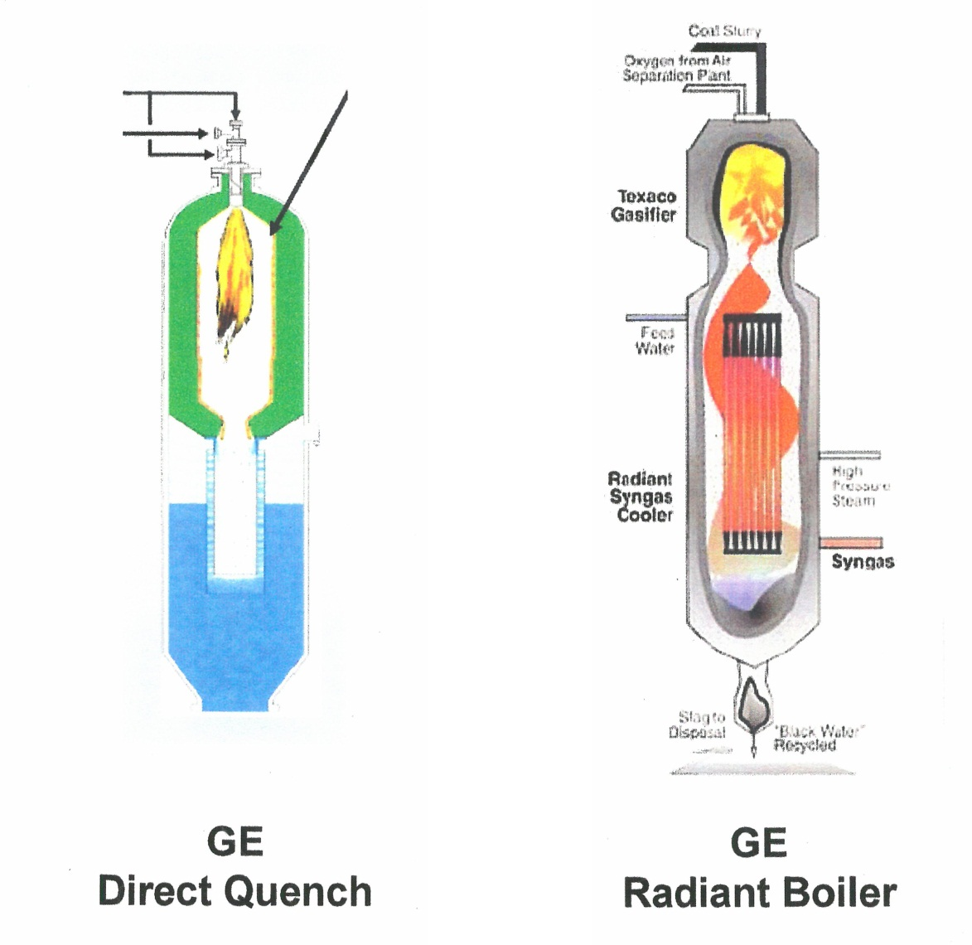

Figure 5. Schematic View – GE Gasifier

Table 3. Gasifier Technology Imported in Early Program⁽²⁾
Table 4. Projects with General Electric (GE) Gasifiers

Figure 6. Project Location of GE

REFERENCES
- www.GE.com/energy
- www.GE.Com 10/29/12
- Coal Gasification Guidebook: Status, Applications ,and Technologies, Electric Power Research Institute, Technical Report TR102034, Project 2221-39, Final Report , December 1993.
- Pilot Plant Evaluation of Illinois No.6 and Pittsburg No. 8 Coal for the Texaco Coal Gasification Process, Palo Alto, California: Electric Power Research Institute, January 1987, AP5029
- .Coal Gasification Tests at TVA, Palo Alto, California: Electric Power Research Institute, February 1987 AP5047.
- Illinois No. 6 Coal Tests on Ruhrkohle/Ruhrchemis’s 165 TPD Texaco Gasifier, Palo Alto, California: Electric Power Research Institute, September 1982, AP 2607.
- Performance Comparison of Coal Gasification in 15 TPD and 165 TPD Texaco Gasifiers, Palo Alto, California: Electric Power Research Institute, January 1983, AP-2814.
- Texaco Environmental Test on a 165 TPD Texaco Gasifier, Report Summary, Palo Alto, California: Electric Power Research Institute, October 1983, AP-3240
- Radian Environmental Tests in a 165 TPD Texaco Gasifier, Palo Alto, California: Electric Power Research Institute, January 1983, AP 2811.
- Integrated Gasification Combined Cycle Technology (IGCC), The United States of America and the People’s Republic of China Experts Report, DOE/FE-0357, December 1996.
- Horton, Robert S., “Meeting Customer’s Needs-Texaco’s Experience Deploying Gasification Technology in China”, Fourth Annual Clean Coal Conference, September 5-8, 1995, Denver, Colorado.
- The GE Gasifier: http://www.netl.doe.gov/technologies/coalpower/gasification/ginetlgaspedia
- GE and Shenhua Announce Formation of Cleaner Coal Technology Joint Venture in China, GE News, emailinformation@mastopt.com. January 18, 2011, downloaded October 15, 2012.
- “Sino-American Company Promotes Coal Technology”, Press Release, Shanghi, May 10, (Xinhua) 2012.
- Liu Jian Feng, “GE Gasification and IGCC Technology, Harmonious and Sustainable Coal Power Generation”, APEC Clean Fossil Energy Seminar, Xian, China, October 15-17, 2007.
- Crew, Jason, “GE Gasification Project Update”, Gasification Technologies Conference, October 10, 2011.
- GE Press Release, Houston , Texas, March 5, 2012.
- Henley, John P. “Overview of China’s Lead in Coal Gasification Implementation”, The DOW Chemical Company, March 23, 2007.

2.A.4 KBR Inc. (TRIG)
Gasifier / Gasification Technology: The Transport Integrated Gasifier (TRIG); A Pressurized, Circulating Fluidized- Bed Reactor
Technology Owner and / or Licensor: KBR, INC

KBR, Inc.
KBR, Inc. is a global engineering, construction, and services company supporting the energy, hydrocarbon, government services, minerals, civil infrastructure, power, industrial and commercial markets in more than 65 countries worldwide. KBR delivers a wide range of services through its Hydrocarbons; Infrastructure, Government and Power; and Services Business Group Divisions. The Company, currently ranked 193 on the 2010 Fortune 500 annual ranking of America’s largest corporations, differentiates itself as a technology-driven engineering, procurement and construction (EPC) company⁽¹⁾.
For more than 100 years, KBR has maintained a strong, long term relationship with its key customers, including international and national oil and gas companies and the world’s largest defense and government out-sources. In the government services sector, KBR has more than 60 years of experience supporting various United States and United Kingdom military operations, as well as numerous government departments and entities.
The KBR organization includes three major branches or divisions: Hydrocarbons; Infrastructure, Government & Power (IGP); and Services. The responsibility for the Corporation’s interest in technology resides in the Hydrocarbon Division. The technology effort specializes in developing and licensing energy-efficient and cost-effective process systems that enhance the technical and economic positions of global oil and gas, and petrochemical companies. KBR offers a variety of technology licenses and process equipment for: Ammonia and Fertilizer, Synthesis Gas/Syngas, Olefins, Coal Gasification, Refining, Carbon Capture and Storage/CO₂ Sequestration, Hydrogen, and Organic Chemicals.
One of the major efforts of KBR’s technology development program has been its participation with the southern Company and the support of the U. S. Department of Energy in the co-development of the Power systems Development Facility (PSDF) in Wilsonville, Alabama. At the PSDF, utilizing the data generated during the more than 60 years of operation of KBR’s fluidized catalytic cracking (FCC) technology⁽²⁾, the Transport Integrated Gasification (TRIG) gasifier’s mechanical design was completed and its operation demonstrated. Subsequent to the successful demonstration of the TRIG gasifier, KBR has been seeking commercial opportunities for utilization of the technology.

THE TRANSPORT INTEGRAED GASIFICATION (TRIG) GASIFIER
Background
The Power Systems Development Facility (PSDF) located near Wilsonville, Alabama, is a joint Industry, Department of Energy, large scale pilot/demonstration plant. The objective of the PSDF is to test and gain operating experience with new process configurations and critical components for advanced fossil fuel-based power generation systems at a scale large enough to provide data for scale up to demonstration or first commercial plants.
“The PSDF is divided into two systems, a transport reactor system for parametric testing of components under typical Integrated Gasification Combined Cycle (IGCC) or Pressurized Fluidized Bed Combustion (PFBC) conditions, and an advanced pressurized fluidized bed gasification/combustion (APFBC) system for longer term testing of components in an integrated power generation system”⁽³⁾.
The transport reactor, a concept initially being developed by KBR as both a gasifier or a combustor, was first studied in the combustor configuration. The history of the development process for the Transport Gasifier has been outlined⁽⁴⁾:
- 1976 - Orthoflow design
- 1980 - Design based on FCC Technology
- 1990 - Pilot Plant Technical Center
- 1996 - Grand Forks, ND, - 2,600 hours Test Run
- 1996 - Wilsonville, AL, - 8,000 hours of Test Runs
- 1999 - Transport Reactor converted to Gasifier Configuration
- 2000 - Shakedown of Transport Reactor
The TRIG gasifier at the PSDF is an engineering-scale, 50 tons per day, demonstration unit. The unit has been successfully operated on a wide range of coals including bituminous and various lignites and has logged thousands of hours of operation in both air-blown and oxygen-blown configurations.

The Technology
The TRIG gasifier is an advanced, pressurized (e. g. 500 psia), circulating, fluidized bed, gasifier that operates at moderate temperatures (1,500 – 1,950 ºF). As noted, the mechanical design and operation of the gasifier are based on KBR’s fluidized catalytic cracking (FCC) technology. As shown in Figure 7, the TRIG gasifier is simple in design and has no internals, expansion joints, valves or other moving parts. It has been designed to operate on air, pure oxygen, or enriched air/oxygen mixtures as an oxidant.. While the air-blown mode is ideally suited for power generation applications, the oxygen-blown mode supports a coal conversion application for the production of syngas for production of chemicals and fuels synthesis. Some of the more significant features of the technology include:
- A dry feed injection system and non-slagging operation
- Continuous dry ash handling system that eliminates the technical difficulties associated with slag handling and removal
- Lower operating temperatures allow use of conventional alumina-silica type refractory
- Improved gasification cold gas efficiencies and reduced specific oxygen demand
- Operating temperature range is sufficient to achieve high carbon conversions while mitigating formation of tars and oils

Current Status
Data from the years of operating experience at the PSDF and from the operation of proprietary FCC technology, is reflected in the optimized commercial-scale TRIG gasifier designs that are available for both air-blown power applications as well as oxygen-blown coal conversion systems for the production of chemicals and fuels. KBR has been seeking commercial opportunities for utilization of the technology and has reported that the TRIG projects worldwide include⁽³⁾:
- Pilot Plant, Grand Forks, North Dakota
- Demonstration Unit, Wilsonville, Alabama
- Gasification Project, Kemper County, Mississippi
- Pilot Plant, Daejeon, South Korea
- IGCC Retrofit Project, Dongguan, China
- Coal Conversion Facility, Inner Mongolia, China
- Reducing Gas Project, Direct Reduction of Iron, Angul, India

The TRIG Gasifier in China
Currently, there are two coal gasification projects being implemented in China that utilize TRIG gasifiers and gasification technology. The two projects offer the opportunity to test both the IGCC and Coal Conversion applications of the reactor. These projects are summarized in Table 5. Their general location is shown in Figure 8 and they are briefly outlined below.
- Dongguan IGCC Retrofit Project
As reported⁽⁶⁾, The Beijing Guoneng Yinghui Clean Energy Engineering Co., Ltd (Beijing Guoneng) has awarded KBR a contract to provide licensing, engineering services, and proprietary equipment for the implementation of KBR and Southern Company’s Transport Integrated Gasification Technology (TRIG) at a power plant operated by Dongguan Tian Ming Electric Power Co., Ltd (Dongguan TMEP) in Guandong Province, People’s Republic of China. It also has been noted⁽⁶⁾, that the contract award marks China as a site for the first worldwide commercial implementation of the TRIG Technology with the goal of producing low-emission, coal-based, electricity.

At the Dongguan TMEP facility, TRIG technology will be added to an existing gas turbine combined cycle plant so that it can use Synthetic gas from coal as its fuel for generating electricity rather than fuel oil. The 120 Mw Dongguan IGCC power plant, expected to be in operation in 2011, is the first phase of the total 920 Mw Sun State IGCC Power Project being developed by Beijing Guoneng. The second phase will be an 800 Mw IGCC power plant expected to be completed in 2012.

- Berun Holding Group’s 100,000 ton per year Glycol Project
It has been reported⁽⁵⁾⁽⁷⁾, that Xilinguole Sunite Alkali Industry Co., Ltd. a subsidiary of Boyuan (Berun) Holdings Group, Ltd., has contracted with KBR to provide one oxygen-blown TRIG gasifier to produce syngas for an ethylene glycol plant. The facility located in Inner Mongolia, China, will use a high ash lignite feedstock from an adjacent mine to generate 35,000 Nm³ per hour of syngas as a feedstock for a grassroots ethylene glycol plant. In addition to the gasifier, KBR will provide basic engineering, proprietary equipment and startup services. Start-up is expected in 2012. It will be the first worldwide commercial implementation of the TRIG gasifier to produce chemicals from coal.
With the information currently available, projects with a TRIG gasifier or gasification system will be located in 2 of the 30 Chinese provinces. A current projection of the data suggests that these projects will consume 3,400 metric tons per day of coal to generate 120 Mw of IGCC power and produce 100 kt per year ethylene glycol.

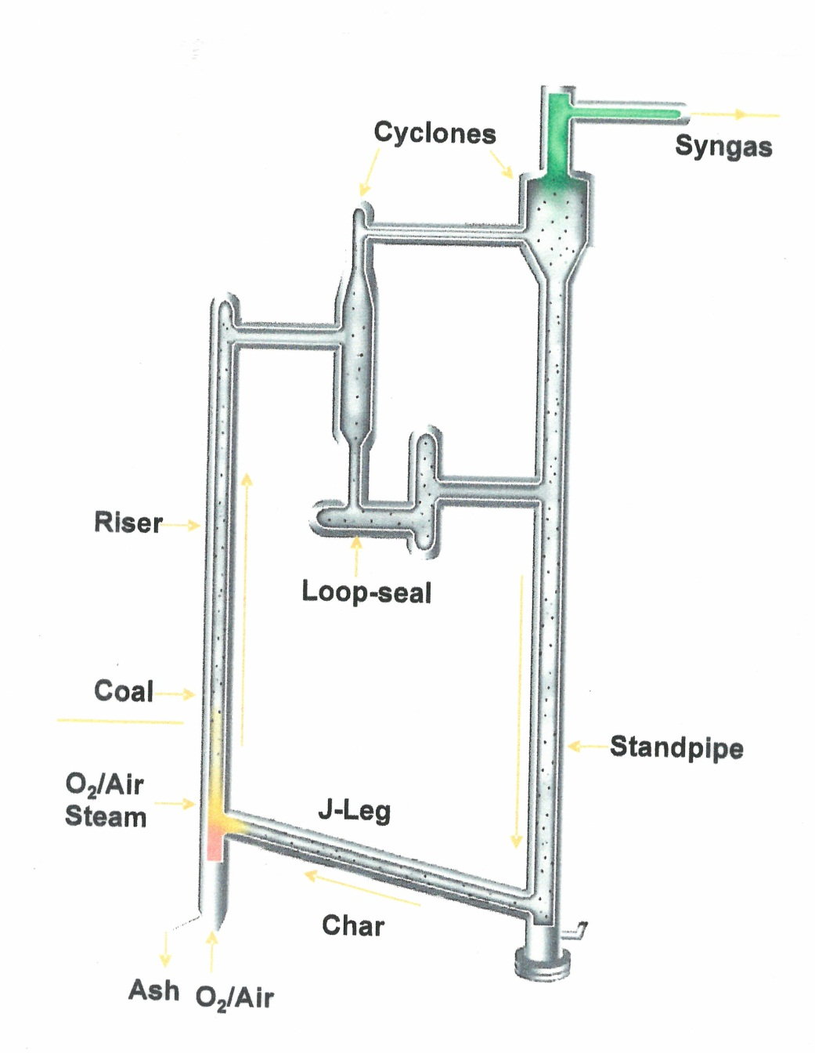

Figure 7. Schematic Illustration of the TRIG Gasifier

Table 5. Projects with TRIG Gasifiers

Figure 8. Project Location of TRIG (KBR)

REFERENCES
- KBR, 2012 Fact Sheet
- Ariyapadi, Siva, Philip Shires, Manish Bhargavi, David Ebbern, “KBR’s Transport Gasifier (TRIG^{TM)}) – An Advanced Gasification Technology for SNG Production From Low Rank Coals”, Twenty-Fifth Annual International Pittsburgh Coal Conference, Pittsburgh, PA, September 29 – October 02, 2008
- Longanbach, James R., Timothy E. Pinkston, “Development and Demonstration of Advanced Power Generation Systems at the Power Systems Development Facility”. Proceedings of the 25th International Conference on Coal Utilization and Fuel Systems, Sherton, Sand Key, Clearwater, Florida, March 6-9, 2000
- Joyner, Todd, “The Pathway to Commercialization of the TRIGTM Technology”, The KBR and Southern Alliance Gasification Industry Overview Conference, The Gasification Council, 2007
- Gualy, Ron, “How in Your World” Coal Monetization Presentation, KBR, 2011
- Eco – Friendly Posting, “China to be Site of First Commercial Implementation of the TRIG Coal Gasifier, September 20, 2009. www.ecofriendlymag.com/sustainable-transportation-alternative-fuel/china
- Ariyapadi, Siva, “KBR’s Transport Gasifier – Technology Advancements and Recent Successes”, Coal Monetization Presentation, KBR Paper #2219, TRIGTM Gasification Technology 2010.

2.A.5 Gencorp / Pratt Whitney Rocketdyne (Entrained)
Gasifier / Gasification Technology: The Rocketdyne Single Stage, Oxygen Blown, Dry Feed, Plug Flow Entrained Reactor
Technology Owner and / or Licensor: Gencorp / Pratt Whitney Rocketdyne

PRATT WHITNEY ROCKETDYNE:
Pratt Whitney Rocketdyne (PWR) is a United States Company that designs and produces rocket engines that use liquid propellants. Formerly a wholly owned subsidiary of United Technologies Corporation, PWR recently was purchased by GENCORP, an aerospace and technology firm⁽¹⁾.
PRW was formed in 2005 when Pratt Whitney Space Propulsion and Rocketdyne Propulsion and Power were merged following the latter’s acquisition from Boeing. The Division’s history reaches back to the Rocketdyne Division of North American Aviation and later as Rockwell’s International Unit, Rocketdyne. Prior to its purchase, PRW had been a subsidiary of United Technologies Corporation.
The sale of Rocketdyne to GENCORP marks the combination of two iconic California rocket companies and long-time competitors. GENCORP also owns Aerojet, the Sacramento Aerospace firm founded in 1942⁽²⁾.
Pratt and Whitney is reported to be participating in several Research and Development activities of interest to those in the coal energy business.

THE ROCKETDYNE GASIFIER, A SINGLE STAGE, OXYGEN BLOWN, DRY FEED PLUG FLOW, ENTRAINED REACTOR
The Technology
The Rocketdyne gasifier (Figure 9) is an oxygen-blown, dry feed, plug flow, entrained reactor able to achieve carbon conversions approaching 100%. As reported⁽³⁾, the gasifier uses Rocketdyne rocket engine technology to produce a compact, long life, efficient gasifier that increases performance and availability while decreasing capital costs. Some its major features include:
- An injector design that uses multi-element injection to rapidly mix the coal with hot steam and oxygen while rapidly dispensing the coal across the reactor’s cross section
- Efficient cooling of the injector’s face plate
- Active cooling of the ceramic matrix composite (CMC) producing a protective solid layer of slag on the gasifier side of the liner
- The ability to process all ranks of coal through the use of the dry feed system rapid mix injector and cooled refractory liner
Previous research and development activities performed by Rocketdyne has included demonstration of compact gasifiers with actively-cooled, rapid-mix injectors, short residence times, high pressure (up to 1,500 psia) operation, high flame temperatures (up to 5,000 ⁰F) and the use of cooled refractory liners. The R & D activity also has demonstrated dense-phase, dry feed as well as slurry feed systems. Rocket engine technologies incorporated into the advanced gasifier include CMC liners and advanced injectors that promote long component life under the expected operating conditions.

Current Status
Pratt Whitney Rocketdyne currently is participating in several R & D efforts that will advance their goals in the coal utilization markets. Among these are the development of a commercial- scale-dry-solids prototype pump⁽⁴⁾ and a study to identify an economical way to capture greenhouse gases from coal-fired plants⁽⁵⁾.
The commissioning stage of the pump development effort was recently initiated at the University of North Dakota Energy and Environmental Research Center (EERC). The pump will be used to feed Rocketdynes’s advanced gasifier and would be capable of processing a variety of feed-stocks (e.g. coal, biomass, and petcoke). The pump is being designed to process up to 400 tons-per-day.
It is estimated that the use of the pump will assist in reducing capital costs of a commercial scale unit by 20% compared to conventional systems. The same report notes⁽⁵⁾that the system also reduces carbon emissions by 10% and the gasifier offers a 90% reduction in size compared to traditional systems.
In a second R & D activity, Pratt and Whitney Rocketdyne received a one million Federal contract to study an economical way to capture greenhouse gases from coal fired plants. The feasibility study is phase one of a two phase project being sponsored by the Department of Energy. In the study PWR is reviewing oxyfuel combustion. The goal is to capture more than 90% of generated carbon dioxide with no more than a 35% increase in electricity costs. The second phase of the project will be to develop and test a pilot energy plant using oxyfuel combustion.
In addition to PRW, other team members working on the oxy-combustion technology project include Linde Llc, Electric Power Research Institute, Pennsylvania State University and Jamestown Board of Public Utilities.
Pratt Whitney Rocketdyne also is reported⁽⁶⁾ to have collaborated with Exxon Mobile Research and Engineering Co. and with Canada’s Alberta Innovative Energy & Environmental Solutions, and the Illinois Department of Commerce and Economic Opportunities to develop the technology . Pratt Whitney Rocketdyne has also granted a world-wide license to Zero Emission Energy Plants, Inc. to use the technology in the development of commercial energy centers.

The Technology in China
Pratt and Whitney Rocketdyne has signed a negotiation framework agreement with two energy industry partners to design, construct, and operate a commercial scale advanced gasification plant in China’s Central Eastern Henan Province⁽⁶⁾⁽⁷⁾. The Zhongyuan Da Hua Group and East China Engineering, Science and Technology will share development costs for construction and operation of a demonstration plant with PWR subject to terms of a formal agreement currently being negotiated.
Zhongyuan Da Hua Group is reported⁽⁶⁾⁽⁷⁾to be a unit of Henan Coal Chemical Industry Group Company Ltd, a state owned enterprise in China’s Henan Province. Henan Coal Chemical Industry Group Co. Ltd, the 2nd largest coal company of China and the largest industrial enterprise in Henan, specializes in coal-to-gas projects. East China Engineering Services & Technology Co. with more than 40 years of expertise in coal/chemical production, facility engineering, procurement and construction has completed more than 2000 projects including dozens of turnkey initiatives throughout China and 10 other countries.

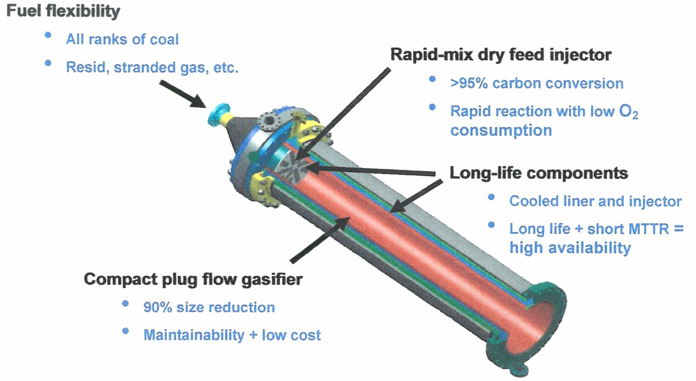

Figure 9. Schematic Illustration Rocketdyne Dry-Feed, Plug-Flow, Entrained Gasifier

REFERENCES
- Http://articles/atimes.com/print/2012/jul/24/business/la-f1-ro
- Ibid
- Fusselman, Steven P., Kenneth M. Sprouse, Alan K. Darby, Jenny Tennant, Gary J. Stiegel, “Pratt & Whitney Rocketdyne/DOE Advanced Single-Stage Gasification Development Program”, Report Prepared Under Contract No. DE-FC26-04NT42237, 2005.
- Geiver, Luke, “Rocket Developer, EERC Begin Testing Solids Pump for Gasification”, http://biomassmagazine.com/articles/6265/rocket-developer,april11,2012
- “Pratt & Whitney Receives a $1 Million DOE Contract: http://www.sfbj.com/news/2012/oct02/pratt-whitney-rocketdyne
- Pratt & Whitney to Build Gasification Demonstration Plant in China: http://www.elp.com/articles/2012/02/pratt-whitney-to-build-1
- Pratt & Whitney Rocketdyne Sign Agreement for Commercial Scale Gasification Demonstration Plant in China: Posted February 2, 2012 on American Fuel Coalition.

2.A.6 Shell Global Solutions International B.V. (Shell)
Gasifier / Gasification Technology: Dry Feed, Pressurized, Upflow, Entrained, Slagging Reactor – Shell Gasifier (SCGP)
Technology Owner and / or Licensor: Shell Global Solutions International B.V.

Royal Dutch Shell
As the World’s second largest company (as measured by its revenues of 2011)⁽¹⁾ Royal Dutch Shell plc is a Dutch British multi-national oil and gas company headquartered in the Hague, Netherlands. The firm, more widely known as “Shell”, has a registered office in London, United Kingdom. The firm is vertically integrated and although active in every sector of the oil and gas industry has major renewable energy activities including bio-fuels, hydrogen, solar and wind-power.
Shell records the beginning of the corporation as occurring in 1907 when the Royal Dutch Shell Group was created through a merger of the two rival companies, Royal Dutch Petroleum Company and the Shell Transport and Trading Company Ltd of the United Kingdom. The merger was reported “to be driven by the need to compete globally with the dominant American petroleum company, The John D. Rockefellers Standard Oil, and as a strategy to face the challenges brought about by the crisis of 1907”⁽¹⁾. The reference to “Royal Dutch” in the firm’s name of The Royal Dutch Petroleum Company reaches back to the date of its founding in 1890 when a Royal Charter was granted by King William III of the Netherlands to a small oil exploration and production company known as Royal Dutch Company for the Working of Petroleum Wells in the Dutch East Indies. In 2004, the two legally separate companies (Royal Dutch and Shell) were merged into a single legal entity which exists today. “Shell” has established operations in over 90 countries, produces around 3.1 million barrels of oil equivalent per day and has 44,000 service stations worldwide”⁽¹⁾. Shell Oil Company is its subsidiary in the United States.

Shell Global Solutions International B. V.
The current licensor and supporter of the continued development of the Shell Gasification technology is the Shell Global Solutions International B V. Formed in 1998, Shell Global Solutions coordinates the operations of half a dozen Royal Dutch Shell Technology Businesses world-wide⁽²⁾. The company has been given the responsibility to provide research and technical services to a range of petroleum related industry segments including active process industries, automotive manufacture and supply, exploration and production, chemicals, gas and LNG processing, motor parts, refining, oil marketing and supply, and distribution Its services, “include chemical analyses, crude oil evaluation, engineering, energy optimization, gas-to-liquids conversion, gasification, hydrocracking, inspections, thermodynamics and water treatment”⁽²⁾.
Shell Global Solutions International B.V. operates in over 135 countries and employs more than 90,000 people.

THE SHELL GASIFIER
A DRY FEED, PRESSURIZED, UPFLOW, ENTRAINED,
SLAGGING GASIFIER
Background
Two dates,1956 or 1972, could be listed as the beginning of the development of the Shell gasifier. The earlier date of 1956 is identified as the start of the development of the Shell Oil Gasification Technology process for the partial oxidation of oil and gas. However, it was not until 1972 that Shell International Petroleum Maatschappij B. V. began work on coal gasification. At that time, the development of the Shell Gasifier, a pressurized, entrained-flow, slagging, coal gasifier, began with the construction of a six ton-per-day process development unit at Shell’s Amsterdam Laboratories.
The developmental data generated by the operation of the 6 ton-per-day unit provided the foundation for the design and construction of a larger 165 ton-per-day demonstration facility at Shell’s Harburg refinery in Hamburg, Germany. This larger unit is reported to have operated successfully for approximately 6,000 hours during the period from 1978 – 1983 and had successfully gasified over 30,000 tons of coal⁽³⁾.
During these early stages of the technology developmental process (from1974 – mid 1981), Shell, in cooperation with Heinrich Koppers GmbH (now Krupp Koppers), supported the gasification technology research and development effort. In June 1981, the partnership was terminated. Subsequent to the termination, Shell continued the development of the Shell Gasifier. Krupp Koppers also continued its own development of a similar pressurized, dry-feed, entrained-flow gasification technology identified as ,”PRENFLO”. Krupp Koppers also is the licensor of the commercially proven Koppers-Totzek coal gasification technology, an atmospheric pressure, entrained-flow, slagging gasification system.
Shell’s continuing effort in the development of a gasifier and gasification technology was moved to the United States in 1984 when Shell’s affiliate in the United States, The Shell Oil Company, was given the lead in the R & D effort. Confirmation of this change was the construction of a demonstration plant designed to operate at a feed rate of 250 tons-per-day bituminous coal or at a feed rate of 400 tons-per-day of high-moisture, high ash, lignite at Shell Oil’s refinery and chemical complex at Deer Park, Texas, near Houston. This new unit, the Shell Coal Gasification Plant -1 (SCGP-1) was successfully started up in July 1987⁽³⁾.

The subsequent operation of SCGP-1 has been characterized by a number of significant milestones⁽³⁾:
- The unit achieved design capacity operation within the first 50 hours of operation
- A continuous run of over 60 hours days was completed in May 1988, (10-11 months after initial start-up
- After 15,000 hours of operation and before the end of the program, eighteen different feed-stocks were gasified
- The variety of feed-stocks that were successfully gasified included domestic coals ranging from lignite to high sulfur bituminous, three widely traded foreign coals and petroleum coke
In the spring of 1989, Shell announced that its technology had been selected by N. V. Samenwerkende Electriciteits Produktieledrijven (SEP), a consortium of Dutch electric utilities, for the large commercial scale Demkoloc, B. V. IGCC plant at Buggenum, near Roermond, in the Netherlands. Since 1998, the Buggenum Coal Gasification plant has operated with a single Shell gasifier consuming 2000 tons-per-day coal to generate 250 MW of IGCC electricity. Successful operation of the plant has generated the technical and operational data needed for the continued improvement of the design of a Shell coal gasification plant.
The commercial interest of Shell in China as a market for its technology was confirmed by the comment, “it is said that the first coal gasification project transferred by Shell to Sinopac Hunan Balin Fertilizer Company’s Coal-to-Oil project was started in 2001, and was then put into production in March 2006”⁽⁵⁾. Several other projects in China also demonstrate Shell Technology operating in a commercial capacity in early 2000. These include the identification of a facility to produce Urea operating in 2003, several plants operating in 2003 to produce methanol and the start-up of 4 ammonia plants in 2005⁽⁶⁾.

The Technology
Shell Global Solutions commercial activity provides two gasification processes to the energy marketplace. The process that was first to appear is dedicated to the gasification of liquid refinery residues and is identified as the Shell Gasification (SGP). The second process dedicated to the gasification of coal and coke is referred to as the Shell Coal Gasification Process (SCGP). The differences between these two systems have been reported to be⁽⁷⁾:
- SGP: Non-Slagging SCGP: Slagging
- SGP: Refractory lined gasifier SCGP: Membrane wall gasifier
- SGP: Liquid Feed System SCGP: Dry Feed System
- SGP: Fire tube boiler SCGP: Water tube boiler
- SGP: Soot water handling SCGP: Solid slag handling

The SCGP gasifier is a dry-feed, pressurized, up-flow, entrained, slagging reactor. It features a membrane wall protected by a slag layer (Figure 10) and currently uses one of two versions of an overhead cooling system (a Syngas Cooler Design or a Top Flow Water Quench) to reduce the temperature of the gasifier off-gases. It should be noted when evaluating the comparative merits of these two cooling systems that Shell Global Systems is well advanced in the development of a bottom-flow water quench system designed to replace both of the existing systems. The development effort dedicated to this new system is a component of an aggressive and continuing research and development program. It is responsive to an ongoing effort to reduce the capital cost of the gasifier and its associated technology. The bottom quench option is expected to offer lower cost than either of the existing systems. It is reported, “that in the new design, which uses the new bottom water quench technology, the hot gases pass directly into a water bath ……instead of raising steam separately using expensive equipment, the steam is now generated by mixing the hot gases with water. This is a very cost effective solution for down-stream plants that need a mixture of syngas and steam as a feed stock. Good examples are SNG, methanol, and fertilizer plants^{(8)”}.
Shell Global Solutions reported also⁽⁹⁾ that they have joined forces with Wison Engineering Ltd., Shanghai , China to build a demonstration plant to test the new quench technology. It is anticipated that the demonstration gasifier currently under construction by Wison Engineering at the Chemical Industry Park in Nanjing, China is the ‘Hybrid Gasifier’ recently introduced by Shell Solutions. This gasifier, not only will test/develop the new bottom-flow water quench system, but will introduce and develop a dry-feed, side-fired, multiple burners system. The completion of this developmental program will provide Shell Solutions with a significantly different gasifier for the commercial market. It will be a dry-feed, pressurized, SIDE BURNERS, DOWN-FLOW, entrained, BOTTOM-FLOW WATER QUENCH gasifier. A illustration (copyright) of this gasifier exists⁽⁹⁾.
It is reported that the demonstration plant will be completed sometime in 2013 and the commercial availability will occur sometime in 2014.

Current Status
In May 2012, Shell Global Solutions International B. V. reported the presence of SCGP technology world - wide in the form of approximately 25 licenses and 20 running facilities utilizing a cumulative coal intake greater than 47,000 tons-per-day⁽⁹⁾. The syngas being generated is being used to produce ammonia, methanol and hydrogen. This commercial activity receives support from Shell Gasification Centers and/or by Clean Coal Energy Technology Service Teams located in Houston, Texas, Amsterdam Technology Centre, The Netherlands, Gunmersbach Gasification Equipment Design Centre, Germany, Beijing Service Centre, China, Bangalore Design Centre and Kuala Lumpur, Malaysia.
China is the site of Shell’s 1st investment in a coal gasification plant. The Sinopec-Yueyang Sinopec and Shell Coal Gasification Company Ltd. is a 50/50 joint venture in a facility that utilizes a SCGP to convert 2000 tons-per-day of coal to generate a syngas feedstock for the production of fertilizer.

Shell in China
Several factors might be considered as key to the presence, growth, and future role of Shell’s SCGP in China:

- The first being, as noted earlier, the transfer of the first coal gasification project by Shell to the Sinopac Hunan Bolin, Fertilizer Company’s Coal-to-Oil project in 2001.
- The second might be the selection of two Shell gasifiers, each capable of generating 313 tons-per-day of hydrogen, for the world’s first direct coal liquefaction plant. The facility has been operating successfully since its start-up in 2008.
- In between these first two activities, the third factor was Shell’s first investment in a coal gasification plant, i.e. the 50/50 joint venture of Sinopec- Yueyang Sinopec and Shell Coal Gasification Company Ltd. The plant featuring a 2000 ton-per-day gasifier was started in 2006.
- The fourth factor, of particular importance to Shell’s future role in the energy market of china, is the research and development demonstration facility currently under construction at the Chemical Industry Park in Nanjing, China as a joint effort between Shell and Wison Engineering Ltd, of Shanghai, China. As reported, the Hybrid Gasifier technology to be developed and tested is expected to achieve significant reductions in the capital costs of coal gasifiers and associated systems.
The position of Shell as a major competitor in the supply of coal gasifiers and gasification equipment in China is supported by a recent report listing the installation of 36 gasifiers in 23 projects. Two additional projects have been identified but the contracts have not been implemented. These projects, their location and products, are listed in Table 6 and an approximate site location for each is shown in Figure 11. With the information currently available, projects with one or more SCGP gasifiers or gasification systems operating or planned are/or will be located in 15 of the 30 Chinese Provinces. A current projection of the data suggests that these projects will be consuming 60,000 tons/day of coal to produce 3,660 kt/y ammonia, 4,000 kt/y methanol, 300 t/d hydrogen, as well as 460 t/d polypropylene and 3,500 kt/y liquids from coal.

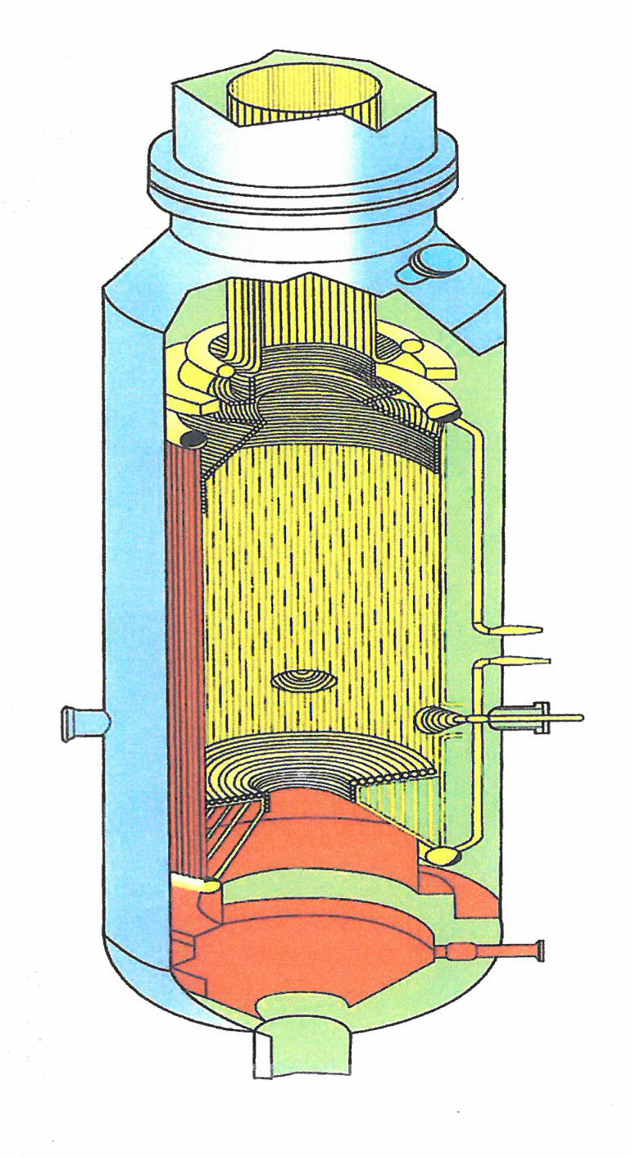

Figure 10. Schematic Illustration of the Shell Gasifier⁽⁴⁾

Table 6. Projects with Shell Gasifiers

Figure 11. Project Location of Shell

REFERENCES
- Royal Dutch Shell, http://en.wikipedia.org/wiki/Royal Dutch Shell
- Shell Global Solutions International B. V.: http://www.hoovers.com/companyinformation/en/company
- Coal Gasification Guidebook: Status, Applications, and Technologies, Final Report, TR-102034, Research Project 2221-39, Prepared by SFA Pacific, Inc., for Electric Power Research, December 1993
- Xu, Zhengang, “The Dominant Position of Coal in China’s Energy Mix”, Fifth Meeting of the Working Group on Energy Planning and Policy, Beijing Research Institute of Coal Chemistry (BRICC)/China Coal Research Institute (CCRI), Chiang Mai, Thailand, May 7-8, 2008
- “Report on Applying Coal Gasification Technology in China’s Coal Chemical Industry”, UNESCO/Shell Chair in Coal Gasification Technology, UNESCO Office, Beijing, PRC 2009
- Ma, LinWei, “WP2 – Future Energy Technology Perspectives, 2.2 Coal Technology Assessment”, Tsinghua – BP Clean Energy Research & Education Center, Tsinghua University, Beijing, China
- De Graff, J.D., “Shell Coal Gasification Technology”, Shell Global Solutions, September 23, 2008
- http://www.Shell.Com/home/content/globalsolutions/impact
- Van Paasen, Sander V. B., “Technology Development for Shell Coal Gasification”, 5th International Freiberg Conference on ICCC & Xtl Technologies, May 2012
- Cai, Ningsheng, “ Development of Coal Gasification & Poly-generation in China:, IEA – MOST Workshop on Fossil Fuel Technologies, Beijing, China, November 6, 2011
- Fava, Ross G., “2005 Power-Gen, Two Shell Gasification Processes”, (Liquids or Solids), Shell Global Solutions

2.A.7 Siemens AG (SFG)
Gasifier / Gasification Technology: Siemen’s Fuel Gasifier (SFG)
Technology Owner and / or Licensor: Siemens AG

Siemens AG
Siemens AG, founded in 1847 by Werner von Siemens, is a German Multi-National Conglomerate Company headquartered in Munich, Germany. It is an integrated technology company with activities in the fields of industry, energy, and healthcare. Siemens AG and its subsidiaries employ approximately 360,000 people across nearly 100 countries and in 2011 had a reported global revenue of approximately 71 billion Euros. The firm is listed on the Frankfurt Stock Exchange and has been listed on the New York Stock Exchange since March 12, 2001.
In October 2011, Siemens AG presented⁽⁹⁾ a planned organizational structure that featured the following four major divisions: Industry, Infrastructure and Cities, Energy, and Healthcare. The Firm’s strategy in the Energy Sector is defined by its five units. These include:
- Fossil Power Generation
- Renewable Energy
- Power Transmission
- Oil and Gas
- Energy Service
It is within the Fossil Power Generation Organizational Unit that Siemens has assigned its corporate interest in the development and marketing of gasification technology. It is reported⁽³⁾ that Siemens entered this market in 2006 with the acquisition of a gasification process that would enable it, as an EPC contractor, to offer the entire Integrated Gasification Combined Cycle (IGCC) process. The technology acquired was the GAS SCHWARZE PUMPE (GSP) gasification technology from Sustec Groupe, a holding Company that had previously, in 2004, acquired the process through the purchase of the German Firm, Future Energy GMB in Freiberg, Saxonia.
The acquisition of Future Energy GMB, a recognized developer of an entrained flow gasifier and gasification technology also gave Siemens access to a development center in Freiberg, Germany. The Center has a history of gasifier technology development activity that began in the 70’s and possesses an extensive research and development data base as well as considerable commercial operational data acquired through the operation of the Center’s 200 Mw_{th} gasifier at the Schwarze Pumpe SZV, Germany. Consistent with Siemens long term presence in China, it also acquired, through the acquisition of the Sustec Holding Company, 50% of the (Swiss) Sustec part of the Sustec-Shanghai Ningxia Coal Group. Currently this interest continues as the GSP China Technology Company, Ltd, a 50%-50% Joint Venture between the Shenhua Ningxia Coal Group and Siemens AG.
THE SIEMENS GASIFIER AND GASIFICATION TECHNOLOGY
Background
As early as the 1970’s, the development of the technology that was to become the Siemens Gasifier had begun. The technology originally was developed in 1975 by the Deutsches Brennstoffinstitute (DBI) for the gasification of pulverized local brown coal and other solid feed-stocks. From that point and up to 2006, the Research and Development activity performed to further develop the gasifier and gasification technology at Freiberg, Saxonia was supported by one of three companies, i.e. Noel GmbH (1991 – 2000), Babcock Borsig Power GmbH (2000 – 2004), Sustec Holding Company (2004 – 2006). In 2006, Future Energy, a subdivision of the Sustec Holding Co. at that time, was acquired by Siemens AG⁽¹⁾and the Gaskombinat Schwarze Pumpe Gasifier (GSP) became the Siemens Fuel Gasifier (SFG)⁽³⁾. A few of the significant milestones in this development process include:
- As noted⁽²⁾, the development of the gasifier now known as the Siemens Fuel Gasifier (SFG) began in the mid-1970s.
- From 1975 until the present, the development of an entrained-flow gasifier has continued at the Freiberg, Germany test center in either the 3 Mw or 5 Mw demonstration unit. As noted⁽²⁾, over 90 feed-stocks have been tested and the gasifier technology has been successfully scaled up from a 3 Mw_{th} to a 200 Mw_{th} capacity.
- In 1984, a DBI 200 Mw entrained gasifier (an early version of the Siemens SFG-200 Gasifier) was installed in the Schwarze Pumpe SZV facility to produce syngas for methanol and power. The operational experience acquired during the operation of the gasifier is part of the developmental data base of the Siemens gasifier/gasification system technology.
- As a result of the purchase of Future Energy GmbH in 2004 by the Sustec Holding Co., Sustec acquired access to the GAS SCHWARZE PUMPE (GSP) gasifier and gasification technology.
- In 2005, the GSP China Technology Co., Ltd Joint Venture was established representing a 50/50 relationship between Shenhua Ningxia Coal Industry Group Co., Ltd and Siemens AG. The Joint Venture is the exclusive GSP licensor for Siemens gasification technology in China.
- Through the subsequent purchase of several subdivisions of the Sustec Holding AG (e.g. Future Energy GmbH) by Siemens AG in 2006, Siemens AG acquired a gasifier and a strong gasification technology data base. The gasifier is now known as the SFG gasifier and the Future Energy’s Freiberg Gasification Development Facility is the Siemens Gasification Testing Facility.
- The acquisition of an entrained flow gasifier technology company by Siemens was completed not only for Siemens to become owner of a very promising gasification technology, but also to be able to act as an EPC contractor for power plants in the future⁽³⁾.

The Technology
The Siemens Fuel Gasifier (SFG) is an entrained, down-flow system with a centrally located burner (Figure 12) that has demonstrated the capability to operate with a wide variety of fuels (e.g. bituminous and sub-bituminous coal, lignite, bio-mass, and liquid wastes)⁽⁵⁾. The internal wall of the gasifier features one of two designs, a cooling screen or a refractory wall and is designed to handle temperatures in the range of 1,300 to 1,800 degrees centigrade⁽⁵⁾. Although the gasifier is reported⁽⁶⁾to be commercially available in three standard sizes, (e.g. SFG-500, SFG-850, and SFG-1200), the SFG-500 is the system most in commercial use.
The design for the 500 Mw_{th} gasifier was completed in 2004, utilizing the considerable amount of data acquired through the operation of the GSP 130 Mw_{th} – 200 Mw_{th} units at the Schwarze Pumpe and from the ongoing development effort at Future Energy’s Freiberg test center⁽⁸⁾⁽²⁾. Although it is reported that the system can use either a slurry or a dry feed⁽⁴⁾ , the system most described and currently in use features the dry feed system and water quench. The SFG-500 gasifier, with cooling screen, is reported to be 18 meters in length, with an outside diameter of 3.5 meters, an inside diameter of 3 meters and a weight of 220 tons⁽⁹⁾ . Depending on the operational parameters used, it is estimated that the SFG-500 can process a coal feed stock at an estimated rate of approximately 1,600 – 1,800 tons per day and is able to operate at elevated pressures, e.g. 500 psia⁽²⁾ .
In an earlier World Energy Congress Meeting⁽³⁾, it was noted, within the context of the Siemens Gasifier that, “In the future, gasifiers need to be scaled up to 1,200 – 1,500 Mw_{th} single train capacity in order to be in line with the future H-Class gas turbine capacity”. Siemens now offers the SFG-1200 unit. Some of the key features of this system include a feed capacity of 3,500 -4,000 tons per day (e.g. hard coal, petcoke), dry feed, cooling screen design, and a full water quench⁽¹⁰⁾. To accommodate the larger capacity, the gasifier has 3 burners, top mounted and similar to a configuration used at Schwarze Pumpe, has a central pilot burner. Consistent with the earlier observation, each SFG-1200 is designed to support one advanced F-Class Gas Turbine⁽¹⁰⁾.
Although it has been reported⁽⁶⁾ that a SFG-850 gasifier is available, no details are available. However, using data given for the other two units (i.e. SFG-500, SFG-1200), it is estimated that the availability of a gasifier of this size permits a system to be designed with an intermediate feed capacity (e.g. 2,400 tons per day).

Current Status
In the six years since its acquisition of a gasifier and gasification technology (i.e. 2006), Siemens AG, through its Fossil Power Generation Division of its Energy Sector, has been successful in implementing its extensive interests in markets for coal utilization technologies. Some of the projects (with the exception of those in China) now being supported, either as operating facilities, current projects, or potential projects for which Siemens technology has been selected are reported⁽⁶⁾ to be:
- Capital Power Corporation, Canada – 270 MWe IGCC
- Tenaska, Inc., Taylorville Energy Center, Taylorville, Illinois – Hybrid IGCC (power and/or SNG)
- Summit Power, Texas Clean Energy Project – Polygen – 400 MWe IGCC and urea
- Secure Energy, Inc., Decatur Gasification Plant, Decatur, Illinois – Coal to gasoline
- Schwarze Pumpe – 200 MW_{th}, Germany – coal to methanol
- Vresova, CZ – liquid feed stock for 175 MW_{th} – coal to urea
- Freiberg Test Center, Germany
It should be noted that Siemens AG continues to support its efforts in the coal utilization market sector through its research and development activities at the Freiberg Test Center. This Center has a wide range of experimental capabilities being used in R&D activities to improve plant economics for a range of applications⁽⁵⁾.

The Siemens Gasifier in China
Although Siemens AG has been a corporate presence in China since the 1800’s, the company was awarded its first coal conversion equipment supply contract, (i.e. two SFG-500 Mw_{th} gasifiers) in December 2006. Since that time and as shown in Table 7, Siemens AG has successfully provided a total of 19 SFG-500 Mw_{(th)} units for five major coal conversion projects and, as of October 2011, is reported⁽⁹⁾ to be in negotiation to the supplier of 24 similar units for at least one other major project. These projects are briefly described:
- The Jincheng Project⁽¹⁾⁽¹¹⁾
The project, developed for the Shanxi Lanhua Coal Chemical Co, Ltd, is at a fertilizer plant near Jinching City in the southern part of the Shanxi Province (Figure 13). The two SFG-500 gasifiers (one in operation and one on standby) constructed for pressure operation (i.e. 4.0 Mpa) are being operated to produce 300,000 tons/year ammonia, 520,000 tons/year urea. The feedstock is Tangan coal (anthracite). It has been reported that commercial operation was achieved in 2010.
- The NCPP Plant⁽⁶⁾⁽⁹⁾
Listed as the largest coal to chemical plant in China, the Ningxia Coal-based Polypropylene Project was developed for the Shenhua Ningxia Coal Industry Group Co. Ltd. The facility is located in the Ningxia Province at an estimated 40 km from the Federal Capital (Figure 13). The project features the use of 5 SFG-500 Mw_{th} gasifiers to produce 540,000 Nm³/hr (CO+H₂) which, as reported⁽⁹⁾ will be converted to an estimated product slate of 23 tons/hour gasoline, 5 tons/hour LPG and 61 tons/hour polypropylene. It has also been noted that first methanol production was achieved at the end of 2010 and pre-commercial operation to polypropylene was begun in mid-2011.
- The Coal to SNG Project⁽⁹⁾
China Power Investment Corporation (CPI) Yinan, as one of China’s major utilities, is developing the first coal to substitute natural gas (SNG) plant. The project is reported to be the first phase (2 billion Nm³/yr) of a 6 billion Nm³/yr SNG facility. As shown in Figure 13, the plant is to be located in the extreme northwest area of China at or near Yili City, Xinjieng Province, China. This first phase of the project will use 8 SFG-500 gasifiers and associated feeding systems. It has been reported that the contract was signed in July, 2011 and it is estimated that commissioning will start in mid-2014.
- The World’s Largest CTL Plant⁽⁹⁾
Future collaboration between Shenhua Ningxia Coal Industry Group and Siemens may result in the world’s largest CTL plant. The plant will utilize 24 SFG-500 gasifiers with their delivery currently estimated to occur in mid-2013 with the start of commissioning projected to occur at the end of 2016. The current process envisions the use of an indirect liquefaction process with the use of Fischer Tropsch reactors.
- Coal to Ammonia Project
A smaller facility utilizing two SFG-500 gasifiers is reported to have been constructed by the Yancon Energy Chemical Co., Ltd near Kaiyang, Guizhou Province.
With the information available, projects with one or more Siemens Gasifiers or gasification systems operating or planned will be located in 4 of the 30 Chinese Provinces. A current projection of these data suggests that the projects will be consuming 79,000 tons per day to produce:
- 520,000 tons per annum polypropylene
- 184,800 tons per annum gasoline
- 41,200 tons per annum liquid fuels
- 830,000 tons per annum dimethylether
- 1,400.000 tons per annum ammonia
- 520,000 tons per annum urea
- 6 billion nm³ per annum substitute natural gas.

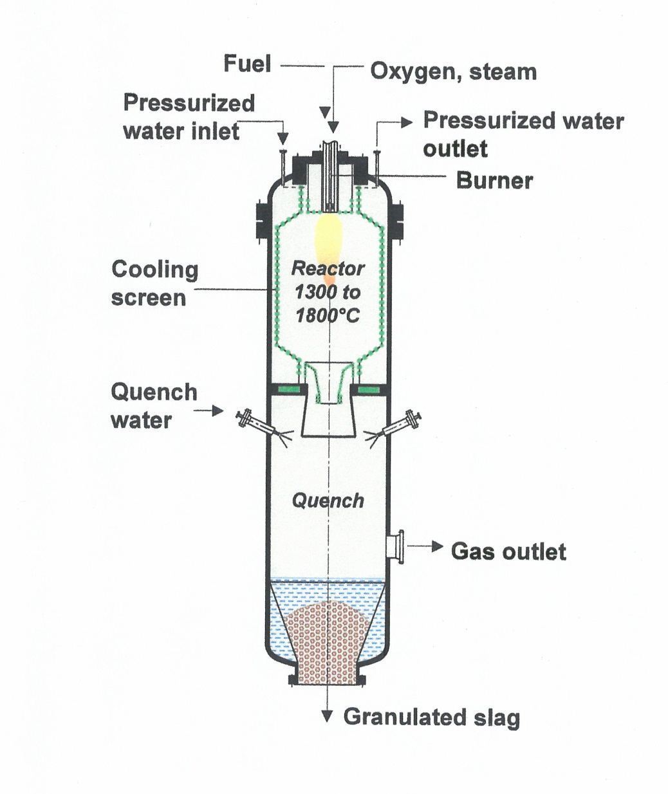

Figure 12. Schematic Illustration of the SFG-500 Gasifier

Table 7. Projects with Siemens Gasifiers

Figure 13. Project Location of Siemens

REFERENCES
- Morehead, Harry, “Siemens Gasification and IGCC Update”, ASIA Pacific Partnership Meeting, Columbus, Ohio, October 31,2006
- Morehead, Harry, “The Siemens Gasification Process and its Application in the Chinese Market”, Siemens Power Generation/E/431, March 23, 2007
- Voges, Klaus, “Climate Change Mitigation Technologies: The Siemens Roadmap to Carbon Capture and Storage”, 2007 World Energy Congress, Rome, Italy
- http://wwwgreencarcongress.com/2006/06/Syntroleum
- Morehead, Harry, “Siemens Gasification and IG Update”, Gasification Technologies 2008, Washington, D.C., October 7, 2008
- Morehead, Harry, “Siemens IGCC and Gasification Update”, Gasification Technologies Conference, Washington, D.C. November 1, 2010
- Hannemann, Frank, Manfred Schingnitz, Gerhard Zimmerman, “2nd International Freiberg Conference on IGCC & XtL Technologies”, May 8 – 12, 2007
- http://iea Task 33.Org/app/webroot/files/file/minutes_and_presentations/Dresden
- Hannemann, Frank, Wang, De Hui, Yang, Jia Yi, Huang, Bin, “Siemens Gasification Technology at the World’s Largest Coal to Polypropylene Plant”, Gasification Technologies Conference, San Francisco, California, October 2011
- Morehead, Harry, “Siemens IGCC and Gasification Activities: North America & China”, 2009 Gasification Technologies Conference, Colorado Springs, CO, October 6, 2007
- Morehead, Harry, “Siemens Global Gasification and IGCC Update”, Coal Gen, Milwaukee, WI, August 3, 2007
- Henley, John P., “Overview of China’s Lead in Coal Gasification Implementation” The Dow Chemical Co., Presentation, March 23, 2007

2.A.8 Synthesis Energy Systems Inc. (U-Gas)
Gasifier / Gasification Technology: Fluidized-Bed, Agglomerating-Bed (U-Gas) Gasifier
Technology Owner and / or Licensor: Synthesis Energy Systems

Synthesis Energy Systems
Synthesis Energy Systems is a global energy and gasification technology company that provides products and solutions to the energy and chemical industries. The company unlocks the value of low-rank fuels and biomass by converting these low-cost feed-stocks into high-value energy and chemical products through its proprietary, exclusive, global license to proven U-GAS coal gasification technology from the Gas Technology Institute (GTI), previously the Institute of Gas Technology (IGT). The U-GAS gasifier gasifies coal cost-effectively with low water usage and without many of the harmful emissions normally associated with coal combustion plants. The primary advantages of U-GAS technology relative to other gasification technologies are (a) greater fuel flexibility provided by the ability of SES to use all ranks of coal (including low rank, high ash, high moisture coals, which are significantly cheaper than higher grade coals), many coal waste products and biomass feed stocks and (b) the ability of SES to operate efficiently on smaller scale, which enables the construction of plants more quickly, at a lower capital cost and in many cases, in closer proximity to coal sources.
One of the SES’s stated paths to growth and profitability is, “Selective Project Investments”. This path is a major characteristic in the two projects that the firm is supporting in China. The Shandong Hai Hua Coal & Chemical Co., Ltd. (HH) Project is a joint venture effort (96% SES and 4% HH) while the joint venture with the Yima Coal Industry Group Co., (the Yima Project) is supported 75% by Yima and 25% by SES. In this second project SES has an option to increase its participation up to 49%.
SES, headquartered in Houston, Texas, has major operations in Shanghai and Beijing, China.

THE U-GASIFIER TECHNOLOGY
Background
The Gas Technology Institute (GTI), formerly the Institute of Gas Technology (IGT) originally developed the U-GAS technology to produce low to medium heating value fuel gas from a variety of feed-stocks including highly caking, high-sulfur, and high-ash coals. The process uses a single-stage, fluidized-bed gasifier where sized fuel is de-caked, de-volatilized, and converted to a combustible fuel/synthesis gas rich in hydrogen and carbon monoxide and free of tars and oils. Within the fluidized bed, fuel is reacted with steam and air or oxygen at a temperature of 1550 to 2000 ºF (840 to 1100 ºC). The temperature of gasification depends on the type of fuel used and is controlled to maintain high carbon conversion and non-slagging conditions for the fuel ash. Gasifier operating pressure is dependent on the end-use of the gas and can vary from 14 to 425 psig (1 to 30 kg/cm²).
The development of the U-GAS technology is marked by a number of key milestones that include:
- U-GAS concept⁽¹⁾ is an outgrowth of studies begun in 1945 when IGT constructed a reactor to study the kinetics of carbon-oxygen-steam reactions at 2700 ºF and atmospheric pressure. Later, a similar reactor extended the studies to the 750 psig range.
- A 6-inch diameter fluidized-bed reactor with a capacity of 8 tons per day (tpd) of coal was built in 1950.
- The data base was used in the design and operation of the low pressure U-GAS Gasifier that was part of the Energy Research and Development Administration (ERDA) and American Gas Association’s (AGA) HYGAS Program. The concepts of elutriated fines return, carbon utilization and ash agglomeration using metallurgical coke or char from the COED pilot plant as feedstock were examined.
- During development of the U-GAS Gasifier, IGT conducted bench-and pilot-scale operations with a wide variety of coal types, accumulating over 11,000 hours of pilot operating experience.
- Other significant steps/stages in the development of the U-GAS process are summarized in Figure 14⁽⁴⁾.
- In 1991, the U-GAS gasifier was selected by the Shanghai Coking and Chemical Corporation (SCCC), a large, coal-based chemicals production company with its primary manufacturing facilities located in the Wujin Chemical Industry Area southwest of Shanghai, as one of two types of gasifiers for the Chinese Trigeneration Project. The U-GAS Process was to provide fuel gas to an existing battery of coke ovens, freeing up the higher value coke oven gas for blending into town gas. A second gasifier, the Texaco Gasifier, was selected to produce synthesis gas for methanol and chemicals production⁽²⁾.
- In 1992, IGT prepared the process design package (PDP) for the (SCCC) U-GAS plant according to the following design basis⁽²⁾.
    - 8 parallel trains, each processing 130 metric tons per day of Shen Fu coal to produce a coal gas with a Higher Heating Value of 120 Btu/scf.
    - 8 gasifiers total, 6 on line and 2 spares (75 percent availability)
    - Gasifier operating pressures range from 23 to 32 psig (160 to 220 kPa)
    - Three stages of cyclone dust separation with fines recycle from the first two cyclones
    - Heat recovery steam generator and super heaters for process and export steam
    - Product gas cleanup by water scrubbing prior to distribution to the coke ovens
- Plant construction was started in 1992 and commissioning of the U-GAS facility was begun in the fall of 1994, with light off of the first gasifier completed on December 28, 1994 and commercial gas production initiated in early 1995⁽³⁾.
- It was reported⁽²⁾ that during the first 44 months of operation from December 1994 through July 1998 over 49,000 hours of gasifier operation were logged. Approximately 155,000 metric tons of coal were gasified, with over 25 billion cubic feet of fuel gas delivered to the coke oven batteries. The average duration of the individual gasifier operating periods increased from 302 hours in 1995-96 to 1000 hours in 1998. The maximum run length was increased from 1,409 hours to 3,214 hours over the same time period. During the last 12 months of this operating period, the average total operating hours for the seven gasifiers operated was 3,640, with the seventh train achieving 75 percent availability at nearly 6,200 hours.

Current Status
The U-GAS Gasifier technology, in its current configuration, is the result of the earlier development efforts of the Institute of Gas Technology Institute, the operating experience gathered at the SCCC facility, and the subsequent ongoing development effort initiated by SES during the continued commercialization of the technology following SES’s licensing of the process. As shown in Figure 15⁽⁴⁾, the gasifier has evolved from the earlier pilot plant, a low pressure gasifier of 24 tons per day (tpd) to the 400 tpd, low pressure unit now operating at the Hai Hua facility in Shandong Province, China to the 1200 tpd medium pressure vessel being installed in SES’s Yima Project in the Henan Province, China. Figure 14 introduces a schematic illustration of the gasifier⁽⁴⁾.
In December 2010, SES announced that it had demonstrated, at commercial scale, a significant advancement in its proprietary U-GAS coal gasification technology. The improvement resulted in increased coal carbon conversion to approximately 98 percent or greater. The Improvement, the newly developed fines management system⁽⁵⁾, was the product of a 12-month undertaking by the SES team in China to fundamentally increase gasification efficiency. The process improvement was demonstrated at the company’s Zao Zhuang Joint Venture plant in China over a two month period using low quality, high ash and low-heating value coal. As a result, the Zao Zhuang plant has experienced a reduction in coal consumption by more than 10 percent which can be seen in lower operating costs for the facility.

The U-GAS Gasifier in China
SCCC’s Trigeneration Project demonstrated the U-Gas gasification technology for the first time at commercial scale. The design and operating experience gained in that project have been applied to subsequent plant designs. The improved system was selected for use in the Hai Hua U-GAS gasification facility in Shandong Province, China. In a similar manner the experience being acquired in the Hai Hua facility used in combination with the Research and Development data being generated through the support of SES at the GTI’s Flex-Fuel Test Facility and Advanced Gasification Test Facility located in Chicago, Illinois appears in the 1,200 tpd gasifier and gasification technology now being installed in SES’s Yima Project. These U-GAS gasifiers and gasification systems are discussed below and the two most recent projects are summarized in Table 8. The general location of the projects is identified in Figure 17.
- Shanghai Coking and Chemical Corporation (SCCC), Shanghai, China,
As noted previously, eight U-Gas Gasifiers were constructed at the SCCC Facility to produce a fuel gas that was delivered to an existing battery of coke ovens, freeing up the higher value coke oven gas for blending into town gas. SCCC’s Trigeneration project provided the opportunity for the first commercial demonstration of the U-GAS Technology. As expected, the operation of the plant experienced both process and mechanical problems typical of a first-of-a-kind plant. The problems were resolved through the joint efforts of the IGT and SCCC project teams. The operating experience gained was applied to subsequent plant designs further improving performance and reliability of the U-GAS Gasifier and gasification technology while reducing both capital and operating costs.
- Hai Hua U-GAS facility, Zao Zhuang City, Shandong Province, China,
The Shandong Hai Hua Coal & Chemical Co. Ltd selected the U-GAS Technology for use in an application similar to that it served at SCCC. The two 400 tpd gasifiers (one in operation, one in standby) were designed to generate 22,000 Nm³/h of clean syngas to supplement the feedstock-to-methanol production facility operated by Hai Hua Coal & Chemical Co. As reported⁽⁵⁾, the subsequent operation of the facility (approximately 3.5 years by the end of 2011) has demonstrated high syngas average availability of over 97%, a 30% turndown of design syngas rate, and operation on high ash middlings (55%), run-of-the-mine bituminous, high ash sub-bituminous and lignite feed-stocks.
- Yima Coal Industry Group Co. Yima, Henan Province, China,
The 1,200 metric tons per day (mtpd) gasifiers (2 in operation and one in backup) being used in the Yima project represents a significant advancement in the U-GAS gasifier and gasification system technology beyond that employed in the earlier Hai Hua facility (i.e. 400 mtpd gasifier). The Integrated Coal Gasification to Methanol Project supported by the Yima Coal Industry Group (75%) and SES (25%) is located in the Mazhuang Coal Chemical Industrial Park, Yima, Henan Province, China. Mechanical completion was accomplished by the end of 2012 with COD anticipated 6 months later. It is designed to produce 300,000 mtpa methanol from a sub-bituminous coal with 38-45 percent ash. The Yima Coal Industry Group is one of China’s largest coal companies with total assets of RMB 15.7 billion (USD 2.3 billion)

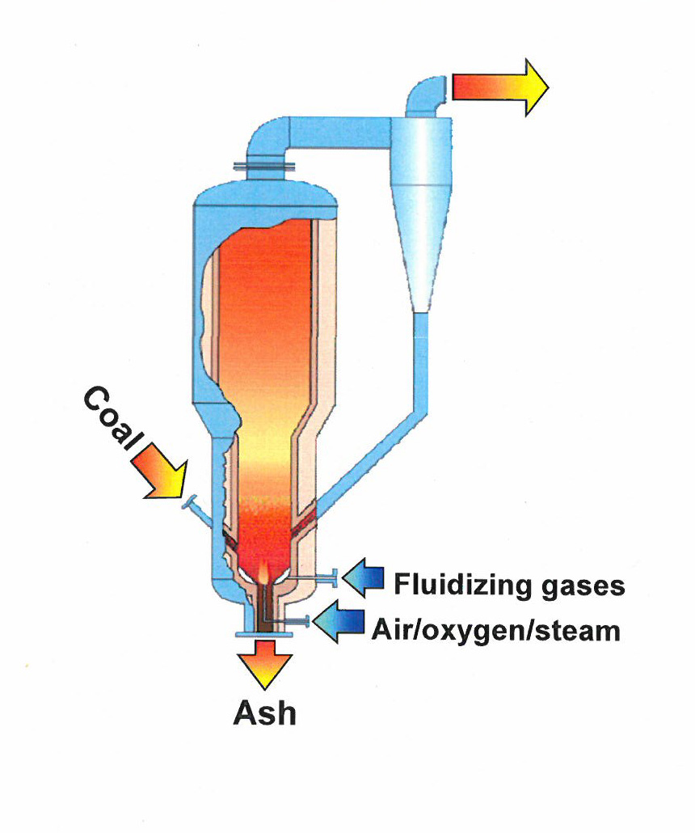

Figure 14. Schematic Illustration of U-Gas Gasifier

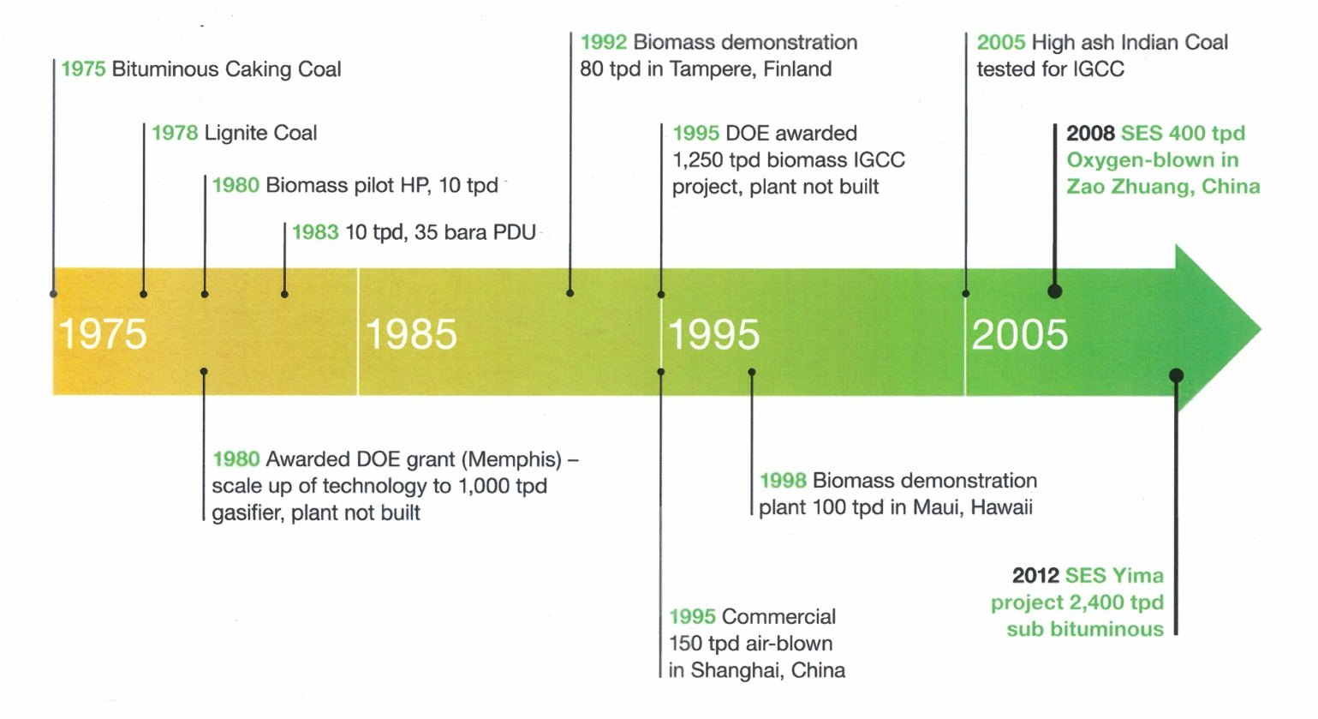

Figure 15. Development of U-Gas Technology

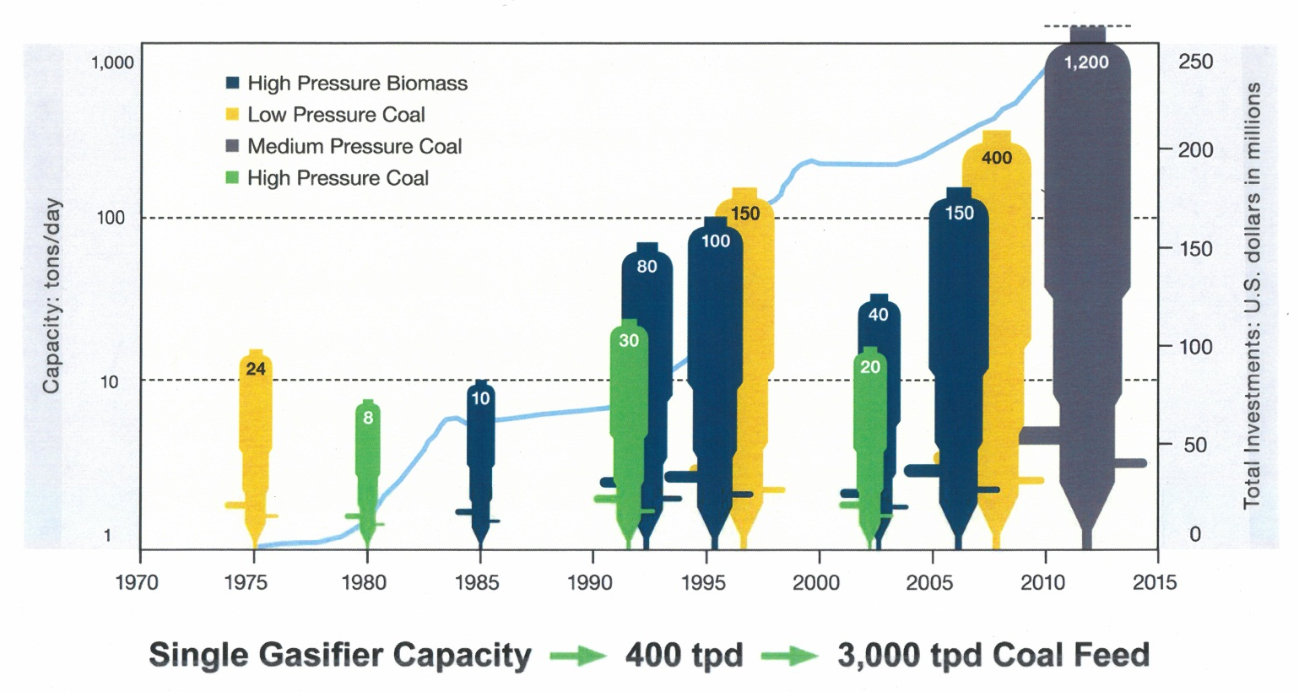

Figure 16. Scale-up of U-Gas Gasifier

Table 8. Projects with U-GAS Gasifiers

Figure 17. Project Location of U-Gas

REFERENCES
- Handbook of Gasifiers and Gas Treatment Systems, Final Report, Task Assignment 4. Engineering Support Services, Dravo Corporation, Pittsburgh, Pennsylvania, 1976.
- Shanghai Coking and Chemical; Corporation, U-GAS Project – Review of Findings, A Report Prepared for the Office of Coal and Power Systems, Office of Fossil Energy, Department of Energy, Washington, D. C,, March 19, 1999.
- Carty, B. G. B. G. Bryan, F. S. Lau, J. M. Abbasian, “Status of the Commercialization of IGT Gasification Technologies”, EPRI Conference on New Power Generation Technology, 1995.
- Lau, Francis, “Commercial Development of the SES U-GAS Gasification Technology, 2009 Gasification Technologies Conference, Colorado Springs, Colorado, October 4 -7, 2009.
- Synthesis Energy Systems, “Making a Global Impact”, Gasification Technologies Conference, San Francisco, California, October 10, 2011

2.B. Chinese Origin

2.B.1 Aerospace Science and Technology Corporation (HT-L)
Gasifier / Gasification Technology: The HT-L Gasifier: A Pressurized, Down-Flow, Entrained Reactor
Technology Owner and / or Licensor: China Aerospace Science and Technology Corporation

China Aerospace Science and Technology Corporation (CASC)
Having originated from the Ministry of National Defense that was established on October 8, 1956 and having experienced the historic evolution of the Seventh Ministry of Machinery Industry, The Ministry of Space Industry, the Ministry of Aerospace Industry, and China Aerospace Corporation,(CASC) was formally founded on July 1, 1999 with its headquarters in Beijing, People’s Republic of China (PRC).
The Organization is a state-owned enterprise with its own brands (e.g. Shenzhou and Long March), intellectual properties, outstanding innovative capabilities and strong core competitiveness. CASC has 8 large R&D, production and industrial complexes that are primarily associated with the aerospace and space industry. The Firm is focused on the research, design, manufacture, and launch of space systems. In the performance of these activities, a wide range of products are produced. The commercial potential of these products is explored further through the operation of four product and services activities, i.e. Space Systems, Defense Systems, Aerospace Technology Applications, and Aerospace Services.
In the process of achieving the commercial goals of the Corporation, the firm has demonstrated the quality of its work by the awards it has received. These include:
- 67 national-level members of the State’s “Hundred-Thousand-Ten-Thousand Talent Project for the New Century
- More than 2,100 recipients of special government allowance
- 7 winners of “China Grand Skill Award
- About 480 winners of “Aerospace Skill Award” and “Aerospace Technical Experts
By the end of 2009, CASC had more than 140 thousand employees, including 33 Academicians of the Chinese Academy of Sciences (CAS) and the Chinese Academy of Engineering (CAE) and was ranked among the Top 10 of the existing 125 central enterprises in the Annual Management Performance Assessment⁽¹⁾.

THE HT-L COAL GASIFIER AND GASIFICATION TECHNOLOGY
The Technology
The technology developed by CASC applicable to China’s coal conversion industry reaches commercial markets through the activities of the Firm’s Aerospace Technology Applications Group. This technology includes the pressure burner used in the gasification of coal slurries accomplished with the HT-L coal gasifier. The HT-L Coal Gasification Technology, as a unit of the Aerospace Technology Applications Group, independently owns the intellectual property rights for the technology.
The HT-L gasifier (i.e. Figure 18), a pressurized, entrained, down-flow, reactor, is reported⁽¹⁾ to be the result of the conversion and extension of Aerospace engine technology. Through the use of the coal gasification burner, the gasifier can transform most of solid-state coals of all qualities into a clean gaseous mixture of carbon monoxide and hydrogen efficiently, cleanly, and environmentally responsive. The technical characteristics of the gasifier and gasification system include:
- Wide adaptability to coal type
- Processing of pulverized coal
- Use of a water membrane wall in a pressurized entrained flow reactor
- Use of a quenching stage and ash water recycling for clean usage of coal
- Equipment sets designed and manufactured domestically and key components further developed and employed in industrial applications
- Lower investment and operating costs
The HT-L gasifier is offered commercially in a series of three coal feed capacities, i.e.:
- Model 2800/3200 – 750 tons-per-day
- Model 3200/3800 – 1,600 tons-per-day
- Model 4000/4000 – 2,500 tons-per-day

The HT-L Gasifier in China
Very little information is available on the physical and performance characteristics of the 25 HT-L gasifiers reported to exist at 15 sites within China. The list of these sites is given as Table 9. The approximate location of these projects is illustrated in Figure 19. There is, at least, one project with one or more gasifiers in 9 of the 30 Chinese Provinces. The projects have the capacity⁽²⁾ to consume a total of 24,000 tons coal/hour, to produce 4,300 kt/y ammonia, 500 kt/y methanol and 2 x10³ M³/yr methane.

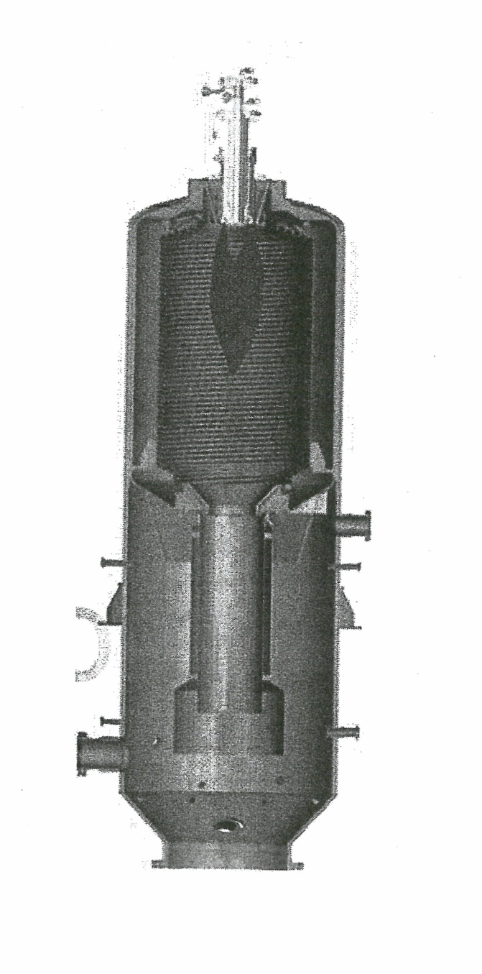

Figure 18. Schematic Illustration of the HT-L Gasifier⁽¹⁾

Table 9. Projects with HTL Gasifiers

Figure 19. Project Location of HT-L

REFERENCES
- China Aerospace Science and Technology Corporation, http://www.spacechina.com
- Ibid
- Ibid
- Cai, Ningsheng, “Development of Coal Gasification & Polygeneration in China”, Department of Thermal Engineering, Tsinghua University, IEA – MOST Workshop on Fossil Fuel Technologies, Beijing, China, June 11, 2010

2.B.2 East China University of Science and Technology (OMB)
Gasifier / Gasification Technology: Opposed Multi-Burner Gasifier
Technology Owner and / or Licensor: East China University of Science and Technology / Institute of Clean Coal Technology

The University (ECUST)⁽¹⁾
- Located in Shanghai, People’s Republic of China, The East China University of Science and Technology, initially named East China Institute of Chemical Technology was founded in 1952.
- East China Institute of Chemical Technology was promoted as a National Key University under the direct administration of the Ministry of Education in 1960. In recognition of its growth, the National Ministry of Education approved the renaming of the university as East China University of Science and Technology in 1993.
- In June 1996, East China University of Science and Technology was established as one of the top 100 universities in China for the National 211 Project.
- ECUST has three campuses, one in XUHUI District, one in FENGXIAN District and one in JINSHAN District. The three campuses called ECUST Park includes 53 academic institutes, 9 national academic bases and 16 provincial research bases.
- ECUST is among one of six universities that are fully authorized as the Nation’s Technology Transfer Center.
- In recent years, 1,300 full-time and part time researchers in ECUST have been conducting more than 1000 research programs each year with their research funds rising from 100 million RMB in 2001 to 200 million in 2004 and to over 400 million in 2009.
- The key laboratory of coal gasification in the Ministry of Education is at the Provincial level and the Ministerial level.

Institute of Clean Coal Technology⁽²⁾
The Institute of Clean Coal Technology of East China University of Science and Technology headed by Professor Yu Zunhong, an outstanding gasification expert, was established in 1995. The Institute of Clean Coal Technology devotes itself to long-term research and development of entrained-bed gasification technology. The Institute is funded by the following programs: the 8th – 10th Five Year National Science and Technology Tackling Plan, National Fundamental Research (863 and 973 Programs), Development Plan of National Major Technical Equipment, National Natural Science Fund, Specialized Research Funds for Doctorial Programs of Higher Education and Subsidy Scheme for Distinguished Backbones of Higher Education, and the Shanghai Daystar Program. The staff consists of approximately 100 people, 17 faculty members including 5 professors, 5 associate professors, and about 100 graduate students
“In the past decade, the Institute of Clean Coal Technology has participated in over 40 National, Provincial, Industry and Enterprise projects and got more than 40 million RMB funding. Many achievements are in leading position in domestic and superior to international counterparts, including the new type of coal water slurry gasification feed nozzle, new type (multi contra-positional) coal slurry gasifier, new-type of scrubbing-cooling technology for entrained coal gasifier, etc. Most of them have won many National Provincial and Ministry of the Science and Technology awards”.
In the ECUST, the Institute of Clean Coal Technology is the R&D heart of “National Engineering and Research Center of Coal Slurry Gasification and Coal Chemistry Industry” in the ECUST. It also is an important research center in the field of Clean Coal Technology and Environmental Protection. The Institute supports a very extensive and sophisticated R&D Program. The significant features of this effort were introduced recently in a conference presentation⁽³⁾.
Some Completed Projects:
- Research and Development of new pressurized entrained-flow gasification technology using pulverized coal (finished in 2004) - The 10th Five Year National Science and Technology Tackling Plan.
- Research of Multi-phase flow and mixing process in a coal water slurry gasifier (2000-2001) – National Minister of Education
- Research and Development of the key parts of a gasifier (1998-2000) – The 9th Five Year National Science and Technology Tackling Plan
- Research of Multi-phase flow and mixing process in a coal water slurry gasifier (2000 – 2001) – The National Minister of Education
- Development of new type (multi contra- positioned) of coal water slurry gasifier (1996 -2000) – The 9th Five Year National Science and Technology Tackling Plan
- Flow behavior and heat transfer of slag shelter in entrained flow gasifier- National Basic Research Program (973)
Current R & D Projects:
- Fundamental research of large scale and highly efficient entrained flow gasification processes – National Basic Research Program (863 Program)
- New type of coal slurry gasification technology development – Hi-Tec Research and Development Program of China (863 Program)
- Study of heat characters in opposed multi-burner entrained-bed gasifier – Ministry of Science and Technology, Shanghai
- Development of new quench chamber of coal gasifier – Fengxi Sanxi Chemical Corporation Ltd
- Process design package for Opposed Multi-Nozzle Coal Slurry Gasifier – Hualu Shangdong Henshang Chemical Corporation Ltd
- Mechanism of pulverized coal pneumatic conveying technology using CO₂ as a carrier gas – National Natural Science Foundation of China

THE OPPOSED MULTI-BURNER GASIFIER
Background
Considerable developmental and commercial data exists on the opposed multi-burner gasifier and gasification process. These data have been generated during two major periods of activity. The initial period began in the late 1930s and continued to the 70s while the second, more recent period, began in the 1990s and continues today.
Beginning with the earlier period, it is reported⁽⁴⁾ that “the original bench-scale development of the opposed-burner gasifier (I.E. Koppers Totzek) was done by Dr. Friedrich Totzek in the late 1930 while working for Heinrich Koppers GmbH of Essen, Germany. A 24-ton/day pilot plant was jointly developed by Heinrich Koppers GmbH and Koppers Company, Inc. of Pittsburgh, Pennsylvania and built in 1948 for the U.S. Bureau of Mines at Louisiana, Missouri.
The first commercial K-T gasification plant was built in France in 1949. In all, Heinrich Koppers has built 39 coal gasifiers in 13 plants for 10 different customers. There are also four other K-T plants which gasify oil, tar, or methane. The primary application for the K-T gasifier has been hydrogen production from coal for ammonia synthesis. It also has been noted⁽⁴⁾ that most of the operating experience of GKT gasifiers has been with the two-headed design. This design features two opposing burner heads giving the gasifier an appearance similar to that of a football. It should be noted however, that the two plants reported as constructed in India⁽⁴⁾ utilize the larger “four-headed” gasifier design. These gasifiers have four heads spaced at 90 degrees apart. A more complete data base resulting from this period of technology development can be found in references (4), (5), (6), and (7).
In the most recent period of development, the design of the Opposed Multi-head Gasifier (OMB) has been advanced significantly through the developmental studies supported by the East China University of Science and Technology’s Institute of Clean Coal Technology. This interest and subsequent developmental work on Coal-Water Slurry (CWS) and OMB technology began in the early 1990s and continues today. The stages in the development and commercialization of this technology at the ECUST/ICCT are outlined as follows and discussed in detail in references (8), (9), (10), and (11):
- Innovation and 22 ton per day (tpd) pilot plant……………………1996 – 2000
- Industrial Demonstration 750 and 1150 tpd………………………..2001 – 2005
- Scale-up integration and polygeneration IGCC at 2200 tpd………..2006 – 2010
- Scale – up to 3000 tpd………………………………………………2011 ~

The Technology
The current level of development of the opposed (opposite) multi-burner gasification technology permits the Institute of Clean Coal Technology of ECUST to offer considerable flexibility in operating performance characteristics of the units it offers. The four injector/burner, coal water slurry gasifier (Figure 20) is the version most in commercial use. The gasifier features four burners located around the top of the gasifier spaced at 90º intervals from each other forming two pairs of opposed burners. This configuration permits equal, flexible control of large amounts of coal slurry and the impinging flow facilitates mixing of the reactants. Other features of this gasifier include:
- Advanced burner/injector design permitting significant changes in the construction and operation of the gasifier
- Feeding systems that can handle coal water slurries and dry pulverized coal
- The use of either a refractory wall, a membrane lining or a water-wall system
- An entrained feed system that uses carbon dioxide as a carrier gas
- Gasifier capacities that can range from 750 to 3000 tons per day
Of equal significance is the ongoing development of a pulverized, dry coal feed, single gasifier with the burner/injector centrally located at the top of the gasifier discharging downward into the reactor. It has been reported⁽¹²⁾ that two demonstration projects, each with two gasifiers operating at 4.0 MPa with a feed capacity of 1200 tons per day are in construction. Other significant developmental activities with the potential to impact the commercial coal conversion market place include:
- Operation of an Air-Blown, two-stage, entrained flow gasification pilot plant (2.4 tpd)
- Operation of a water-wall gasifier at a pilot plant level
- Joint venture of ECUST and Sinopac in development of a dry feed gasifier with a capacity of 1,000 – 2,000 tons per day, an extremely high operating temperature i.e. greater than 1,500 ºC and capable of operating at 4.0Mpa Steam⁽¹³⁾.
- ECUST gasifiers available in five design capacities. Table 10 identifies the number of projects as well as the number of gasifiers planned and operating at each of the design feed capacities. The Table also lists the total number of projects and total number of gasifiers operating within each capacity range.
It should be noted also that ECUST has sold a technology license to Valero, the largest refinery enterprise in the United States. The Valero project currently is planning for the use of 5 gasifiers, each with a capacity of 2,500 tons per day. The gasifiers will be used to generate hydrogen through the gasification of petroleum coke.

OMB Gasifiers in China Projects
It has been reported⁽¹³⁾, that within China 31 coal projects have been identified that utilize an estimated total of 88 OMB gasifiers that have coal feed capabilities ranging from 750 to 3,000 tons per day. Of the 31 projects, 10 are in operation, 8 are under construction and 13 are in development. The distribution of these projects within the 30 provinces of China has been listed in Table 11 and their general location is shown in Figure 21. As shown in Figure 21 the OMB gasifiers are situated in 13 of the 30 Chinese provinces. The principal products of these projects are Ammonia, Methanol, Dimethylether, liquids from coal, Hydrogen and electricity from IGCC systems.

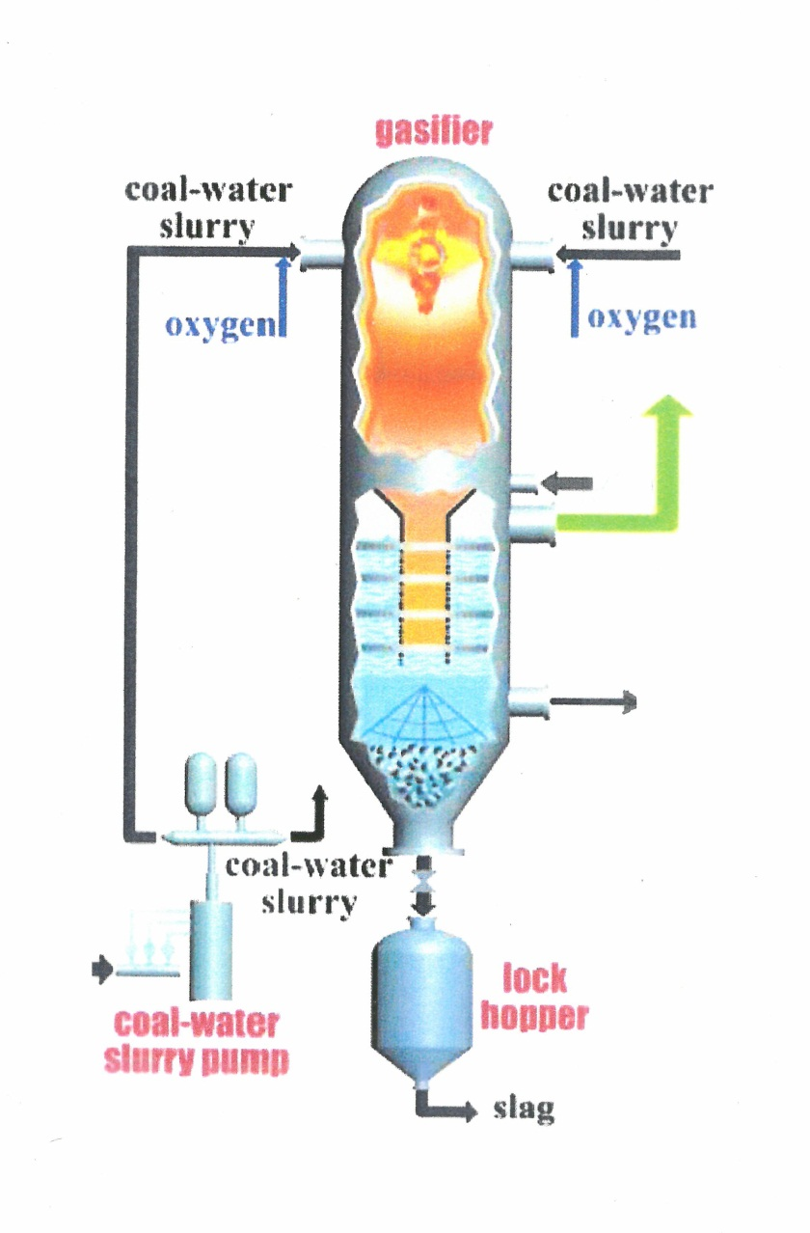

Figure 20. Schematic Illustration of the OMB Gasifier

Table 10^{(13).} Utilization of OMB Gasifiers with Varying Design Capacities

Table 11. Projects with Opposed Burners (OMB) Gasifiers

Figure 21. Project Location of ECUST

REFERENCES
- http://en.wikipedia.org/wiki/east_china_university_of_science
- http://www.nextstepchina.org/east_china_university_of_science
- Zhou, Zhijie, “Opposed Multi-Burner Gasification Development, Demonstration, Applications (ECUST)”, 5th International Freiberg Conference on IGCC and XtL Technologies, Leipzig, Germany, May 21st, 2012
- “Coal Gasification Systems: A Guide to Status, Applications, and Economics”, Electric Power Research Institute, Research Project 2207, AP-3109, June 1983
- “Gas Generator Research and Development: Survey and Evaluation, Phase one, Volume 2”, Bituminous Coal Research, Inc., Report L-156, Prepared for the Office of Coal Research, Department of the Interior, Washington D.C. 1965
- Smith, Howard I, G.J. Werner, “Coal Conversion Technology: A Review”, Auspices of Millmerran Coal Pty. Ltd, Brisbane, Australia, May 1975
- “Handbook of Gasifiers and Gas Treatment Systems”, Prepared for the U.S. Energy Research and Development Administration, Report FE-1772-11, Dravo Corporation, Pittsburg, PA, 1976
- Wang, Fuchen, Guo, Xiaolei, “Opposed Multi-Burner (OMB) Gasification Technology: New Developments and Update of Applications”, Key Laboratory of Coal Gasification of Ministry of Education, Institute of Clean Coal Technology (ICCI), East China University of Science and Technology (ECUST), Gasification Technology Conference, Washington D.C., October 8, 2008
- Yu, Zunhong, Xin Gong, Wang, Fuchen, “Coal Gasification Technology in China: Application and Development”, Research Institute of Clean Coal Technology, East China University of Science and Technology, Shanghai, PRC, January 2005
- Yu, Zunhong, Zhou, Zhijie, and Yu, Guangsuo, “Opposed Multi-Burner Gasification Technology: Seven New Projects in China”, Institute of Clean Coal Technology, Gasification Technologies 2007 Conference, San Francisco, CA, October 15, 2007
- Institute of Clean Coal Technology, East China University of Science and Technology, “Commercial Applications of the Opposite Multi-Burner Gasification Technology
- News Clip: Hong Kong Daily News Everyday, October 9, 2008
- East China University of Science and Technology, “Experience and Future Development of ECUST Gasification” Gasification Technologies 2012 Conference, Washington, D. C., October30, 2012
- Presentation, “Commercial Applications of the Opposite Multi-Burner Gasification Technology”, Institute of Clean Coal Technology, East China University of Science and Technology

2.B.3 Institute of Coal Chemistry (AFB)
Gasifier / Gasification Technology: Ash Agglomerated, Fluidized-Bed Reactor
Technology Owner and / or Licensor: Institute of Coal Chemistry, Academy of Science

Institute of Coal Chemistry/Academy of Science
The Institute of Coal Chemistry (ICC) is one of the high-tech research and development institutions affiliated with the Chinese Academy of Sciences (CAS). The Institute of Coal Chemistry conducts basic and applied research in three major areas: energy and environment, advanced materials, and green chemistry.
The ICCCAS was inaugurated in Dalian, People’s Republic of China in 1954 and was identified as the Laboratory of Coal Chemistry of the Academy of Science. Prior to being named the Laboratory of Coal Chemistry (1952 – 1954), the Laboratory was known as a laboratory of the Institute of Industrial Chemistry. Subsequent to being renamed, it began operation as an independent laboratory under the leadership of the Academy of Science⁽¹⁾.
In June 1959, the CAS decided to move the Laboratory of Coal Chemistry to Taiyuan, Shanxi Province with the actual move taking place in 1961. Subsequent to the move and upon its arrival in Taiyuan, it became known as the Institute of Coal Chemistry, Chinese Academy of Science. The ICC was returned from the responsibility of the local government of the Shanxi Province to the Chinese Academy of Science in 1978. The end of the cultural revolution served as the reason for, once again, making the ICC a subsidiary of the CAS. Its mission was, and is, to conduct research on Clean Coal Technologies responsive to the Nation’s requirements for energy safety and environment aiming at breakthroughs and integrated motivation in theories, as well as core technologies in coal gasification, liquefaction, and emission reductions, even to zero emissions⁽¹⁾.
Since its foundation, the ICC has evolved from a small laboratory with a staff of 64 into a comprehensive national research institution with a current staff of approximately 450 members. Of these members, approximately 335 are scientific and technological workers and 130 are senior scientists. In addition to this staff, there presently are about 300 graduate students studying at the ICC.
The ICC, subsequent to its entry into the 21st century, has adjusted to its strategic developmental goal, i.e.:
“…..with the optimization of coal use as a core, carry out basic strategic and foresighted research and realize commercialization of new and high technologies in areas of energy and environment, green chemistry, and advanced materials, producing science and technology (S&T) achievements and quality talents which meet the Nation’s needs in energy strategy and sustainable development and making achievements in basic research internationalized high tech research patented and applied research industrialized”⁽¹⁾.
The R&D areas of interest in research and development are reflected in the titles of the following organizational divisions:
- Shanxi International Research Center for Coal Chemical Engineering and Technology (SIRCCCET)
- State Engineering Laboratory for Indirect Coal Liquefaction (SELICL)
- State Engineering Laboratory for Carbon Fiber Preparation (SELCEP)
- Pulverized Coal Gasification Engineering Research Center (PC GERC)
- State Key Laboratory of Coal Conversion (SKLCC)
- CAS Key Laboratory of Carbon Materials (CKLCM)
- Laboratory of Applied Catalysis and Green Chemical Engineering (LACGCE)

THE ASH AGGLOMERATED FLUIDIZED BED GASIFIER TECHNOLOGY
Background
A review of the development history of coal gasification in China indicates that the Ash Agglomerated, Fluidized-Bed, Coal Gasification technology was developed by the Institute of Coal Chemistry and Chinese Academy of Science (ICCCAS) and is owned by the ICCAS and the Shanxi Qinneng Tianji S&T Stock Corporation⁽²⁾. The start of the development is recorded as occurring in 1980 when, “people did much work on ash agglomerated fluidized-bed coal gasification technology and the technology was registered as a patent in the ninth 5-year plan”⁽³⁾.
The development effort had advanced to the pilot plant stage by the early 1990s and a commercial version of the fluidized-bed gasifier with a feed capacity of 200 tons-of-coal per day began to operate in 2001. Considerable progress in the development of the concept was accomplished by the numerous industrialized experiments that the Jincheng Anthracite Mining Group began in 2003 and continued until the results passed the review and appraisal of Experts⁽⁴⁾.
The most recent installation of the gasifier technology appears to be a demonstration unit installed in an Indirect Coal Liquefaction Facility located in Inner Mongolia.

The Technology
The operational characteristics of the Pressurized Ash Agglomerated, Fluidized-Bed, Gasification Technology are evident in the schematic illustration of the gasifier shown in Figure 22⁽⁵⁾. These characteristics include:
- Gas-Solid Fluidization
- Regional High-Temperature Generated by Jet
- Ash Agglomeration and Separation from Char
As a step in acquiring a permit, the technology was described in detail. That description is included here⁽⁴⁾:
“This technology is of wide adaptability (the tests for lignite, metallurgical coke, anthracite, lean coal, meager coal, bituminous coal, gas coal, and coal high in dust and with high melting point has been successful). The technology is insensitive to sulfur, and it is suitable to coals high in sulfur and with high dust melting point. The intensity of gasification is relative high (it is 2-4 times higher than that of normal pressure intermittent fixed-bed gasification generators).
Raw coal for gasification is pulverized coal (0-6mm) which only needs to be cracked, screened, separated, and dried. The coal preparation system is small with small investment and low energy consumption. The synthesis gas (CO & H₂) does not contain tar oil and is with low phenol contents. The waste water is easy to be treated. It is continuous, fully enclosed oxygen addition gasification process, which does not discharge any harmful gas to the atmosphere. The coal gasifier has a simple structure and it operates under relatively moderate conditions, with the operating temperature of about 1,000ºC and operating pressure of 0.5 Mpa. The production of equipment for the gasification technology could be localized. Compared with the gasification equipment of Texaco and Shell, domestic gasification equipment could reduce 50 percent of the investment cost”.

Current Status
Not only does the Institute of Coal Chemistry have the responsibility for an extensive R&D program in seven major areas of interest to the Chinese Energy Sustainability Program, it participates in numerous international activities. These include international conferences on coal science such as the World Coal Sciences Conference, Annual International Pittsburgh Coal Conference and the Sino-Japan Symposium on C₁ Chemistry. In addition, extensive academic cooperative ties have been established with renowned universities, research institutions, and companies.
Within China the ICCS has been, as listed in Table 12 and as illustrated in Figure 23, successful in placing the Pressurized, Ash Agglomerated, Fluidized-Bed Gasifier in 12 facilities. One or more of these facilities is located in each of 7 of the 30 Chinese Provinces. A current projection of the data suggests that these projects will be consuming 6,300 tons per day coal to produce 500,000 tons per year ammonia, 800,000 tons per year methanol, 800,000 tons per year alumina, 260,000 tons per year gasoline, 160,000 tons per year olefins, and 60,000 m³per hour of SNG.

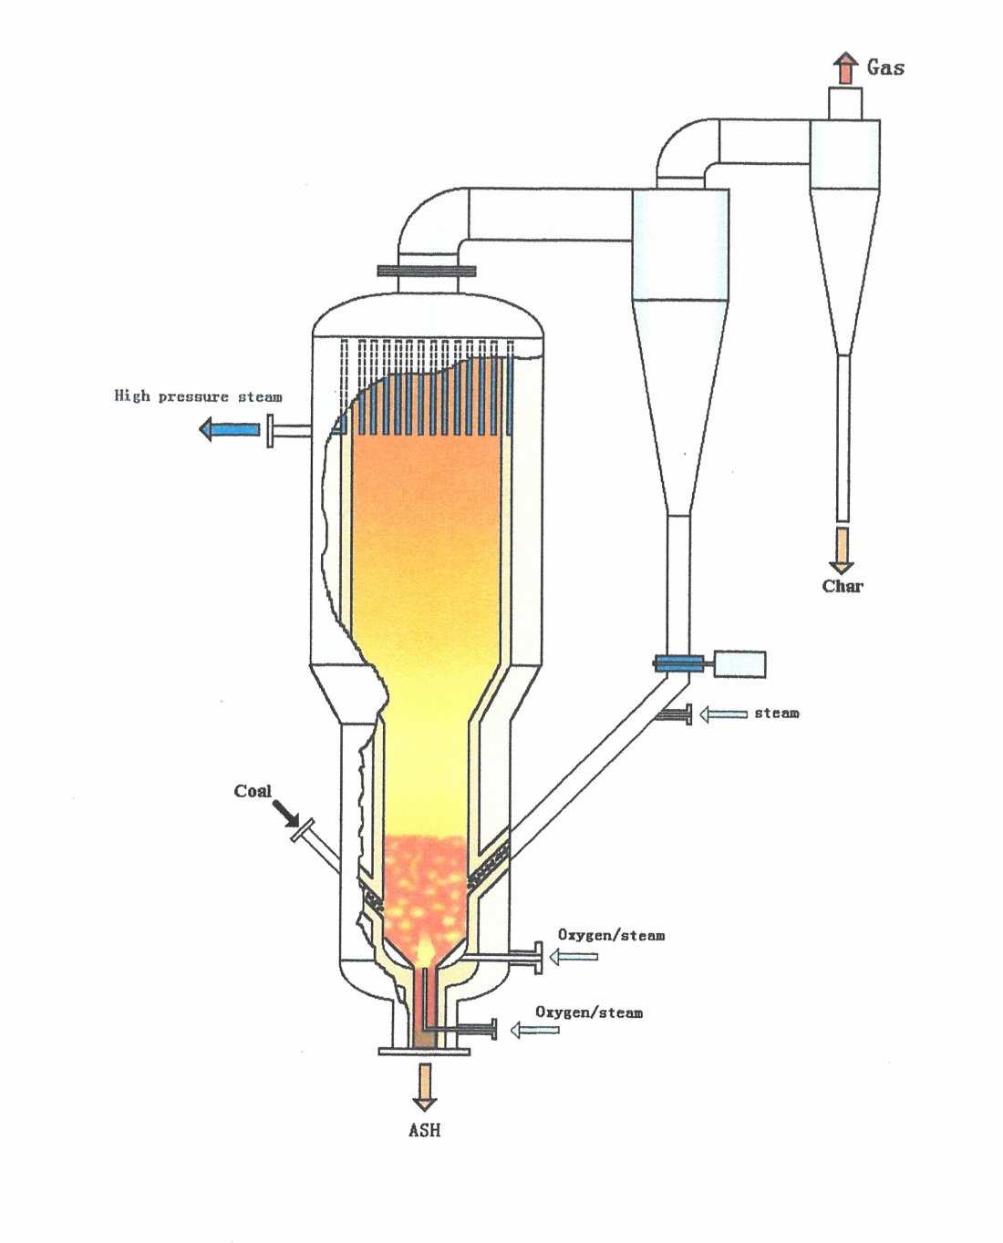

Figure 22. Schematic Illustration of the AFB Gasifier

Table 12. Projects with Pressurized, Agglomerated Fluidized Bed (AFB) Gasifiers

Figure 23. Project Location of AFB

REFERENCES
- Institute of Coal Chemistry; http://www.sxicc.cas.cn/kycg/gkis/ and http://english.sxicc.cas.cn/au/bi
- Ma, Linwei, “WP2 – Future Energy Technology Perspectives”, 2.2 Coal Technology Assessment, Tsinghua University, Beijing, PRC 2009
- Report on Applying Coal Gasification Technology in China’s Coal Chemistry Industry, UNESCO’S University-Science Partnership (UNISPAR) Project, Center for Environmental and Education and Communication (CEEC), UNESCO Office, Beijing, PRC, 2008
- Wang, Xi, Liu, Xiaodong, “Investigation Report on MTG (Methanol-to-Gasoline) Project of Shanxi Jincheng, Anthracite Mining Group”, National Institute for Occupational Safety (NIOS) Clean Coal Information Institute (CCII), February 26, 2009
- Cai, Ningsheng, “Development of Coal Gasification & Polygeneration in China”, Department of Thermal Engineering, Tsinghua University, IEA – MOST Workshop on Fossil Fuel Technologies, Beijing, PRC, June 11, 2010.

2.B.4 Northwest Research Institute (MCSG)
Gasifier / Gasification Technology: The Multi-Component Slurry Reactor (MCSG)
Technology Owner and / or Licensor: The Northwest Research Institute of Chemical Industry / Institute of Coal Gasification

Northwest Research Institute of Chemical Industry⁽¹⁾
The Northwest Research Institute of Chemical Industry (NWRICI) founded in 1967 is an institute under a former Ministry of Chemical Industry, a Shaanxi Provincial Hi-Tech Enterprise, a sponsor of Shaanxi Provincial Engineering and a Research Center for Coal Chemistry. With a research and development team of over 300 researchers, it supports studies in coal chemistry, catalysis (catalysts or sorbents) fine chemicals advanced materials, environmental protection and agrochemicals. The NWRICI encompasses eight institutes and centers, over thirty pilot or commercial plants and eight affiliated companies. The Institute also is the sponsor of, “Industrial Catalysis”, one of the State key periodicals for Science and Technology.
As a developer of Coal Gasification Technology, NWRICI has received R&D support in the National Sixth, Seventh, Eighth, and Ninth five year key technologies R&D programs as well as the Tenth and Eleventh National Five-Year Hi-Tech R&D Programs (863 Programs). The Institute participants in the Technology Development Program for State Key Research Institutes of the Ministry of Science and Technology, the developer of over twenty coal gasification and related technologies.

Institute of Coal Gasification
The Institute of Coal Gasification has been involved in Research and Development of Coal Gasification Technology for over forty years. Utilizing a full-scale, well equipped, coal testing laboratory, the most advanced of its kind in China, the Institute has tested over 1500 types of coal from China and abroad and specialized in R&D studies of fixed-bed, fluidized-bed, and stripped-bed gasification technologies with a focus on stripped-bed coal gasification technology. The processes commercialized or in the process of being commercialized include Coal-Water Slurry Gasification, Multi-Component Slurry Gasification (MCSG), and Dry Pulverized Coal Gasification Technologies, Bituminous Coal Gasification to make medium-caloric fuel gas, CO₂ reduction to make CO and continuous oxygen enriched gasification.

MULTI-COMPONENT SLURRY GASIFIER (MCSG) AND GASIFICATION
TECHNOLOGY
Background
The Northwest Research Institute of Chemical Industry, in the late 1970s, while in the process of investigating entrained-bed, pulverized coal gasification started to investigate and develop coal slurry gasification. In the mid-1980s, the First Design Institute of the Ministry of Chemical Industry designed a testing facility capable of processing 24 - 35 tons of coal per day and operate at 2.6 - 3.4 Mpa with slurry concentrations of 55, 60, and 65 percent and gasification temperatures of 1,350, 1,450, and 1,550 degrees centigrade.
During this same time period, it was determined that if China were to develop the coal chemicals industry, and produce chemical fertilizers in the amounts needed as well as to provide the necessary support to agriculture, it would be necessary to import gasifier technology. Of the most promising modern gasifiers of the time, the Lurgi and Texaco gasifiers were selected for further consideration.⁽²⁾. During the negotiations with the representatives of Texaco, the NWRICI obtained a license to the Texaco technology that permitted them to incorporate experimental data generated at their testing facility into the design of the Texaco Gasifiers. The gasifiers constructed according to these modified designs were subsequently operated in their commercial facilities. During the 1987-1996 time period, nine separate facilities were constructed with Texaco gasifiers (Table 13). These gasifiers were designed by several different organizations under the guidance of NWRICI. A general concept of these gasifiers has been reported⁽³⁾
“Six gasifiers with inside diameters of 2,800 mm, for operating pressures of 4.0 Mpa were built by Jinzhou Heavy-Duty Machinery Works for Lunan and Wujing. The capacity of these gasifiers is about 500 tons coal per day each. As Lunan’s gasification pressure was 2.8 Mpa, only about 350 tons of coal was treated per day per gasifier. Three gasifiers with inside diameters of 2,800 mm, for operating pressure of 6.5 Mpa were built by Haerbin Boiler Works for Weihe. The capacity of these gasifiers is about 820 tons coal per day each. Engineering has begun for nine gasifiers with inside diameters of 3,200 mm for operating pressure of 4.1 Mpa, which will be manufactured for Jinling, Dongting, and Hubei. The capacity of each of these gasifiers will be about 1,200 tons per day”.
The commercial operation of these facilities, in combination with the R&D data being generated at their test facility on coal slurry gasification has served as the data base for the design, construction, and operation of NWRICI’S commercial gasifier, the Multi-Component Slurry Gasifier (MCSG) and Gasification System.

The Technology
The gasification technology being licensed for commercial operation, i.e. e. the Multi-Component Slurry Gasification Technology shown in Figure 24, is a patented technology developed as the result of thirty years of research, development and commercialization efforts. The Technology has been put into commercial use in nearly thirty large-scale, coal-based methanol, ammonia, or coal-to-liquid plants capable of operating at different pressures and feed capacities with the capability also of processing a wide variety of feed stocks. Other advantages listed include lower investments costs, environmentally responsive operation, and proven performance.
Other performance characteristics include, but not limited to, are:
- Availability of bituminous brown coal fixed-bed gasification to make fuel gas or syngas
- Gasifier slurry preparation technologies utilizing coal, petroleum coke, asphalt, biomass, or various residues, waste liquids or water as the feed for a one-step, wet-grinding process to prepare gasification slurries
- Processes for the reduction of CO₂ to CO using CO₂ and O₂ as the gasification medium and coal as the feed
- Continuous fixed-bed gasification using steam, oxygen or oxygen-rich gas as the gasifying medium and coal (char) as the feed to make syngas
- Proprietary nozzle technology for slurry feed to entrained-bed gasifiers
- A database composed of data for nearly 1,500 sorts of coal that provides the basis for selection, testing, and evaluation of potential feed-stocks for coal based projects
As listed in Table 13, the MCSG is available in seven processing capacities that range from 500 – 1,800 tons per day.

The MCSG in China
A recent report identifies the location of 24 facilities that have at least one or more, planned or operating MCSGs and gasification systems. These projects, listed in Table 14 and shown in Figure 2, are located in 11 of the 30 Chinese Provinces. These facilities have the projected capability of producing 1,700 kt/yr ammonia, 6,900 kt/yr methanol, and 160 kt/yr coal-derived liquids.
The nine original facilities featuring Texaco gasifiers with some possible modifications made by the NWRICI are not included in Table 14 and it is unknown how many, if any, are still in operation.

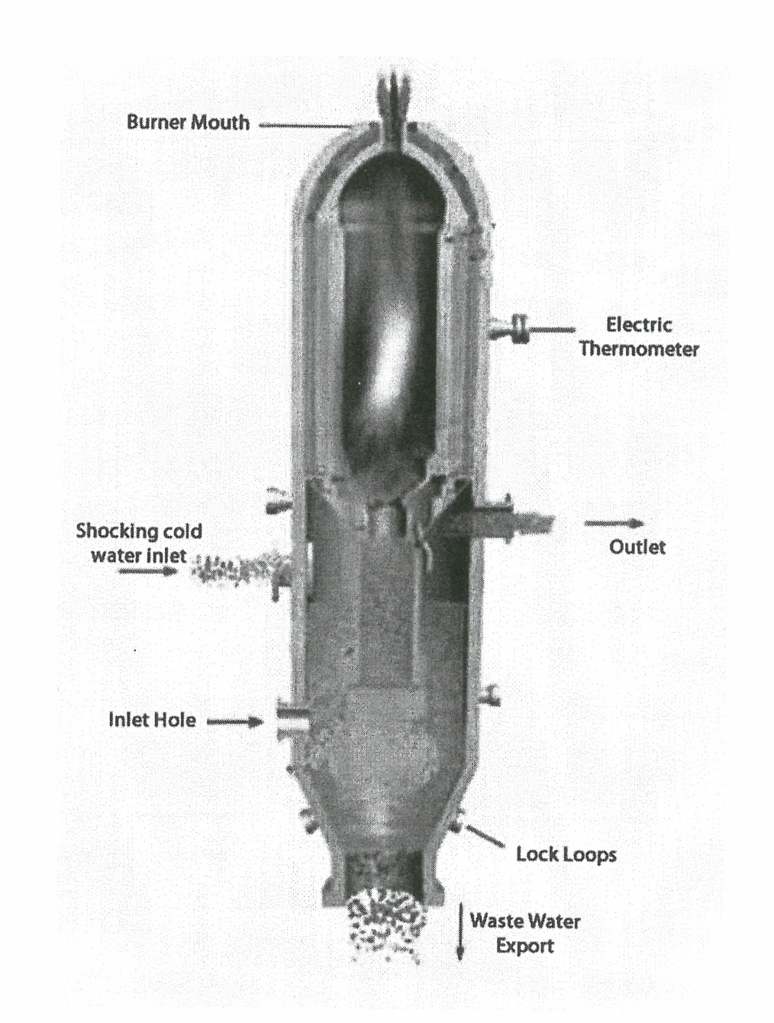

Figure 24. Schematic Illustration of MCSG Gasifier

Table 13. Multi-Capacity, Slurry Gasifiers (MCSG) – Available Capacities⁽¹⁾

Table 14. Projects with Multi-Component Slurry Gasifiers (MCSG)

Figure 25. Project Location of MCSG

REFERENCES
- “The Northwest Research Institute of Chemical Industry and the Institute of Coal Gasification”, http://www.nwrici.com/eng/q/hua.aspx
- INTEGRATED GASIFICATION COMBINED CYCLE TECHNOLOGY (IGCC), A Report Prepared Jointly by the U.S. Department of Energy, Office of Fossil Energy, Off\ice of Coal and Power Systems, Federal Energy Technology Center and the PRC State Science and Technology Commission, Chinese Academy of Sciences, Institute of Engineering Thermophysics, Peoples Republic of China
- Ibid

2.B.5 SiChuan Blue Star Machinery (WUG)
Gasifier / Gasification Technology: Watergas, Entrained-Bed, Dry-Feed, Gasifier (WUG)
Technology Owner and / or Licensor: SiChuan Blue Star Machinery, Co., Ltd

Sichuan Bluestar Machinery Co., Ltd
The Sichuan Blue Star Machinery Co. Ltd., an affiliate of the China National Chemical Equipment Corporation, is the largest pressure vessel manufacturer for Southwest China’s chemical industry. The company was founded in 1966 and is headquartered in Deyang, Sichuan Province. It’s two production facilities are in Deyang’s economic and technology development zone and Mazu, a part of the city of Shifang, both of which are in Sichuan Province. The Company is one of China’s key technical equipment enterprises and ranks among the top 500 largest industrial equipment manufacturing companies in China and top 50 manufacturers of oil refinery and chemical production equipment nationwide. The firm employees more than 1000 employees and has a registered capital of 269.16 million Yuan⁽¹⁾⁽²⁾.

China Wuhuan Engineering Co., Ltd.
China Wuhuan Engineering Co., Ltd., is an engineering, consulting, design, and contracting firm working with the Chemical, Petrochemical and Medical industries. In the 40 years since its founding, Wuhuan has achieved 28 items of National Patents and over 180 prizes accredited by State and Provincial levels which included the “Prilling Nozzle” that was awarded as the only National Golden Prize of the Chemical Industry in China⁽³⁾.

SICHUAN BLUESTAR WATERGAS GASIFIER (WHG)
Background
Sichuan Bluestar Machinery Co., Ltd., recently announced (August 7, 2012) that a commercial Watergas, Entrained Bed, Dry Pulverized Feed Gasifier (WHG) is now in the assembly stage in Henan Province. This is the first China production of its kind. It will become the Company’s independent intellectual property and is reported to be capable of replacing large imported gasifiers, preserve energy and cut emissions of the down-stream coal chemical industry as well as reducing operational costs and upgrading industrial technology⁽⁴⁾.
The WHG Gasifier was designed and developed by the China Wuhuan Engineering Co., Ltd. and it was manufactured by Sichuan Bluestar Machinery Co..

The Technology
The WHG gasification technology is considered by the developer to be a leading key generic technology that can be applied to all coal chemical projects. It has wide applications in the coal chemical (e.g. methanol), the coal based fuel industries, and the coal based power sector (e.g. integrated gasification combined cycle systems}.
The prototype gasifier, an entrained bed, pressurized system built by Sichuan Bluestar Machinery Co., in 2006, has been in development for six years. Its recorded operational capabilities include the production of syngas with CO plus H₂ component reaching 89 -91 percent, a carbon conversion rate reaching 99 percent, a cold gas efficiency reaching 78 -83 percent, an oxygen consumption rate of 300- 330 Nm³/Knm³ and a coal consumption of 512 Kg/Knm³ (CO plus H₂). The continuous running time of the demonstration unit exceeded 4000 hours with an annual running time above 8000 hours. It can be used for many types of coal and it is anticipated that through continued development it will also feature a zero discharge capability⁽⁴⁾.
The commercial gasifier, also built by the Sichuan Bluestar Machinery Co., Ltd., is equipped to accommodate a daily coal feed of 1,300 tons and can achieve a carbon conversion rate as high as 99 percent. Using a slag quenching technique it can process a wide variety of coal ash⁽⁵⁾.
The installation of the commercial unit is considered as being one step closer to achieving the Company’s WHG gasifier goal.

The WHG Gasifier in China
A single commercial version of the WHG gasifier currently is being constructed in Henan Province. Its approximate location is shown in Figure 1.

Table 15. Projects with Wuhuan Gasifiers (WHG)

Figure 26. Project Location of WUG

REFERENCES
- Bluestar Machinery Co., Ltd., http://cnce.chemchina.com/zhuangbeien/gywn/zzjg/webinfo/z
- http://www.sc-bluestar.com.cn
- Wuhuan Engineering Co., Ltd., http://www.cwcec.com/english/ht/news_view.asp?newsid=1
- “China Develops Its First Coal Pressurized Gasifier (WHG)”, http://www.chinaechgadget.com/china_develops-its-first-co
- Yang, Feiyue, “Industry Special: Homegrown Coal Tech Marks its New Milestone”, http://www.chinadaily.com.cn/cndy/2012-08/15/content_15676457.htm

2.B.6 Thermal Power Research Institute (TPRI)
Gasifier / Gasification Technology: The TPRI Gasifier, a Pressurized, Entrained Flow, Two-Stage Reactor
Technology Owner and / or Licensor: China HuaNeng Group (CHNG)

The Thermal Power Research Institute (TPRI)
The Thermal Power Research Institute (TPRI) is one of two technology Research and Development subsidiaries of the China Huaneng Group (CHNG). The Institute is a leading research organization in the field of thermal power engineering in China. Prior to the restructuring of the Chinese power sector in 2002, TPRI had been directly under the administration and actively involved in key R&D projects funded by a number of different Chinese Government Ministries. These Ministries included the National Development and Reform Commission (NDRC), the Ministry of Science and Technology (MOST), and the former State Power Corporation Commission of China (SPC).
Subsequent to the reorganization of the Chinese power sector, TPRI has been owned jointly by the five major independent power generation groups (i.e. China Huaneng Group (CHNG), China Huadian Corporation (CHD), China Power Investment Corporation (CPI), China Datang (Group) Corporation (CDT), China Guodian (Group) Corporation (GD)). Of these five power Companies CHNG, the largest independent power generation group in china, is the majority stockholder (52%) of TPRI. TPRI’s major R&D efforts were dedicated to thermal power generation technologies and equipment, mainly to thermal power plant operation, automation, and information management, clean power generation (e.g. ultra super critical and super critical generation technology), nuclear power generation, renewable power generation technologies and clean coal technology. The R&D effort in clean coal technologies includes:
- Integrated Coal Gasification Combined Cycle (IGCC)
- Natural Gas Combined Cycle (NGCC)
- Coal Gasification and Syngas Cleanup
- Hydrogen Production from Coal
- Fuel Cell and Hydrogen Turbines
- GreenGen Program
TPRI’s extensive experience acquired over a period of 50 years has been used to achieve significant improvements in the overall efficiency, reliability, and availability of fossil-fuel power plants in China. Its footprint can be found in almost all of the Chinese power plants and as the gasifier technology currently installed by the Huaneng Clean Energy Research Institute (HCERI) in the Chinese GreenGen Facility⁽¹⁾.

TPRI GASIFIER and GASIFICATION SYSTEMS
Background
As noted, TPRI has been active in the investigation and development of thermal power generation systems for at least 50 years. A substantial portion of that effort during the last 15 years has been research and development in coal gasification technology. A major focus of that activity has been the development of an entrained flow, dry feed, oxygen blown, slagging, two-stage, membrane wall gasifier. The gasifier has been designed also for pressure operation and various thru-put capacities. The major stages of the development process have been reported as⁽²⁾:
- The First Stage – Theoretical Research and Simulation (1993 ~ 1997)
- The Second Stage – Bench Scale Experiments in an Experimental System with a Maximum Feed Capacity of 0.7 tons/day (1997 ~2001)
- The Third Stage – Pilot Scale Experiments in a System with a Throughput Capacity of 36 tons/day (10Mw_{th}) (2001 ~ 2005)
- The Fourth Stage – Demonstration/Commercial Gasifier at a Feed Capacity of 2000 tons/day (2005 – present)
The Ministry of the Office of Science and Technology (MOST) has supported the gasifier R&D activity at the Pilot Scale and along with the China Huaneng Group (CHNG) has continued the support of technology development at the demonstration and currently at the commercial scale.
Other R&D programs performed by TPRI and funded by Most that have significantly contributed to the development of the two-stage gasifier and support systems include⁽²⁾:
- System integration and dynamic characteristics of IGCC
- Pressurized entrained flow gasification with dry feed
- Coal pyrolysis gasification and hot gas cleanup
- Development and demonstration of coal gasification (2000 t/d) with dry feed
- Operation and control technology of an IGCC cogeneration system
- Test and demonstration of a 250 Mw IGCC system

The Technology
The concept of the two-stage gasifier is illustrated in Figure 27 and described as⁽²⁾:
- Entrained flow
- Dry Feed
- Pure Oxygen
- Water Wall
- Pressure: ~ 4.0 MPa
- Two Stages Reaction
- Cold Syngas Efficiency >81%
- CO +H₂ > 90%
- Carbon Conversion > 99%
- Syngas Cooler and Quencher
In the operation of an entrained flow, dry feed, oxygen-blown, slagging gasifier system, 75-85 % of the design feed rate of coal, along with steam and oxygen, are injected into the first stage. The resulting exothermic reactions raise the internal temperature to 1500 degrees centigrade. The resulting heated mixed stream of solids and gases enters the second stage along with up to 25% of the design coal feed and steam initiating an endothermic reaction that generates the mixed gas stream exiting the second reaction chamber. In the TPRI gasification system, the hot gas stream leaving the second stage passes into and thru either a Syngas Cooler (SNG) or a Syngas Quench (SCG) System and into a following processing system being used for the production of fuels, chemicals, and/or power.
The advantages of the two-stage TPRI gasifier are reported to be⁽³⁾:
- High fuel flexibility – petcoke to lignite
- Low maintenance: Membrane wall – 20 years, Burners – 10 years
- Second stage fuel or quench reduces O₂ consumption
- Wide pressure range (0.5 – 4 MPa) provides operating flexibility
- Minimal gas recycle required for gas cooling
- Dry Feed: low O₂ consumption and high cold gas efficiency >83%

Current Status
The China Huaneng Group (CHNG) includes two research units, the Thermal Power Research Institute (TPRI) and the Huaneng Clean Energy Research Institute (HCERI). In the formation of HCERI, CHNG relocated two departments (i.e. CFB Boiler Dept. and the GreenGen Dept.) formerly in TPRI to HCERI effectively separating and assigning the responsibilities for the thermal power generating units to TPRI and the clean coal power generation and renewable generation technology to HCERI⁽⁴⁾. As a result the two-stage gasifier previously known as the TPRI reactor may also be referred to as the HCERI gasifier. CHNG also has given HCERI the responsibility for the Chinese GreenGen project.
Access (i.e. exclusive rights) to the gasification technology of CHNG has been acquired by EmberClear, Inc. of the United States. As a result EmberClear’s 270 Mw IGCC project located in Good Springs, Pennsylvania will utilize a 2000 t/d TPRI gasifier. The Project currently is scheduled to be on line in 2014⁽³⁾.

The TPRI Gasifier in China
In addition to the 2000 t/d TPRI gasifier installed in the GreenGen 250 Mw IGCC facility, and as summarized in Table 16, a 1000 t/d gasifier is being used in each of three projects for the production of methanol. In a fourth facility for the production of methanol, a TPRI gasifier with a capacity of 2800 t/d is being constructed. A recent report also introduces a CHNG Xinjiang project for the production of Substitute Natural Gas. The facility will use eight TPRI gasifiers each with 3300 tpd through put capacity. The general location for each of these projects is shown in Figure 28.
With the information currently available, projects with TPRI gasifiers and gasification systems operating and planned are, or will be, located in 5 of the 30 provinces of China. A current projection suggests that these projects will be utilizing 37,600 tons of coal per day to produce 2, 600 kt/y methanol, 400 kt/y olefins, 4.0 x 10⁹ M³/y SNG and 250 Mw IGCC power.

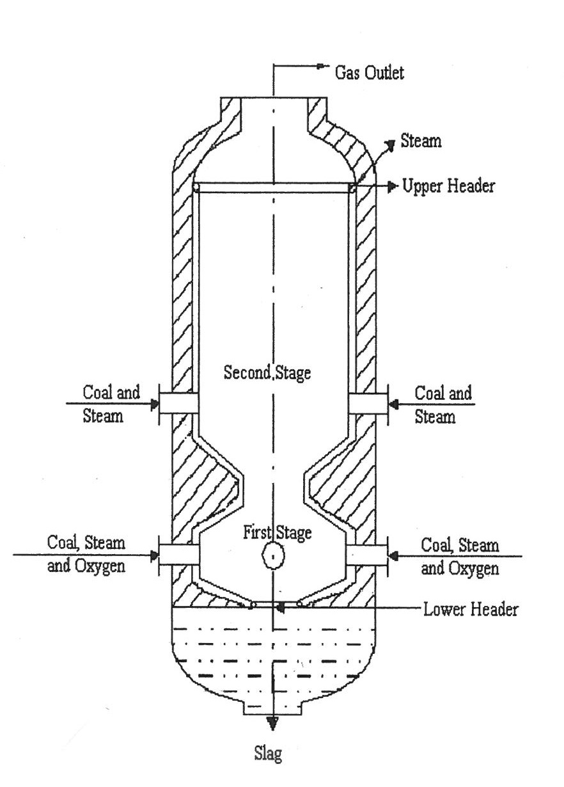

Figure 27. Schematic Illustration of TPRI Gasifier

Table 16. Projects with Two-Stage, Dry-Feed, Up-Flow (TPRI) Gasifiers

Figure 28. Project Location of TPRI

REFERENCES
- http://www.tpri.com.cn/eng/intro.htm
- Xu, Shisen, “Industrial Application of Two-Stage, Dry Pulverized, Coal Gasification Technology”, Huaneng Clean Energy Research Institute, November 2012
- Douglas, Bill, “TPRI Technologies and our Projects Update”, EmberClear, Inc., Gasification Technologies Conference, Washington D. C., October 31 – November 3, 2010.
- “GreenGen IGCC Demonstration Project of China Huaneng Group”. Huaneng Clean Energy Research Institute, October 2011

2.B.7 Tsinghua University (OSEG)
Gasifier / Gasification Technology: Oxygen-Staged, Entrained-Flow Reactor
Technology Owner and / or Licensor: Tsinghua University / Institute of Thermal Engineering

Tshinghua University⁽¹⁾⁽²⁾
Located in the Northwestern suburbs of Beijing, Peoples Republic of China, Tsinghua University was established in 1911 on the site of Qing Hua Yuan (Tsinghua Garden), a former royal garden of the Qing Dynasty. It functioned as a preparatory school called Tsinghua Xuetang (Tsinghua Imperial College) for those students who were to be sent by the government to study in the United States.
In 1925, Tsinghua College launched its four year undergraduate program. In 1929, its name was changed to “Guoli Tsinghua Daxue (National Tsinghua University)” and in the autumn of 1929, its graduate school was established. Tsinghua University became a multi-disciplinary polytechnic university specializing in training engineers in 1952.Since China opened up to the world in 1928, Tsinghua has become a leading university. At present the University has 14 schools and 56 departments with facilities in science, engineering, humanities, law, medicine, history, philosophy, economics, management, education and art.. The University has now over 25,000 students, including 13,100 undergraduates and 12,800 graduate students.

Institute of Thermal Engineering⁽³⁾
The Department of Thermal Engineering, one of the 56 Departments of the University, has, as organizational units, five Research Institutes. The Institute of Thermal Engineering, one of the five, is responsible for the following areas of research:
- Theory and practice of fluidized-bed combustion
- Theory and practice of pulverized coal
- Theory and practice of gasification of coal
- Pollution control in combustion
- Multi-phase flow and heat transfer
- Optimization of systems for utilization of heat
- Modern measurements in Thermal Power Engineering
As stated⁽³⁾ , the Institute of Thermal Engineering is paying: “great attention to the requirements in the field of thermal power, and put their efforts on the most important developmental of technologies in China and in the world. Therefore, they put their efforts in the development of new technology in coal combustion.
The Scientific and Technical research and projects at Tsinghua University are mostly supported by the special projects and funds of the National Science and Technology Programs. These programs provide, for the University, over 1,500 million Yuan for more than 1000 projects every year. With a prospective increase in State investment in Science and technology research, Tsinghua University expects to receive additional financial support for the State.

THE OXYGEN STAGED ENTRAINED FLOW GASIFIER
AND GASIFICATION TECHNOLOGY
Background
The Oxygen Staged Entrained Flow Gasifier is a product of the research and development work performed by the experts in the field of Thermal Engineering within Tsinghua University’s Institute of Thermal Engineering.
In the late 80’s, early 90’s, the Institute’s Research and Developmental efforts included work on coal technology and a recent report⁽⁴⁾ supports the belief that this effort included research, development, demonstration and commercialization of gasifier/gasification technology. The effort was supported by the National 863 Program (i.e. the National High-Tech Research and Development Program of China).
By 2003, a two-stage, entrained-flow, gasifier had been developed and the Shanxi Fengxi Fertilizer Group had constructed two industrial producing facilities using the gasifier with a feed stock input for each facility of 500 t/d. A second, follow-on, phase in the development of the Oxygen-Staged, Entrained Flow Gasifier was initiated in 2005. The Research and Development activity focused on utilization of coal-water slurry feedstocks and water cooling wall technology. The resulting 2nd generation gasifier was put into operation, again in Fengxi, in August 2011.
Both types of Gasifiers, (i.e. First Generation available since 2003, Second Generation available in 2011) have been commercialized.

Technology
The concept of the Oxygen –Staged, Entrained- Flow Gasifier is shown in Figure 29⁽⁵⁾. As reported recently^{(1),(2)} , the coal gasification process as performed in the current version of the reactor features five instead of the earlier three stages. These include:
- First Stage: removal of moisture and volatile matter
- Second Stage: combustion
- Third Stage: Gasification
- Fourth Stage: Re-Burning
- Fifth and Last Stage: Re-Gasification
The staged introduction of oxygen into the gasifier is reported to improve the working condition of the main burner, the axial temperature and the temperature field as well as coal adaptability.
The impact of these variables, as well as many others, with the potential to have significant impact on the performance of the gasifier have been examined in “A Dynamic Modeling Effort for an Oxygen-Staged, Slagging, Entrained-Flow ,Gasifier⁽⁶⁾ . The Abstract of the study states, in part:
“A dynamic gasifier model including slag flow behavior simulation was established to simulate a new type of oxygen-staged gasifier recently developed in China……two types of oxygen-staged gasifiers were simulated: the refractory wall gasifier and the membrane wall gasifier…..The temperature distribution simulation results also showed that staged oxygen feeding can reduce the temperature near the main burner significantly, therefore extending the lifetime of the burner compared with one without staged oxygen feed.
Further insights into the gasification technology and the gasifier’s operational characteristics are available through a detailed review of the analysis.
The Second Generation utilizing a coal slurry feed and water cooling wall is reported⁽⁷⁾ to offer a number of significant advantages. These include:
- Increased flexibility in coal feed-stocks – The gasification temperature is not limited by the refractory materials, and that temperature could reach 1500 ºC or even higher. It introduces the advantages of high speed of gasification reaction, high rate of carbon conversion, and the ability to absorb coal of high ash content, high ash melting point and high sulfur.
- Operational Stability – The coal-water slurry gasifier avoids the problems of instability of coal-power feeding, (e.g. flammable or explosive conditions).
- Reduced Environmental footprint and higher efficiency operation – The high temperature operation reduces carbon content in the slag which is easily collected and treated and the waste-water is easy to treat leading to zero effluent operation.
- High pressure gasification – Operation at high pressure is not affected by the material handling systems. It could reduce the energy consumption in the synthesis and compression of methanol.
- Reduced capital costs – The process of manufacturing is entirely domestic thus saving 30% to 50% in costs when compared to other gasification technology and the gasifier provides a new option in technology selection for large coal chemical industry enterprises

Current Status
Tsinghua University, to date, has been successful at placing into commercial operation two generations of the Oxygen-Staged, Entrained-Flow gasifiers. As listed in Table 17, six facilities utilize the first generation gasifier and seven facilities (Table 18) have or will utilize the second generation unit. In each case, the gasifier was initially placed in operation by the Fengxi Fertilizer Group, Linyl Branch in Yunching, Shanxi Province . The general location of each of the projects using the First Generation Oxygen-Staged Entrained, Gasifier is shown in Figure 30 and the general location of the projects using the Second Generation System is shown in Figure 31.

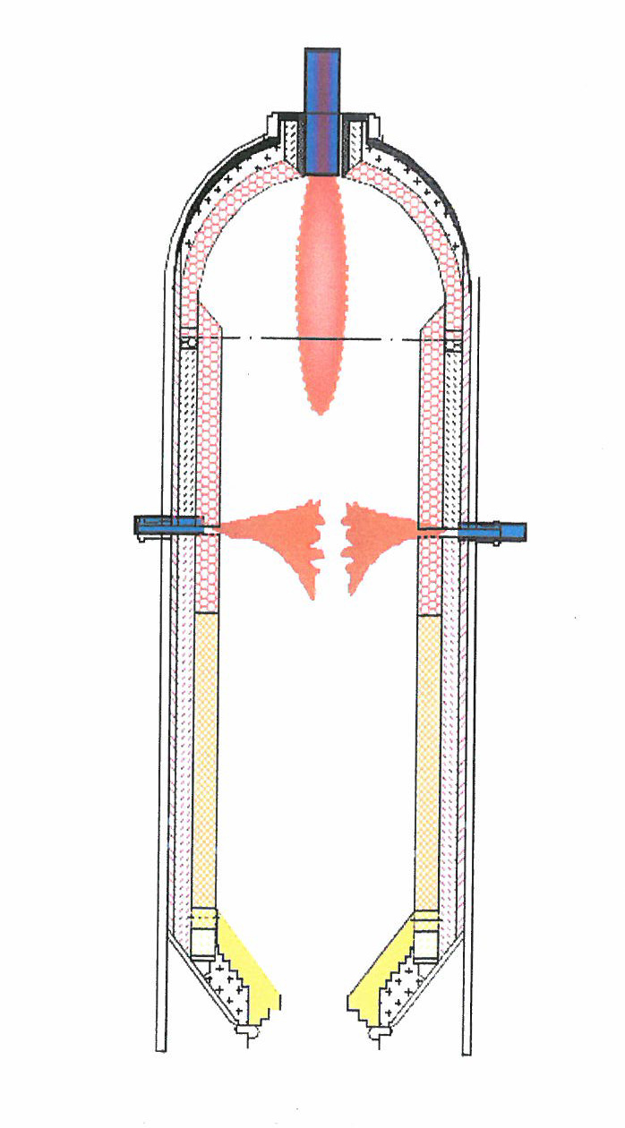

Figure 29. Schematic Illustration of OSEF Gasifier

Table 17. Projects with Oxygen-Staged Entrained-Flow (OSTF) Gasifiers

Table 18. Projects with Coal-Water Slurry and Water Cooling Wall Gasifiers

Figure 30. Project Location of Tsinghua First Generation

Figure 31. Project Location of Tsinghua Second Generation
REFERENCES
- http://www.tsinghua.edu.cn/publish/then/5781/index.html

- http://www.tsinghua.edu.cn/publish/then/5779/index.html

- http://www.tsinghua.edu.cn/publish/teen/2481/index.html

- Ma, Linwei, WP2 Future Energy Technology Perspectives: A NZEC Report By Tsinghua – BP Clean Energy Research & Education Center, Tsinghua, University

- Cai, Ningsheng, “Development of Coal Gasification & Polygeneration in China” IEA – Most Workshop on Fossil Fuel Technologies, Beijing, PRC, 2010-6-11

- Yang, Zhiwei, Zhe, Wang, Yuxin Wu, Jihong Wang, Juntu Lu, Zhang Li, and Weidou Ni, “A Dynamic Model for an Oxygen-Staged Slagging Entrained-Flow Gasifier”, State Key Lab of Power Systems, Department of Thermal Engineering, Tsinghua University, Beijing, PRC, School of Engineering, University of Warwick Coventry, CV47AL, U. K. Energy Fuels, 2011, 25(8)

- http://ydgd.yingdegas.com/chinese/product/product1-01.asp

SUMMARY

A review of the Chinese Coal Utilization activity established that currently eight International and seven Chinese licensors of coal gasification/gasifier technology have successfully commercialized their systems in China. These Licensors along with their respective technologies are listed in Table 19. The data collected in the study, to date, indicate that collectively these 14 Licensors are operating or planning to operate their coal utilization/gasification technologies in over 180 projects widely distributed among 28 of the 30 Chinese provinces. Of these projects, it appears that International technology is or will be used in 78 (i.e. 43%) and Chinese technology will be used in 103 (i.e.57%) of the total 180 projects. Further examination of these data indicate that of these projects, two International Licensors (i.e. Shell Global Solutions International and General Electric) and two Chinese Licensors (i.e. East China University of Science and Technology and Northwest Research Institute/Institute of Coal Chemistry) will, collectively, have their technology in 110 (i.e. 61%) of the Projects.
During the study, numerous references confirmed that a comprehensive research and development program in coal chemistry and conversion continues within China. This effort could result in the development of new gasifiers and advanced coal conversion systems. In a parallel activity, the Chinese Coal Community continues its efforts to acquire and utilize additional coal gasification technology available from the international community.
In most cases, the identification of a coal conversion/utilization project also included an identification of its existing or planned location, the technology being used, the Licensor, and some characteristics of the project (gasifier type and expected products). While this information has been presented in earlier sections of the report, some general correlations of the project data with the coal resource (i.e. coal type, amount, location, etc.) information may permit some assessment of the impact of the technology on the industry and the country.
As shown in Table 22, the estimated coal reserves of China are grouped(1) by type (i.e. brown, bituminous, gas, rich, coking, lean, meager, and anthracite) and amount as located within one of six Coal Planning Regions (i.e. North, Northeast, East, South Central, Southwest, and Northwest). Further clarification of this relationship between Planning Region and Province is provided in Figure 32. The total number of coal conversion/utilization projects located in each Planning Region is shown in Table 20. The distribution of projects among the gasifier/gasification Licensors that are included in the total number of projects also is given.
Further correlation of the individual provinces within the Coal Planning Regions and the individual coal conversion/utilization projects is given in Table 21. These data support a number of observations:
• Three of the 30 provinces (i.e. Fujian, Hainan, Tibet) do not have a coal conversion/utilization project within their respective boundaries
• Consistent with the data illustrating that of the 30 provinces (i.e. Fujian with 2.56 Gt, Hainan with 0.00 Gt, Tibet with 0.081 Gt) that have little if any coal reserves do not have any coal conversion/utilization projects
• Two of the Coal Planning Regions (i.e. North and East) together have 101 (i.e.56%) of the 180 coal conversion projects
• Eighty Four percent (i.e. 156) of the projects are located in four of the six Coal Planning Regions (i.e. North, East, South Central, Northwest).

Table 19. Summary list of Chinese and International Gasifier Being Commercialized in China

Table 20. Distribution of Gasification Projects to Coal Planning Regions

Table 21. Distribution of Projects to Provinces

Table 22. Estimated Coal Resource by Province and Type (Gt)

Figure 32. Grouping of Provinces into Coal Planning Regions

