Contents

Full Proposal Submission 2

FWP and Budget Justification 2

Subrecipient Funding 3

Merit Review Criteria 4

Justice 40 4

Red Team 4

Project Schedule 5

Principal Investigator 6

Cover Page 6

# Full Proposal Submission

Q1.  While developing a template to produce a comprehensive proposal for this Research Call, the table lists everything that should be included in the table of contents and saved as a single PDF file under the following file name: “Full Application – Lab Name – PI – Topic Area Number”. The instructions for developing the R&D Community Benefits Plan states it must be submitted in PDF format using the following convention name for the title: “Control Number_LeadOrganization_CBP”. Should the CBP be included in the full application PDF or should it be submitted as a separate PDF along with the full application? If it should be submitted separately, how do we identify the control number?

A1. Please include the Community Benefits Plan in the Full Proposal single pdf file, under Section IX. The entire proposal should be saved as a single PDF file; however, it is acceptable to submit the CBP as a separate file in addition to the full proposal.

# FWP and Budget Justification

Q2. Does the Subrecipient have to provide a field work proposal (FWP) and a budget justification for this Research Call?

A2. No, the subrecipients do not have to provide an FWP or budget justification. This is only a requirement for the prime National Lab. The Budget Justification for the prime National Lab should clearly identify all subrecipient costs on the Contractual tab. The Project Narrative needs to clearly explain the roles of all participants, including any work to be performed by subrecipients.

Q3. Per the requirements on page 14:

The applicants shall prepare a Field Work Proposal and Detailed Budget Justification. See Attachment 1 – NL Field Work Proposal....

When downloading the document from the NETL website, the title of the "Attachment 1" document is "Attachment 2." Is the attachment on the NETL site the correct document?

A3. The Attachment filenames are correct: Attachment 1 is the Field Work Proposal (FWP) Template, Attachment 2 is the Detailed Budget Justification spreadsheet. The title of the FWP Template has been updated to correct the title. It is now Attachment 1.

Q4. For full responses to announcement number RC-40125b-2023, is the “Monthly Spending Profile” tab required to be filled out in the Detailed Budget Justification Attachment?

A4. Yes, the Monthly Spending Profile should be completed on the Detailed Budget Justification.

Q5. The Budget Justification excel workbook has an error.  The Summary Tab under d. Contractual does not have a row for FFRDC so the Total Contractual row does not add up.  We are able to insert a row for FFRDC so will do so as well as insert the correct formula to pull the FFRDC information from the Contractual Tab.

A5. Yes, you are correct the Summary Tab of the Detailed Budget Justification inadvertently excluded FFRDC as a cost input under category “d. Contractual”. Please update the Summary Tab to insert FFRDC costs, if applicable, and ensure the “Total Contractual” cost on the Summary Tab matches the Contractual Tab.

Q6.  Do you want the Budget Justification also pdf in the full application file?  OR do you want the budget justification attached to our submittal email separately?

A6. Please include the Detailed Budget Justification in the single Full Application PDF file.

Q7. The budget justification workbook does not have a tab for Indirect Costs. Where should we capture them on the file?

A7. Please capture the indirect costs under the "Other Costs" category.

# Subrecipient Funding

Q8. Our proposal will include multiple DOE FFRDC labs. Will each DOE lab be funded directly via the W.A.S? If so, is a standard 2-page work proposal (per DOE O 412.1A) required for each DOE lab in addition to the FWP template listed in the requirements?

A8. No, the prime recipient will be responsible for funding and managing all sub-awardees.

Q9. Is it possible to have CESER directly fund partner companies rather than the funding flow through the National Laboratories to partners?

A9. No, the prime recipient will be responsible for funding and managing all sub-awardees.

Q10. I would like to clarify an answer to a question listed in the attached Q&A from this call.

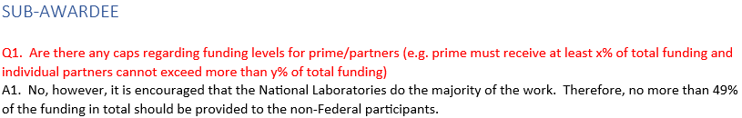

Does this mean that the 49% limitation for non-Federal participants is regarding the type of entity listed as a subrecipient in the call that would receive Federal funds from an award as opposed to the type of funding that would be provided (Federal to be awarded to the lead/subrecipients of the lead and non-Federal meaning Cost Share)?

Example, the total funding of the National Lab (as lead or combination of National Lab as lead plus any National Labs as sub) needs to be 51% of the total funding with total funding including the National Lab funding plus all subrecipients receiving Federal funding plus Cost Share.  Is this correct?

A10. It is encouraged, not required, that most of the federal funding should be allocated to the National Laboratory/Laboratories under the award. Please note that there is no Cost Share requirement for this Research Call.

# Merit Review Criteria

Q11. Is the merit review criterion discussion part of the 25-page limit within the project narrative? Is it possible to incorporate the review criterion into project narrative pieces or does merit review criterion need to be addressed separately within the project narrative under a heading of merit review discussion topic discussion with each review topic specifically called out/addressed?

A11. Yes, the merit review criteria discussion is included in the 25-page limit for the project narrative. Please address the merit review criteria separately within the project narrative.

# Justice 40

Q12. Is meeting the Justice 40 target a requirement for this proposal, or rather a suggestion? If yes, what budget justification is required to show that Justice 40 target will be met?

A12. Yes, the Justice 40 section is required to be included in the R&D Community Benefits Plan. The Justice 40 section requirement is being evaluated under Criterion 5. It is up to the applicant to describe how the Justice 40 objective will be achieved.

# Red Team

Q13. I had a clarification question regarding the requirement to include an "independent third party to red team test the developed solution to evaluate the developed tool or technology for vulnerabilities and threat vectors."   Can you clarify what you mean by “independent third party”?  Would any/all of the interpretations below apply:

* An internal Red Team within the same DOE-FFRDC that is submitting the proposal (they would not be involved with the proposed work outside of the Red Team)?
* Another FFRDC (outside of the proposing entity)?
* A commercial entity?

Secondly, does this requirement mean that the red team's scope of work would entail only the final product/technology validation for vulnerabilities prior to release, or would they need to be involved in validating the fundamental solution itself?

A13. The independent third party used to red team test must not involve anyone from the project development team or otherwise have knowledge of what the team is working on. The three scenarios you list would be suitable red teams, if independent of the development team.

Per the General Requirements of the Research Call (pg. 6), the purpose of the red team is to evaluate the developed solution for vulnerabilities and threat vectors. The red team should analyze the fully developed solution, but this is expected to occur before project demonstration.

# Project Schedule

Q14. For the project schedule as required in the FWP:

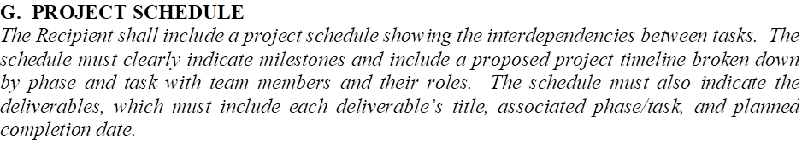

The FWP is required to have a list of

* Deliverables
* Milestones

As stated above in the Project Schedule description, do you also want them repeated in the project schedule?

A14. Yes, the Project Schedule should show the Deliverables and Milestones. The emphasis with the schedule is to depict the timeline relationship between the project phases and tasks and each Deliverable or Milestone.

# Principal Investigator

Q15. Is it allowed to make a change in the lead PI for a submission to this call?

A15. Yes, but please provide a brief explanation to support the change from the PI listed in the Concept Paper that was approved.

# Cover Page

Q16. Can a cover page be included and would it be counted toward the 25 page limit?

A16. If a cover page is included in the full application, it will not be counted towards the 25-page limit.