Please fill in the name of the event you are preparing this manuscript for. | 2019 SPE Western Regional Meeting
Please fill in your 6-digit SPE manuscript number. | SPE-195257-MS
Please fill in your manuscript title. | First Ever Polymer Flood Field Pilot - A Game Changer to Enhance the Recovery of Heavy Oils on Alaska’s North Slope
Please fill in your author name(s) and company affiliation.
Given Name | Surname | Company
Abhijit | Dandekar | University of Alaska Fairbanks
Baojun | Bai | Missouri University of Science and Technology
John | Barnes | Hilcorp Alaska LLC
Dave | Cercone | DOE-National Energy Technology Laboratory
Jared | Ciferno | DOE-National Energy Technology Laboratory
Samson | Ning | Reservoir Experts, LLC/Hilcorp Alaska, LLC
Randy | Seright | New Mexico Institute of Mining and Technology
Brent | Sheets | University of Alaska Fairbanks
Dongmei | Wang | University of North Dakota
Yin | Zhang | University of Alaska Fairbanks

This template is provided to give authors a basic shell for preparing your manuscript for submittal to an SPE meeting or event. Styles have been included (Head1, Head2, Para, FigCaption, etc) to give you an idea of how your finalized paper will look before it is published by SPE. All manuscripts submitted to SPE will be extracted from this template and tagged into an XML format; SPE’s standardized styles and fonts will be used when laying out the final manuscript. Links will be added to your manuscript for references, tables, and equations. Figures and tables should be placed directly after the first paragraph they are mentioned in. The technical content of your paper WILL NOT be changed. Please start your manuscript below.

Abstract
The development pace of Alaska’s vast, 20-25 billion barrels, heavy oil resources has been very slow due to high development costs and low oil recovery using conventional waterflood, and the impracticality of deploying thermal methods due to the presence of continuous permafrost. Although, polymer flooding has attracted attention and has become a promising EOR technique in heavy oil reservoirs due to the extensive application of horizontal wells and advancement of polymer flooding technology, no field tests have been performed to date in Alaska’s underdeveloped heavy oil reservoirs. The overall objective of this research is to perform a field experiment to validate the use of polymer flooding for extracting heavy oil in Alaska’s challenging environment.
Two pre-existing pairs of horizontal injection and production wells in an isolated fault block of the Schrader Bluff heavy oil reservoir at the Milne Point Field are currently being used for the field experiment. Hydrolyzed polyacrylamide (HPAM) polymer injection started on August 28, 2018 at 600 ppm (4 cP viscosity) concentration ramping up to 1,800 ppm (45 cP viscosity) over a three week time period, and has been maintained at an average concentration of ~1,800 ppm. Current injection rates in the two horizontal injectors are ~2,200 and 600 bwpd. Laboratory experiments to determine the polymer retention, optimum water salinity, synergistic effects of water salinity and polymer, and handling of produced fluids, in support of the field experiment, are currently ongoing. Similarly, reservoir simulation of coreflood behavior and history match of previous waterfloods to predict polymer flood performance in the project area are also conducted in parallel.
The field data and scientific knowledge that have been collected since the start of the injection indicates that the field pilot is performing as predicted. To date, no unexpected injectivity issues or polymer breakthrough have been encountered, and the two horizontal producers are showing positive response to the polymer injection, resulting in incremental increase in oil production rate. Since the research is still in its early stages, selected field, laboratory and simulation results are presented and discussed to highlight the integrative approach adopted in this first ever polymer flood field pilot in Alaska.

Introduction
Alaska North Slope (ANS) contains vast resources of heavy oils, primarily concentrated in West Sak (also called Schrader Bluff) and Ugnu reservoirs. There are currently six fields producing heavy oil in Alaska: Orion, Polaris, Milne Point, Tabasco, Kuparuk, and Nikaitchuq. General delineation of these pools is indicated in Figure 1. Tabasco is a Kuparuk River Unit Satellite, and the Ugnu formation overlies the West Sak (Schrader Bluff) formation across the North Slope fields.

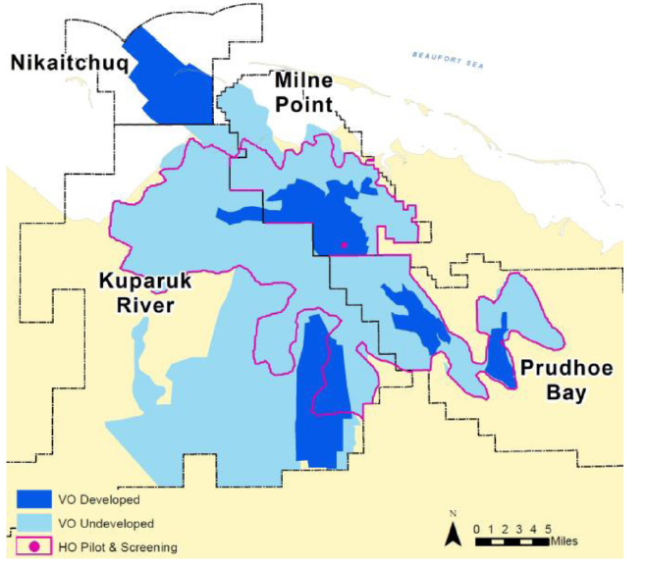
BEAUFORT SEA

Figure 1: Alaska’s viscous oil and heavy oil reserves (Paskvan et. al. 2016).

Figure 2 below shows the cross-section of various heavy oil formations in this heavy oil belt on ANS. The estimated total oil in place within these reservoirs amounts to about 20-25 billion barrels, with about two-thirds of the heavy oil lying under the Kuparuk River Unit (Targac et al. 2005). The ANS oil viscosity vs. depth profile delineated in Figure 3 shows that at present, oils from “West Sak-Schrader Bluff” formation are being developed.

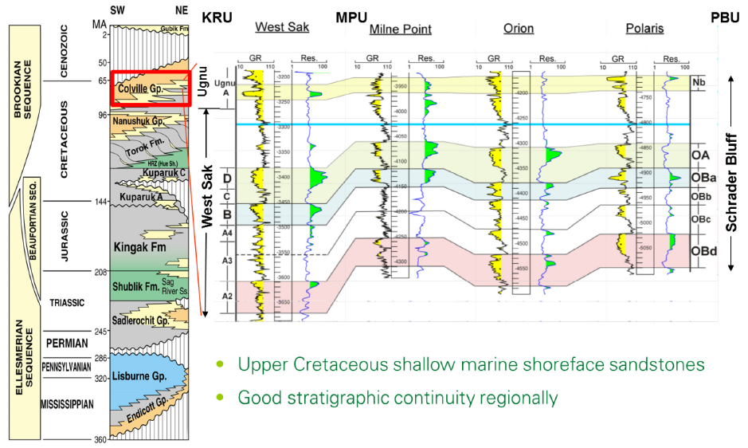

Figure 2: Schrader Bluff reservoir with multiple commercial horizons (Paskvan et. al. 2016).

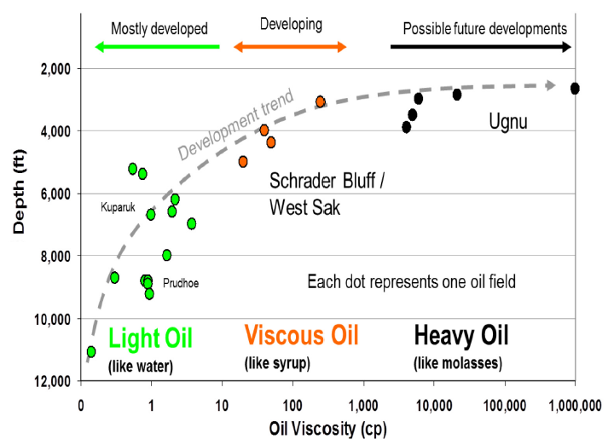

Figure 3: Viscosity of various ANS oils vs. depth and their development trend (Paskvan et. al. 2016).

Despite the fact that viscous and heavy oil represent about a third of known ANS original oil in place (OOIP), the development pace has been very slow, with cumulative production contributing only 1% of the OOIP slope wide. High development costs, significant logistical and environmental challenges, and low oil recovery using conventional techniques have been the major factors for under-development of these vast resources. As seen from Figure 3, an oil viscosity of 100 – 300 cP in the West Sak-Schrader Bluff area vs. water viscosity of 1 cP means a significant mobility contrast and thus a poor volumetric sweep efficiency for waterflood. Although thermal methods and gas injection are common techniques to enhance heavy oil recovery and have been successfully applied in many parts of the world, they are not readily applicable on ANS for multiple reasons. Thermal recovery methods, such as steam injection, are impractical on ANS because of the high cost and most important concerns of thawing the nearly 2,000 ft of continuous permafrost, which could cause disastrous environmental damage. Note that the viscous and heavy oils lie in close proximity to the permafrost. In miscible flooding processes, the minimum miscibility pressure (MMP) between the heavy oil and solvent (hydrocarbon-based or CO₂) would be much higher than the reservoir pressure at these depths. Although there is limited application of immiscible enriched gas injection in the Schrader Bluff heavy oil reservoirs via the viscosity reduction water-alternating-gas (VRWAG) process (McGuire et. al., 2005), the expected incremental oil recovery is relatively small compared with a miscible process.
On a much broader level, there are a number of motivating factors that outweigh the development challenges mentioned above: (1) Decline of legacy ANS production, combined with recent growth of lower-48 production has reduced the contribution from Alaska to merely 5%; (2) Successful technology development is important to the State of Alaska economy as well as US national interests; (3) The resource base is too large to ignore, and is particularly attractive given that it lies within established production infrastructure on the ANS; and (4) Light crude is still available as a diluent for high viscosity oil transport through the Trans Alaska Pipeline System (TAPS). From a technology standpoint, preliminary laboratory and simulation studies indicated that polymer flooding has great potential to enhance oil recovery from the Schrader Bluff heavy oil reservoirs (Seright 2010, 2011), but yet to be tested and proven due to lack of any prior field tests. In fact, no large-scale polymer flood of a heavy oil and other unconventional resources has occurred to date in the entire United States, although it has been tested and implemented in other countries, such as Canada and China. Initial scoping studies suggest that successful implementation of polymer flooding could increase heavy oil recovery by 50% on ANS. Additionally, improvements in the quality of the polymer and positive synergistic effects of low salinity water (readily available on ANS) and the polymer increase the probability of success. Similarly, the existing pairs of horizontal injectors-producers in the Milne Point Unit offer a distinct advantage of available wells to conduct the polymer flood field test, thus eliminating the need to drill new wells.
Therefore, given the foregoing motivating factors, technical merit based on prior research and analogy, and a pre-existing favorable test site are conducive to test the efficacy of polymer flood on a field scale, representing a significant investment by the US Department of Energy and Hilcorp LLC. However, the uniqueness of every crude oil brine rock (COBR) system, logistics of polymer mixing in a remote arctic operating environment, and the sheer scale of injection at a field level, which in itself is not trivial, also means several unknowns and unresolved issues such as the type of polymer, concentration, polymer retention, injectivity, salinity of water for making the polymer solution, conformance control, and flow assurance. Herein lies the purpose of this research on which a team of multi-university experts and industry has collectively embarked on addressing the immediate technical challenges that pertain to the design and implementation of ANS’ first ever polymer field pilot. The subsequent sections in the manuscript logically lay out the various important elements and results of this joint research and conclude with the main findings to date.

Description of the Polymer Field Pilot Area and Test Wells
Figure 4 below provides the overall depiction of the project area, Milne Point Unit (MPU), which is nestled between the Prudhoe Bay Unit (PBU) and Kuparuk River Unit (KRU) respectively. The MPU is located about 30 miles to the Northwest of PBU and about 15 miles Northeast of KRU. Current working interest owners of MPU are 50% Hilcorp Alaska LLC, being the operator, and 50% BP Alaska Inc.
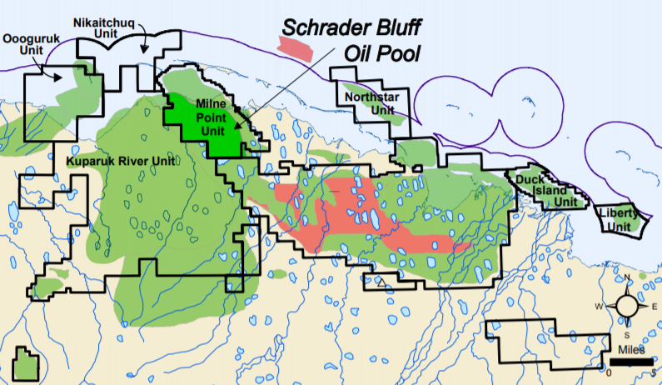
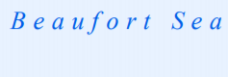
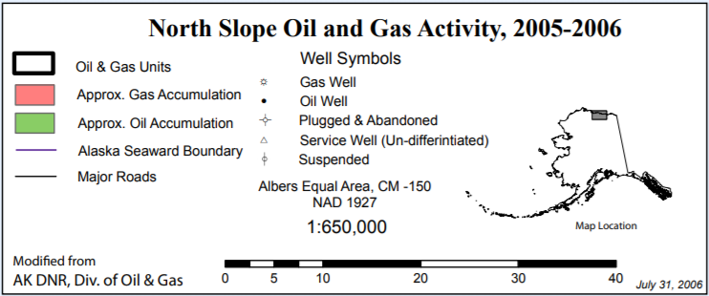
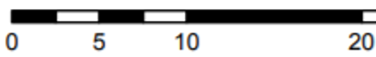
Project area
Miles
N
Project area
Miles
N
Prudhoe Bay Unit

Figure 4: Map of the project area for the polymer field pilot.

The pilot area contains two horizontal injectors and two horizontal producers drilled into the Schrader Bluff NB-sand at J-pad of MPU (Figure 5). Both well pairs are easily accessible in all seasons via an existing gravel road.
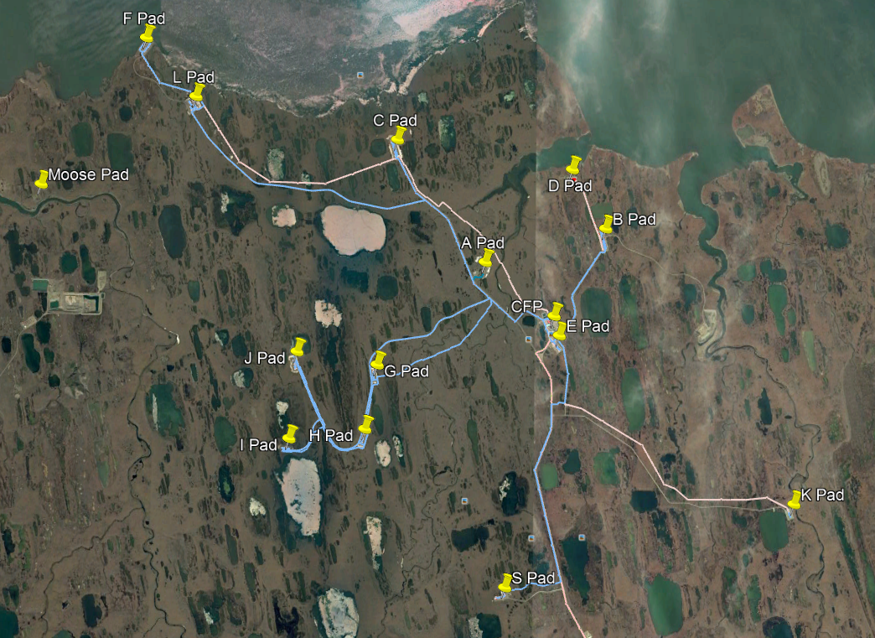
TEST SITE
5 miles
Milne Point Unit
Beaufort Sea

J Pad

Figure 5: Location of various pads, including the pilot area J-pad, at Milne Point.

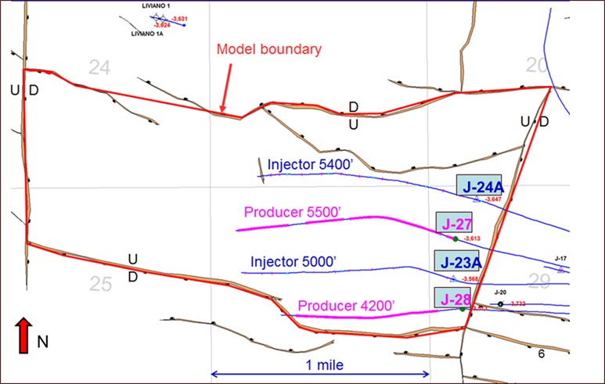
Figure 6 shows additional details of the horizontal injector-producer well patterns located in an (isolated) fault block in which the OOIP is 22 MMSTB. The lengths of the horizontal wellbores are from 4200 to 5500 feet and the inter-well distance is approximately 1500 feet. These wells have been used for waterflooding in which the OOIP is 13 MMSTB in the flood pattern, resulting in a recovery factor of only 7.6% after a cumulative water injection of 1.82 MMSTB and a water cut of 65%.

Figure 6: Polymer field pilot area boundary and injector-producer well patterns.

The reservoir characteristics in the pilot area are favorable in that they are amenable to polymer injection (pilot) with formation porosity and permeability in the range of 30-35%, and 100-3000 mD respectively, low reservoir temperature of 70ºF, oil API of ~15º and in-situ oil viscosity of ~300 cP. The oil is undersaturated.

Polymer Slicing Unit
The polymer mixing and pumping facilities named Polymer Slicing Unit (PSU) were custom designed and manufactured in Canada. As shown in Figure 7, the PSU consists of 5 modules, the pressure letdown module, the injection pump module, the polymer make-down module, the hopper and the utility module. Results from prior laboratory and simulation studies were used in the initial selection of the polymer (HPAM). The polymer, in powder form, is transported and stored in super sacks, each containing 750 kg (1650 lbm) of polymer. The super sacks are loaded onto the hopper with a forklift and the polymer is fed into the make-down unit below where it is mixed with water to make a mother solution. After 100 minutes hydration time in the tank, the mother solution is slipstreamed into the main water supply that feeds into the 3 triplex positive displacement injection pumps in the pumping unit, one for each injector plus a spare.

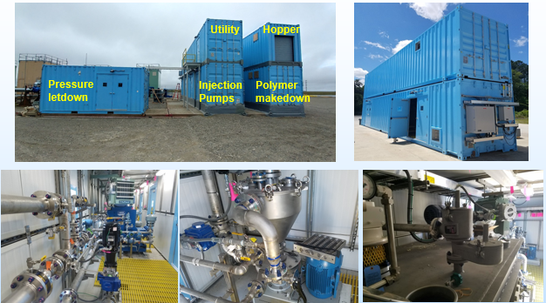
Figure 7: Polymer injection unit on the J-pad at Milne Point.

Prior to commencing the polymer injection, an injection profile log was obtained which confirmed that no thief zones are apparent, thus precluding the need for any profile control treatment.

Rock and Fluid Samples and Reservoir Data
Although no cores were cut while drilling in the project reservoir, cores have been taken in nearby areas throughout the development history. Two appraisal wells, Liviano and Pesado, were drilled on ice pads just north of the project area in 2007, while cores and fluid samples using MDT tools were collected from both wells throughout the Ugnu and Schrader Bluff Formations. Extensive routine and special core analyses as well as PVT analysis have been performed on these samples, which are used in the reservoir simulation model developed for this project. All laboratory corefloods are based on representative core material available in the form of plugs, whole core sections as well as loose sand. Additionally, sampling of dead oil, and produced water is undertaken as and when required in the laboratory corefloods and flow assurance experiments.

Results and Discussion
In the following sub-sections, selected results and their discussion is presented for the field pilot, laboratory corefloods, numerical reservoir simulation and flow assurance studies.

Implementation of Polymer Field Pilot
Since the end of August 2018 polymer injection has continued as planned, for the most part. However, two separate operational events (as might be expected in a field), in late September and November respectively caused interruptions in the injection. One was temporary shutdown due to the presence of more hydrocarbon gas found in the source water than expected, that required the modification and reclassification of the PSU to Class I Division II. The second was due to the injection pump repairs and shut-in for the Pressure Falloff (PFO) tests. Figure 8 below shows polymer solution viscosity and concentration profile vs. time in which the gaps indicate the stated events. In order to achieve a target viscosity of 45 cP, polymer concentration has varied between 1,600 to 1,800 ppm.

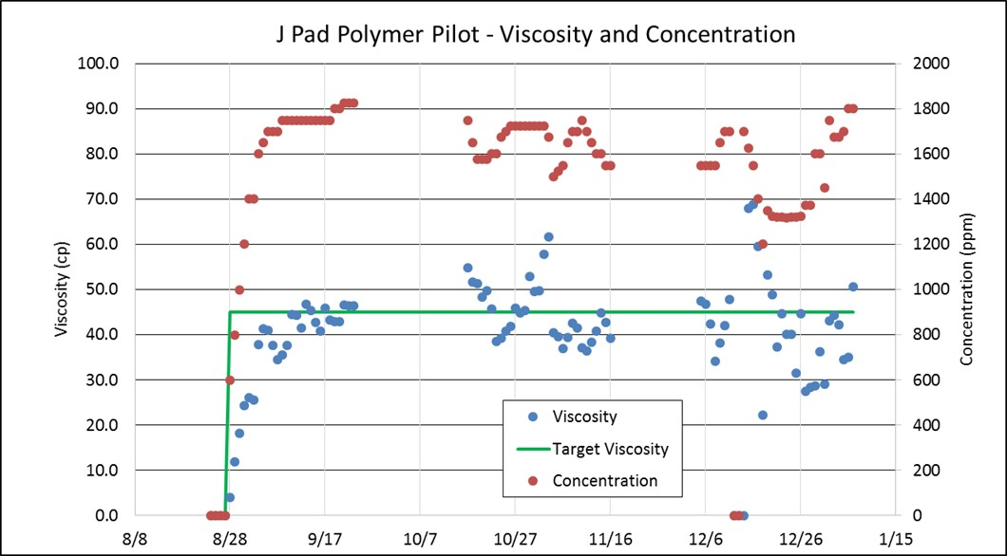
Figure 8: Polymer solution viscosity and concentration vs. time.

As mentioned earlier, polymer injectivity is always a matter of concern due to the high viscosity. Therefore, in order to assess the injectivity, a Hall plot (Hall, 1963) is prepared for both J-23A and J-24A using the data collected until the middle of January, 2019, which is shown in Figure 9. As seen in the plot, the injectivity of J-23A stayed constant (straight line) until a cumulative of 100 mbbl of polymer was injected, then started to increase slowly as evidenced by the slightly decreasing slope. However, the slope of the Hall plot for J-24A has been increasing since the polymer startup which indicates decreasing injectivity. By the middle of January 2019, approximately 110,000 and 54,000 lbm of polymer has been cumulatively injected into the target reservoir through the two injectors J-23A and J-24A, respectively.

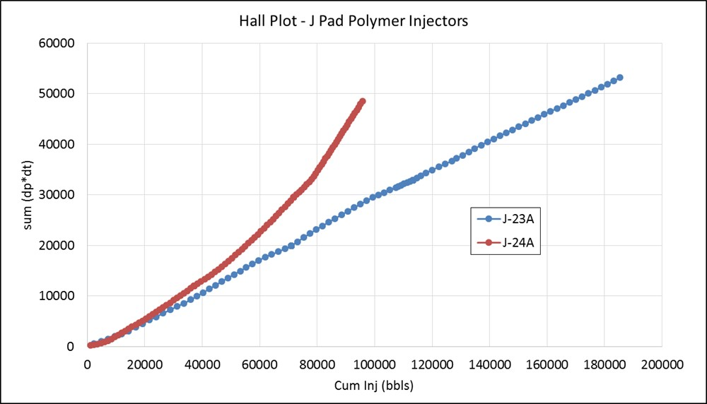
Figure 9: Hall plot of J-23A and J-24A injectors.

The pre and post polymer injection response of the two producers, namely J-27 and J-28, is depicted in Figures 10 and 11 respectively. While the responses of both producers are somewhat self-explanatory, it should be noted that J-27 is supported by two injectors, J-23A (South) and J-24A (North), whereas J-28, drilled close to a sealing fault to the south side, is supported by only one injector J-23A (North). The recent decrease in total liquid production rate was caused by the decline in reservoir pressure due to lower injection than the production voidage. The positive effect of polymer injection was reflected mainly by the decrease in water cut from ~65% to 40-45% in both producers. The oil rate increased by 200-300 barrels/day post polymer injection although the total liquid rate was trending down.
Finally, there is no indication of polymer presence in the producers to date, which has been confirmed via both the clay flocculation and nitrogen-fluorescence water composition analyses.

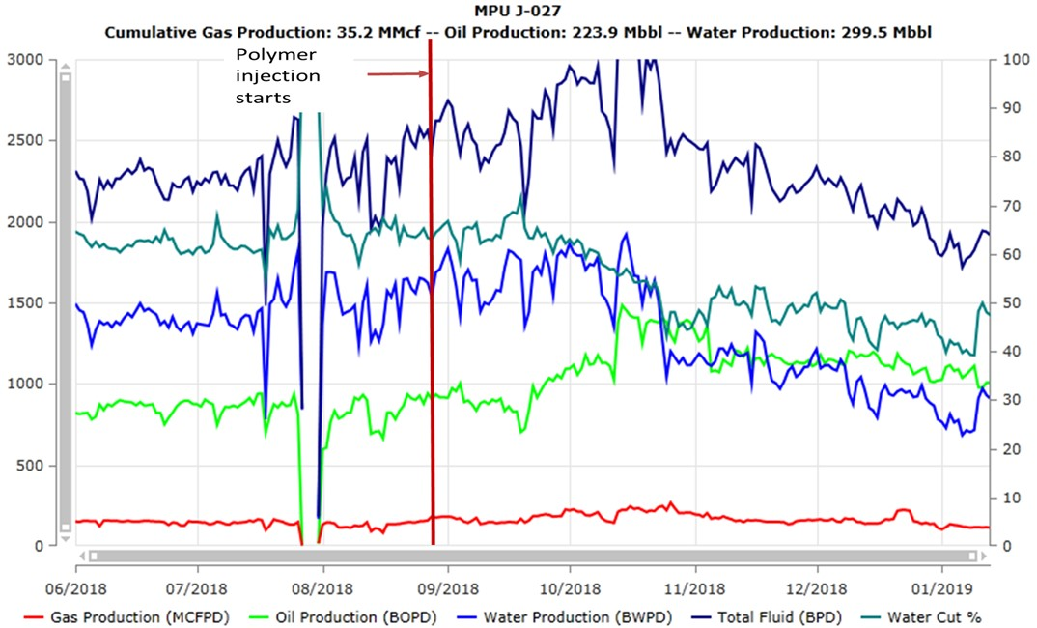

Figure 10: J-27 production performance.

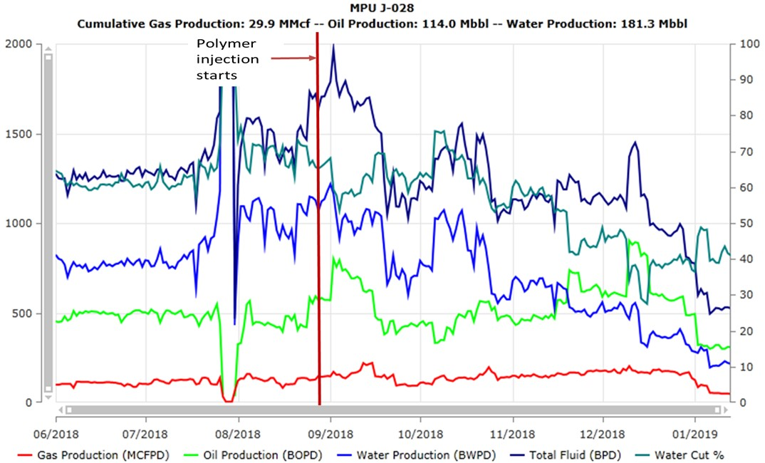

Figure 11: J-28 production performance.

Laboratory Corefloods
If polymer retention (i.e., adsorption and/or mechanical entrapment in the rock) is greater than 50 µg/g, polymer retention can be more important to the economics of the process than polymer concentration or bank size (see Manichand and Seright 2014). Therefore, in order to assess this for the subject set of rock and fluids and the polymer, five different retention experiments have been carried out so far. All these tests are on 6 – 11 Darcy sandpacks created from representative sand from MPU; the major difference is (original) oil coated vs. cleaned sand and the packing in a metal tube vs. plastic since iron influences retention values. Results from the first three tests using old native sand (stored for years without preservation) and freshly cleaned sand, using the conservative and perhaps more accurate nitrogen analysis method, yield polymer retention values in the range of 153 – 290 µg/g which are considered very high. Ongoing experimentation is focused on understanding the high retention and monitoring the polymer pilot that allows the determination of field-based polymer retention values. Our most recent two tests with cleaned reservoir sand and saturated with fresh oil yielded polymer retention values of only 28 µg/g—a much more palatable value.
Two different sandpacks using commercial sands were created to conduct displacement experiments with the following displacing fluids in a sequential mode; waterflood (WF) with synthetic formation brine (SFB), low salinity waterflood (LSWF), ultralow salinity waterflood (ULSWF); polymer flood (PF) and low salinity polymer flood (LSPF). Both sandpacks are 2.54cm diameter, 20.4cm long with porosities of 26% and 35.5% and absolute permeabilities of 207 and 655 mD. Prior to conducting corefloods using different displacing fluids, initial saturations (irreducible water and rest being ~300 cP dead oil from MPU) are established in the sandpacks and displacement experiments performed at ambient conditions (roughly the same as reservoir temperature) in a sequential mode. The salinities of the synthetic formation brine, low salinity water and ultra-low salinity water are 26,673, 4,945 and 495 ppm respectively. Both polymer solutions (concentration of 1,800 ppm) are prepared using the same polymer as used in the field pilot. These experiments are designed to elucidate the effect of salinity alone, and salinity in conjunction with the field used polymer, on oil recovery. As an example, the experimental results for one of the sandpacks (B) is elucidated in Figure 12, which indicate that a lower-salinity polymer solution can increase oil recovery. Additional work is being performed to investigate (1) whether injection of low-salinity water (by itself) can significantly reduce the residual oil saturation (S_{or}) and (2) whether injection of a low-salinity polymer bank can reduce S_{or} below the value projected for extended waterflooding. We will also investigate whether any reductions in S_{or} are consistent with previous literature (Al-Qattan et. al., 2018; Khorsandi et. al., 2017; Unsal et. al., 2018; Vermolen et. al., 2014).

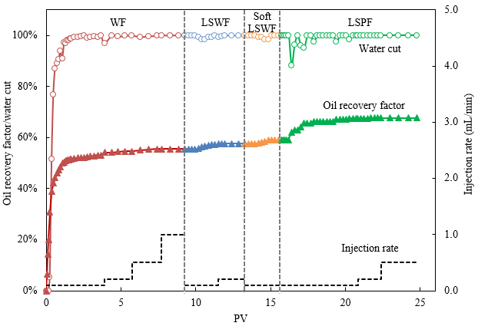
Figure 12: Water cut and oil recovery factor for one of the tested sandpacks.

Numerical Reservoir Simulation
Reservoir modeling efforts have focused on assessing the polymer retention effects using a 1D homogenous and 2D heterogeneous models in areal plane on laboratory sandpack experiments and simulations geared toward field scale analyses. Capillary pressure effects on polymer retention were also simulated using the experimentally determined polymer retention values in oil sand, which indicate that for the target heavy oil reservoir with high permeable oil zones and large pore size sand, there were no significant effects on polymer retention or fluid saturation using the 1D sand pack model. A simulation comparison using the retention values obtained from laboratory studies demonstrated that the polymer absorption behavior agreed with the range of delayed polymer slugs from laboratory experimental results. Large heterogeneity in the areal direction led to less apparent polymer adsorption – suggesting for the heterogeneous cases that high polymer viscosities might be needed to overcome the heterogeneity to improve sweep efficiency.
The 3D grid system of the initial reservoir simulation model, as shown in Figure 13, has been generated based on the geological model which was developed by combining seismic data, well logs, core data as well as wellbore trajectories. Further, the simulation model is populated using available reservoir data such as porosity, permeability, initial reservoir pressure, initial oil and water saturations, rock and fluid properties, and wellbore configurations. As mentioned earlier, since the injector-producer pairs have been used for waterflooding, one of the primary objectives of reservoir simulation is to perform a waterflood history match and continually update the reservoir model as sustained long-term production data from the polymer flood pilot becomes available.

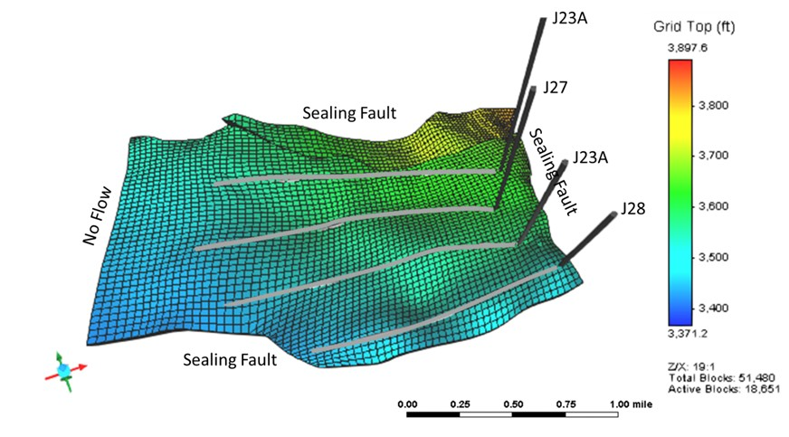
Figure 13: The grid top diagram of the initial reservoir simulation model. Note that the boundary conditions along the model’s edge are fault surfaces that have been modeled as no flows.

Since the water injection rate and the oil production rate are used as well constraints in the reservoir simulation model, only the water cut and gas production rate of the two production wells need to be matched in the history matching process. An optimization module available in the simulation software package is employed to conduct the history matching with the assistance of advanced algorithms. Basically, the permeability and the relative permeability curves are modified step by step to match the waterflooding production history. However, in order to achieve the best and realistic history match, the following methodology has been adopted. First, the homogeneous permeability in each layer is tuned in a layer cake model. Second, the relative permeability curves are tuned in a heterogeneous model. Finally, the permeability distribution in a strip manner is tuned with the estimated relative permeability curves. The oil-water and gas-oil system relative permeabilities are typically expressed by Corey type power law models as shown in Equations 1 - 4:

(1)

(2)

(3)

(4)

where k_{rw} (S_{w}), k_{row} (S_{w}), k_{rg}(S_{g}) and k_{rog}(S_{g}) are the water, oil (in a 2 phase oil-water system), gas and oil (in a 2 phase gas-oil system) phase relative permeabilities, respectively; a_{w}, a_{o}, and a_{g} are the maximum of water, oil and gas phase relative permeability, respectively; S_{w} and S_{wi} is water saturation and irreducible water saturation, respectively; S_{orw} and S_{org} is the residual oil saturation to water and gas, respectively; S_{gc} is critical gas saturation; and n_{w}, n_{ow}, n_{g} and n_{og} are the Corey exponents that control the curvature of the respective relative permeability curves.
Based on laboratory measured core data, a_{o} and S_{wi} are set as 1.0 and 0.235, respectively. The other coefficients of the power law model are directly tuned in the history matching process. The adjustment and estimate of these coefficients are shown in Table 1, which indicates that the best estimates are within the range and for the most part, close to the base case values.

Table 1: Coefficients of power law model in history matching (Equations 1 – 4).
Variable | Base | Range | Best Estimate
S_{orw} | 0.32 | 0.30-0.35 | 0.31
a_{w} | 0.35 | 0.15-0.50 | 0.33
n_{w} | 2.00 | 1.00-4.00 | 1.50
n_{ow} | 2.00 | 1.50-4.00 | 2.70
S_{org} | 0.20 | 0.10-0.30 | 0.20
S_{gc} | 0.02 | 0.01-0.06 | 0.02
a_{g} | 0.30 | 0.10-1.00 | 1.00
n_{og} | 2.00 | 1.50-3.50 | 1.69
n_{g} | 2.00 | 1.50-4.50 | 2.10

A permeability strip model has been developed as shown in Figure 14 to further investigate the heterogeneity of the reservoir. Nine permeability strips are assigned in each layer, resulting in 45 permeability strips in the simulation model. The permeabilities of the strips in each layer are initially assigned with the average permeability of the layer and then tuned between 100 and 7,600 mD during the history matching process. In addition, the average porosity of each layer is used and the estimated relative permeability curves based on Equations 1-4 and the best estimate coefficients shown in Table 1.

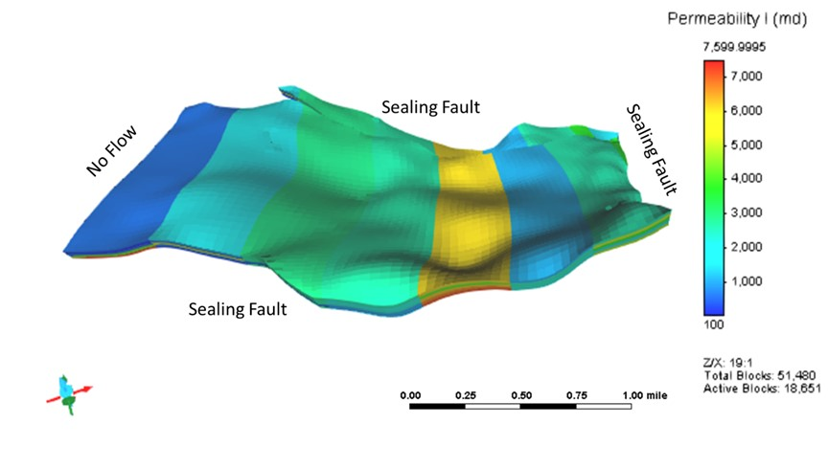
Figure 14: Permeability strips in the simulation model.

The best history matching results in the permeability strip models are shown in Figures 15 (a) and (b) respectively for producer J-27. The humps on the water cut curves have been well reproduced in the simulation due to the heterogeneous and strip-type permeability distribution. Therefore, the estimated permeability strip model is to be used for subsequent predictions.

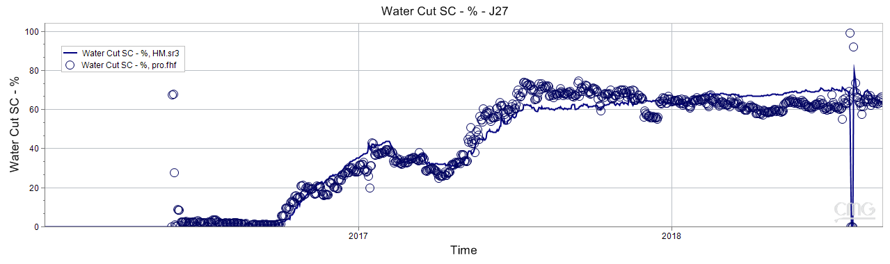
(a)

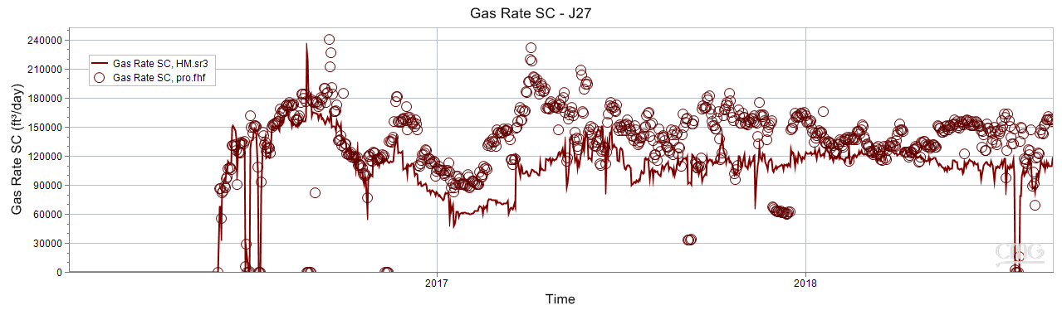
(b)
Figure 15: History matching of the production profile of J-27 in the permeability strip model. Note that data precede the start of polymer injection.

Treatment of Effluent Stream Containing Produced Oil, Water and Polymer
The formation of stable emulsions during polymer flooding poses significant challenges during oil/water separation in surface production facilities. Given the fact that emulsion breakers (EB) are time-tested and commonly employed on ANS for oil-water separation, initial experiments have focused on testing their efficacy for the subject set of produced fluids and the HPAM. The experimental protocol that is typically followed in this work is based on Hirasaki et. al. (2010). In order to cover a wider range, water-oil ratios of 30:70 to 90:10 and polymer concentrations of 100, 250 and 500 ppm respectively have been tested. Note that the lower concentration of the polymer is under the assumption that the spent polymer concentration will most likely be lower than in the 1600-1800 ppm injection stream. Additionally, it is assumed that in the process of preparing the emulsions, the 5000 rpm mixer speed, would result in some shearing of the polymer so as to mimic, at least to some extent, the shearing of the polymer as it flows through the injection system, the reservoir pore spaces, and eventually in the produced stream. While this research is ongoing, we present some results of these tests to highlight the challenges in efficiently separating the oil and water.
Figure 16 shows water droplets (lighter color) distribution in the oil phase as polymer concentration increases. At lower polymer concentration, the existence of polymer reduces the stability of the emulsion and favor oil-water separation. However, at higher concentration, the polymer intensifies the emulsification and increases the difficulty in separating the dispersed droplets.

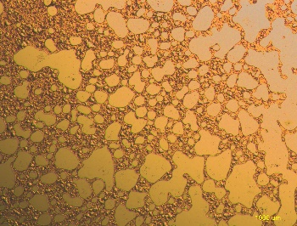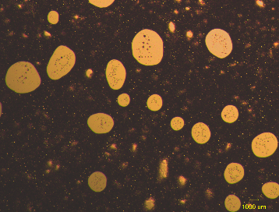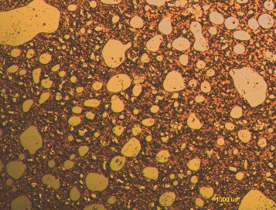
(a) 100ppm (b) 250ppm (c) 500ppm
Figure 16: Microscopy (×50) of 50:50 MPU oil and produced water emulsions containing HPAM (100–500 ppm).

When one of the EB’s is added (identified as EB1) the polymer concentration has little effect on both the separated water volume and rate as shown in Figure 17. When the separated water quality is considered (see Figure 18), the bottom half of the tube remains somewhat yellow stained indicating the presence of tiny oil droplets remaining in the water phase, especially at a polymer concentration of 100 ppm.
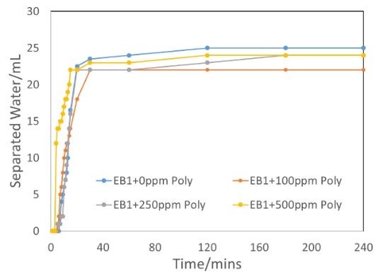
Figure 17: Separated water volume vs. time with EB and various HPAM concentrations.

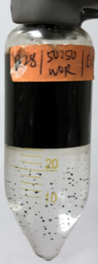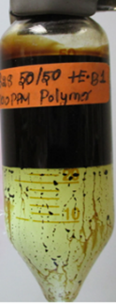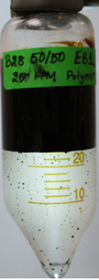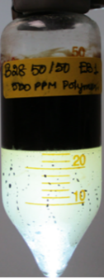
(a) 0 ppm (b) 100 ppm (c) 250 ppm (d)500 ppm
Figure 18: Bottle test results after 24 hours with EB for various HPAM concentrations.

Conclusions
Based on the research conducted so far, the following main conclusions are drawn:

- For the first time, the functionality of the Polymer Slicing Unit has been successfully tested in the remote Arctic environment.
- With nearly five months of polymer injection in the two horizontal injectors, no injectivity issues and polymer breakthrough have been encountered.
- Considering the encouraging response of both producers we are cautiously optimistic, as far as the performance of the polymer field pilot is concerned.
- Initial polymer retention laboratory tests in sand packs indicated high values on cleaned sand. However, tests on cleaned sand that was re-saturated with fresh oil yielded moderate polymer retention values – on the order of 28 µg/g.
- Low salinity polymer flood in a tertiary mode carried out on two sandpacks have demonstrated an improvement in the oil recovery factor over a range of low to high salinity waterfloods.
- A good waterflood history match using the permeability strip model and power law estimated relative permeabilities has been achieved that establishes the reservoir simulation model for future applications.
- An acceptable separation of oil and water, and especially when spent polymers are present, in the produced stream continues to be somewhat challenging as far as application of commercially available emulsion breakers is concerned, thus necessitating further research.
- Finally, based on the foregoing, the authors are confident that this research endeavor is trending toward a positive paradigm shift to enhance the recovery of heavy oils on ANS.

Nomenclature
1D One Dimensional
2D Two Dimensional
a_{g} Maximum of Gas Phase Relative Permeability (Equation 3)
a_{o} Maximum of Oil Phase Relative Permeability (Equation 2 and 4)
a_{w} Maximum of Water Phase Relative Permeability (Equation 1)
ANS Alaska North Slope
API American Petroleum Institute
bbl Barrel
BOPD Barrels Oil per Day
bwpd Barrels of Water Per Day
COBR Crude Oil Brine Rock
cP Centipoise
EB Emulsion Breaker
EOR Enhanced Oil Recovery
ft Feet
HPAM Hydrolyzed polyacrylamide
KRU Kuparuk River Unit
k_{rg} Relative Permeability of Gas in a Two Phase Gas-Oil System
k_{rog} Relative Permeability of Oil in a Two Phase Gas-Oil System
k_{row} Relative Permeability of Oil in a Two Phase Oil-Water System
k_{rw} Relative Permeability of Water in a Two Phase Oil-Water System
lbm Pound-mass
LSPF Low Salinity Polymer Flood
LSWF Low Salinity Waterflood
MCFPD 1000 Standard Cubic Feet per Day
mD MilliDarcy
MDT Modular formation Dynamic Tester
mL Milliliter
MMP Minimum Miscibility Pressure
MMSTB Million Stock Tank Barrels
MPU Milne Point Unit
n_{g} Corey Exponenet of Gas
n_{og} Corey Exponent of Oil in a Two Phase Gas-Oil System
n_{ow} Corey Exponent of Oil in a Two Phase Water-Oil System
n_{w} Corey Exponenet of Water
OOIP Original Oil in Place
PF Polymer Flood
PFO Pressure Falloff
PPM Parts Per Million
PBU Prudhoe Bay Unit
PSU Polymer Slicing Unit
PV Pore Volume
PVT Pressure Volume Temperature
SFB Synthetic Formation Brine
S_{g} Gas Saturation
S_{gc} Critical Gas Saturation
S_{or} Residual Oil Saturation
S_{org} Residual Oil Saturation to Gas
S_{orw} Residual Oil Saturation to Water
S_{w} Water Saturation
S_{wi} Irreducible Water Saturation
TAPS Trans Alaska Pipeline System
µg Microgram
ULSWF Ultra Low Salinity Waterflood
VRWAG Viscosity Reduction Water Alternating Gas
WAG Water Alternating Gas
WF Waterflood

Acknowledgments
"This material is based upon work supported by the Department of Energy, Office of Fossil Energy, administered by the National Energy Technology Laboratory, under Award Number DE-FE0031606."

Disclaimer: "This report was prepared as an account of work sponsored by an agency of the United States Government. Neither the United States Government nor any agency thereof, nor any of their employees, makes any warranty, express or implied, or assumes any legal liability or responsibility for the accuracy, completeness, or usefulness of any information, apparatus, product, or process disclosed, or represents that its use would not infringe privately owned rights. Reference herein to any specific commercial product, process, or service by trade name, trademark, manufacturer, or otherwise does not necessarily constitute or imply its endorsement, recommendation, or favoring by the United States Government or any agency thereof. The views and opinions of authors expressed herein do not necessarily state or reflect those of the United States Government or any agency thereof."

The authors would also like to thank Hilcorp Alaska, LLC and BP Exploration (Alaska) Inc. for cosponsoring this project.

References
Al-Qattan, A., Sanaseeri, A., Al-Saleh, Z., Singh, B.B., Al-Kaaoud, H., Delshad, M., Hernandez, R., Winoto, W., Badham, S., Bouma, C. and Brown, J. “Low Salinity Waterflood and Low Salinity Polymer Injection in the Wara Reservoir of the Greater Burgan Field”, SPE EOR Conference at Oil and Gas West Asia, 26-28 March, Muscat, Oman.

Hall, H.N., "How to Analyze Waterflood Injection Well Performance,". World Oil, 1963(October): p. 128-130.

Hirasaki, G.J., Miller, C.A., Raney, O.G., Poindexter, M.K., Nguyen, D.T. and Hera, J. “Separation of Produced Emulsions from Surfactant Enhanced Oil Recovery Processes”, Energy Fuels 2011, 25, 555–561

Khorsandi, S., Qiao, C., Johns, R.T., 2017. Displacement efficiency for low salinity polymer flooding including wettability alteration. SPE J. 22. SPE-179695-PA.

Manichand, R.N. and Seright, R. “Field vs laboratory polymer retention values for a polymer flood in the Tambaredjo field”. SPE Reservoir Evaluation & Engineering, Vol. 17, No. 3, SPE 169027-PA, 2014.

McGuire, P.L., Redman, R.S, Jhaveri, B.S., Yancey, K.E., and Ning, S.X. “Viscosity Reduction WAG: An Effective EOR Process for North Slope Viscous Oils”, SPE paper 93914, presented at the 2005 SPE Western Regional Meeting held in Irvine, CA, U.S.A., 30 March – 1 April 2005.

Paskvan, F., Turak, J., Jerauld, G., Gould, T., Skinner, R. and Garg, A. Alaskan viscous oil: EOR opportunity, or waterflood sand control first? SPE 180463, 2016.

Seright, R. Use of polymers to recover viscous oil from unconventional reservoirs. DOE report, Award No: DE-NT0006555, 2011.

Seright, R. Potential for polymer flooding reservoirs with viscous oils. SPE Reservoir Evaluation & Engineering, Vol. 13, No. 4, 2010.

Targac, G.W, Redman, R.S., Davis, E.R, Rennie, S.B., McKeever, S.O. and Chambers, B.C. Unlocking value in West Sak heavy oil. SPE 97856, 2005.

Unsal, E., ten Berge, A.B.G.M. and Wever, D.A.Z., “Low salinity polymer flooding: Lower polymer retention and improved injectivity”, Journal of Petroleum Science and Engineering 163 (2018) 671–682.

Vermolen, E. C. M., Pingo Almada, M., Wassing, B.M., Lighthelm, D.J., Shehadah, M. 2014. Low-salinity polymer flooding: improving polymer flooding technical feasibility and economics by using low-salinity make-up brine, IPTC-17342-MS.

